FOR IMMEDIATE RELEASE
MULTI-PLATINUM RAPPER O.T. GENASIS RETURNS WITH NEW SINGLE “EVERYBODY MAD”

DOWNLOAD/STREAM HERE

WATCH THE NEWLY RELEASED MUSIC VIDEO HERE

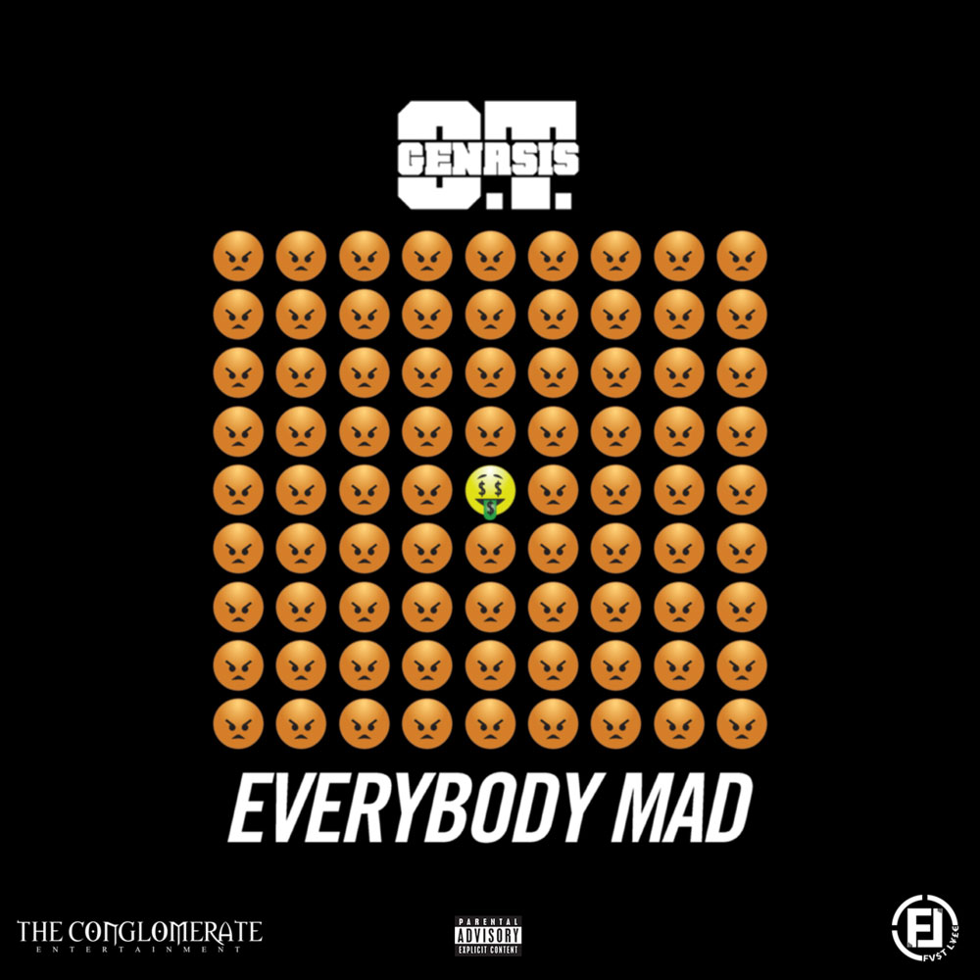
Download the hi-res single artwork here

(NEW YORK, NY) – October 6, 2017 – Conglomerate Entertainment/Fast Life/Atlantic Recording Artist O.T. Genasis has returned with yet another hit on his hands. The rapper has introduced his newest single “Everybody Mad” now available everywhere here. The music video which was released as of this morning is also set to be exclusively featured as a BET Jam of the Week this Sunday, October 8^{th.} The release of his newest single arrives on the heels of his RIAA 2X Platinum “Cut It feat Young Dolph” and Platinum “CoCo” which became one of his most successful songs to chart, peaking at number 20 on the US Billboard Hot 100. The single also arrives as “Thick feat 2 Chainz” and “Push It” remain to be a staple in the club and the streets.
The multi-platinum rapper has continued to climb the ranks of success as a number of shows including FOX’s So You Think You Can Dance, HBO’s Baller’s, MTV2’s Uncommon Sense with Charlamange Tha God and more have featured a collection of his music. Arguably one of his most recognizable tracks, “CoCo” was also recruited by Lionsgate’s Dirty Grandpa which starred Robert Di Nero and Zac Efron.
O.T. Genasis has most recently been seen performing a medley of his latest hits during the BET Experience’s BETX Live #1633Takeover along with the 2016 BET Hip Hop Awards. He also teamed up with the likes of Chris Brown, Fabolous and Kap G. for the nationwide The Party Tour. Additional live appearances have included Beyonce’s World Formation Tour where he performed “Cut It” and “CoCo” live with DJ Khaled and REVOLT TV’s Revolt LIVE where he performed “CoCo.”
He’s recently been featured on an episode of Viceland’s The Therapist with Dr. Siri Sat Nam Singh where he opened up about his son’s autism and was forced to dig deeper into his self-identity.
You can stream O.T. Genasis’ newest single “Everybody Mad” here. His latest mixtape COKE N BUTTER which features YG, 2 Chainz, T.I. and more is also available here.
For more information visit www.press.atlanticrecords.com/o-t-genasis/ or http://www.otgenasis.com/.
# # #
Press Contact:
Sydney Margetson / Atlantic Records
Sydney.Margetson@AtlanticRecords.com

