**DRAM RELEASES STUNNING NEW VIDEO FOR “THE LAY DOWN (FEAT. H.E.R. & WATT)”**

[**WATCH HERE**](https://bigbabydram.lnk.to/TheLayDownVideo)

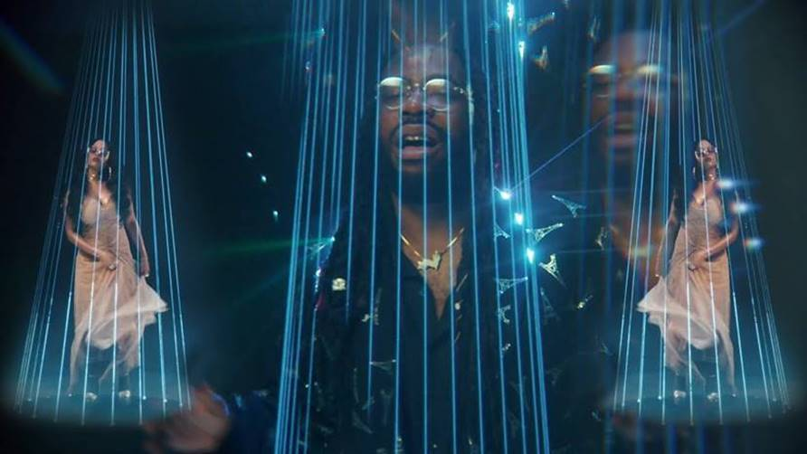

*[Directed by Aisultan Seitov]*

After digging deep into his R&B roots with the release of his new track, **“The Lay Down (Feat. H.E.R. & watt),”** multiple Grammy Award-nominated singer/songwriter **DRAM** dropped an accompanying music video today for the soulful new single. The mesmerizing new video was directed by **Aisultan Seitov**, whose direction credits include videos for **Offset** and **21 Savage**.

Produced by **Watt** (*Shawn Mendes, Post Malone, Justin Bieber, Cardi B*), “**The Lay Down**” debuted earlier this week as Zane Lowe’s World Record on Beats1 & marks the first new song from the multi-platinum, Virginia-bred artist since his critically-acclaimed ***THAT’S A GIRL’S NAME*** EP, released last year.

**A NOTE FROM DRAM:**

*“No one sings anymore. Ain’t no true SANGERS out there! Nobody’s taking it to the stage. No one’s pouring their heart out, but that pattern stops here!*

*Over the last 2 years, I’ve been working on my sophomore album while simultaneously going through the ups and downs of life in general. As a result of this, many of these experiences have been heavily reflected in my work moving forward. As I mature, so does my sound. I’ve always considered myself more of a singer-songwriter so this time around, I’m really owning my R&B and soul roots. So, as you can tell, I’m excited about introducing you to the new Big Baby DRAM chapter.*

*Special shout out to H.E.R., Andrew Watt, Chad Smith, Pino Palladino and Ivan Neville who helped bring ‘The Lay Down’ to life.”*

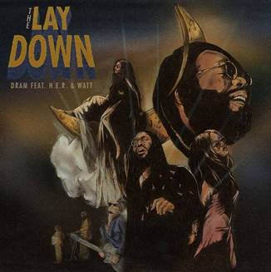

**CREDITS:**

Vocals by DRAM and H.E.R.

Produced by Andrew Watt

Instrumentation & Programming by: Andrew Watt

Keyboards by Ivan Neville

Guitar by Happy Perez and Andrew Watt

Bass by Pino Palladino

Drums by Chad Smith

*Contains an interpolation of Roberta Flack’s “Tonight I Celebrate My Love”*

* * *

**\*NEW PRESS IMAGE\***

*Photo Credit: Renell Medrano*

[**DOWNLAOD HIGH-RES APPROVED PRESS IMAGE HERE**](https://warnermusicgroup.box.com/s/mcrzy1kxr0d3qe8g3tg9a9tt1qfx8k3h)



**CONTACT:**

**Jason Davis |** [**Jason.Davis@Atlanticrecords.com**](mailto:Jason.Davis@Atlanticrecords.com)

# # #