DEATH CAB FOR CUTIE AND ODESZA TO HEADLINE HOMETOWN PERFORMANCE IN BELLINGHAM, WASHINGTON ON MAY 18, 2019

WESTERN WASHINGTON UNIVERSITY ALUMS JOIN FORCES FOR
"DOUBLE MAJOR" SCHOLARSHIP BENEFIT SHOW

DEATH CAB FOR CUTIE RELEASE JAPANESE WALLPAPER REMIX OF “NORTHERN LIGHTS”

BEN GIBBARD ANNOUNCES “THE SWIFT SESSIONS” – EXCLUSIVE 7” RECORD STORE DAY 2019 RELEASE FEATURING UNRELEASED TRACKS FROM HIS SESSIONS WITH RICHARD SWIFT

LISTEN TO “NORTHERN LIGHTS [JAPANESE WALLPAPER REMIX]”:
https://www.youtube.com/watch?v=UdkvKjpBPJc

LEARN MORE ABOUT “DOUBLE MAJOR” BENEFIT:
https://doublemajorbellingham.com

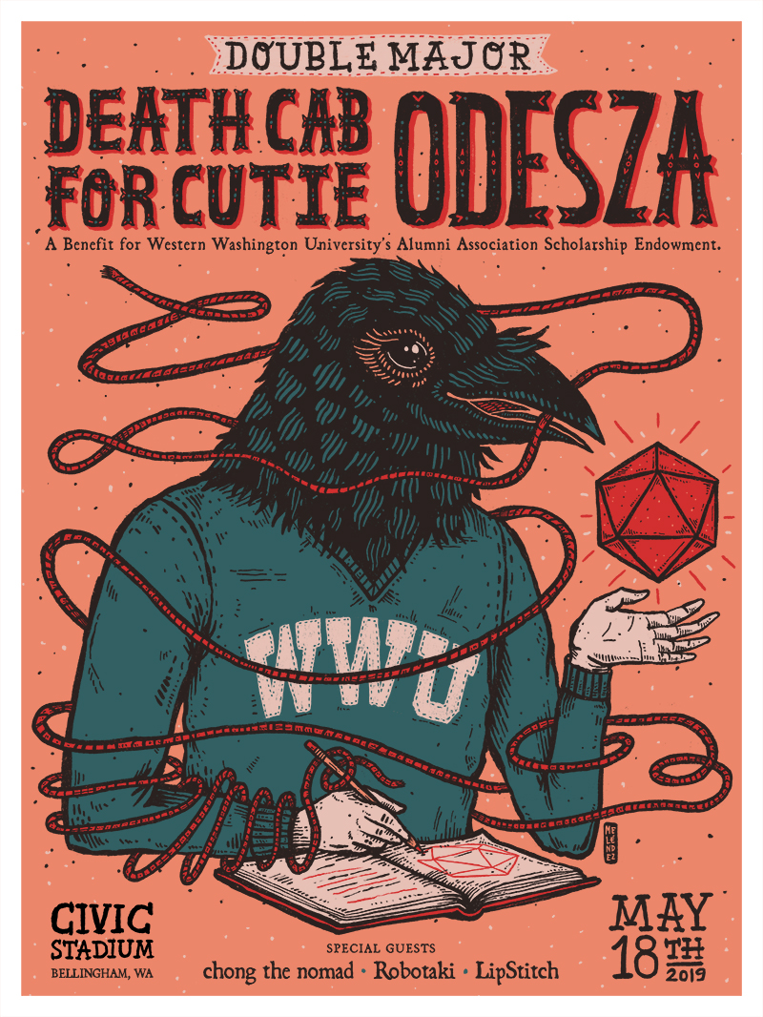

Death Cab for Cutie and ODESZA have announced Double Major, a co-headline benefit show at Bellingham, Washington’s Civic Stadium. The show is a homecoming for both bands, having formed in Bellingham when their members were students of Western Washington University. In appreciation for the school and the city of Bellingham, net proceeds from the show will be donated to WWU’s Alumni Association Scholarship Endowment. The bands will transform Civic Stadium for Double Major, building festival-level stage production for the event. Prior to full headline sets from both Death Cab for Cutie and ODESZA, supporting artists chong the nomad, Robotaki, and LipStitch will open the show.

Advance registration for pre-sale tickets is available now at https://doublemajorbellingham.com. Pre-sale tickets are available starting Tuesday, March 5th at 10am PT. Additional tickets will go on sale Friday, March 8th at 10am PT.

For both bands, Double Major is a celebration of the University community and the city of Bellingham. “Bellingham and WWU is where it all began,” says Death Cab for Cutie’s Nick Harmer. “And as we have continued on, it’s been amazing to see and hear so much music continue to flow out of Bellingham too. So when we met ODESZA our bond of being “from Bellingham” was an instant connection.”

ODESZA’s Harrison Mills and Clayton Knight added in a statement, “We had some amazing times in that town and at that school. We are super excited to come back and do a special benefit show with our friends and fellow alumni Death Cab for Cutie.”

Today also brings the release of a new remix of Death Cab for Cutie’s “Northern Lights” – a track off the band’s critically acclaimed ninth studio album Thank You for Today. The song recently cracked the Top 15 at Alternative radio, after reaching #1 at Adult Alternative (the band’s second number one at that format from this album). Fittingly on the eve of their Australian tour, today’s flip comes courtesy of acclaimed Australian electronic producer Japanese Wallpaper (Gab Strum) – listen HERE. Strum has recently remixed Charli XCX and Your Smith, and previously toured his home country with M83, Melanie Martinez, and Lily Allen.

“Death Cab for Cutie is my favourite band in the world and remixing this song was a dream come true.”
– Japanese Wallpaper

As if all that weren’t enough, lead signer Ben Gibbard today announced “The Swift Sessions” – an exclusive 7” Record Store Day 2019 release. The split single is composed of “Me and Magdalena” and “The Concept,” two previously unreleased tracks taken from separate sessions Ben did with Richard Swift. Net proceeds will go to the Swift family and two incredible organizations, MusiCares and Music Support UK.

Gibbard said of the announcement: “All of us who knew and loved Richard Swift are still reeling from the loss. Thankfully, he left us with a large body of work to remember him by. And while I wish it were under other circumstances, I am beyond proud to share some of the work we did together. He was a brilliant human being the likes of which I have rarely encountered in my career. Rest in Peace, Richard.”

###

ABOUT DEATH CAB FOR CUTIE:

Death Cab for Cutie has spent much of the past year on the road celebrating Thank You For Today, their epic schedule highlighted by intimate theatre performances, sold out headline shows, benefit concerts, and top billed sets at festivals across both North and South America. The band also made a series of high profile TV appearances, including performances of “Gold Rush” on CBS’s The Late Show with Stephen Colbert, The Late Late Show with James Corden, ABC’s Jimmy Kimmel Live!, and the nationally syndicated Ellen DeGeneres Show, alongside performances of “Northern Lights” on Late Night with Seth Meyers, The Late Late Show with James Corden, and NPR’s Live From Here.

https://deathcabforcutie.com/
https://www.instagram.com/deathcabforcutie/
https://twitter.com/dcfc
https://www.facebook.com/deathcabforcutie

ABOUT ODESZA:

ODESZA is currently on tour in support of their GRAMMY-nominated album A Moment Apart, having sold out shows at STAPLES Center in Los Angeles and Barclays Center in Brooklyn, in addition to main stage appearances at Coachella, Panorama, Lollapalooza and Austin City Limits. Later this month, ODESZA will head to Riviera Maya, Mexico for their first ever self-curated all-inclusive festival, SUNDARA, March 13-16.

https://odesza.com
https://instagram.com/odesza
https://twitter.com/odesza
https://facebook.com/odesza

