WATCH LAUREN MAYBERRY OF CHVRCHES JOIN DEATH CAB FOR CUTIE FOR “NORTHERN LIGHTS” DURING WASHINGTON DC SHOW

WATCH: https://www.youtube.com/watch?v=qyUz30Bo0YA
(credit: Jim Powers)

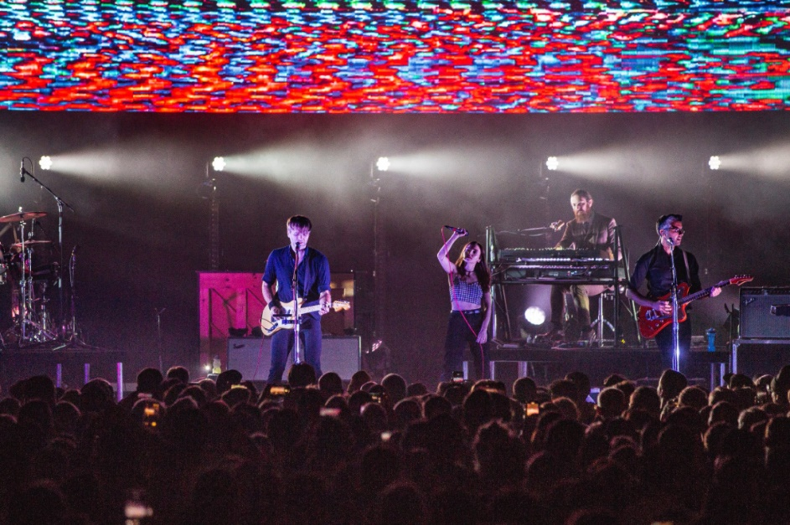
hi-res images here: https://twitter.com/dcfc/status/1052983940942839808

Last night during a tour stop at DC’s The Anthem, 8x Grammy nominees Death Cab for Cutie were joined on stage by CHVRCHES lead singer Lauren Mayberry for a special performance of “Northern Lights” – watch HERE.

While Mayberry indeed lends her vocals to the album version of “Northern Lights,” last night marked her debut live performance of the track with the band. The song comes off Death Cab for Cutie’s ninth studio album – Thank You for Today – which debuted at #1 on the Alternative, Rock, and Vinyl album charts, and was met with widespread critical acclaim from NPR, Rolling Stone, Entertainment Weekly, and many more.

“For a band in its third decade… Death Cab hasn't lost its gift for pairing Gibbard's soft ruminations with propulsive arrangements that know just when to sparkle and sway”

“Death Cab for Cutie sounds rejuvenated on Thank You for Today”

“…both refreshing and consistently piercing…”

Death Cab for Cutie wraps up the first leg of their headline “Thank You for Today” US tour with stops in Virginia, Georgia and Florida, ahead of a festival run in South America and Mexico. December will see the band play a number of holiday radio shows, followed by a European tour in early 2019.

For a full list of tour dates and additional information, visit https://deathcabforcutie.com/tour/.

