ELECTRIC GUEST RELEASE LEMAITRE REMIX OF “DOLLAR”

WATCH: https://youtu.be/YJkCPSd8qPw
BUY/STREAM: https://ElectricGuest.lnk.to/DollarLemaitrePR

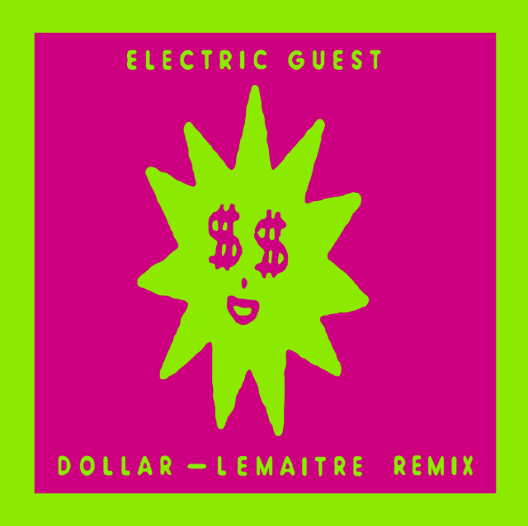
download hi-res art

Acclaimed pop duo Electric Guest has released the first official remix of their Atlantic Records debut single “Dollar” – a funky rework featuring glimmering synths courtesy of Norwegian indie electronic duo Lemaitre – listen here. The remix comes accompanied by an equally shimmery neon lyric video, complete with bright imagery and hand-drawn doodles. Lemaitre’s previous remix discography reads like a true who’s who of electronic artists including Porter Robinson, Martin Solveig, and Passion Pit.

The original track received critical acclaim upon release, with Billboard proclaiming: “Electric Guest have made an eclectic return with feel-good anthem, ‘Dollar.’

Complex premiered the official music video and declared: “The track is representative of the duo's goal of entering this latest era with a desire to make straight up, unapologetic pop.”

“Dollar” sets the tone for the new sound and vibe of Electric Guest’s eagerly awaited Atlantic Records debut album, due in October. The song debuted as a Zane Lowe World Record on his Beats 1 show and came accompanied by a music video directed by The Lonely Island’s Jorma Taccone and featuring an authentic, custom-built DeLorean hovercraft replica!

Co-produced by Lars Stalfors (St. Vincent, Foster the People), Electric Guest’s new album sees Taccone and Matthew Compton pushing modern pop towards their own unique worldview, melding sunshine soul grooves and sugar candy hooks with ambitious production and a subversive lyrical power.

The forthcoming LP marks Electric Guest’s first full-length release in two years, as well as the duo’s first new music since Taccone earned a GRAMMY® Award for co-writing and co-producing Portugal. The Man’s worldwide smash single, “Feel It Still.” Electric Guest’s recent contributions to the pop landscape don’t stop with “Feel It Still.” Taccone and Compton joined forces with Carly Rae Jepsen to co-write and co-produce “Feels Right (Feat. Electric Guest),” the only feature on the pop star’s critically-acclaimed new album Dedicated. As extremely collaborative creators, each have recent credits on tracks for artists ranging from Cold War Kids to Aminé.

Taccone and Compton also have a long resume of creative work beyond commercially released music. Taccone, often working alongside his brother Jorma of The Lonely Island, has contributed musical pieces to TV shows including Saturday Night Live, The Simpsons and American Dad, receiving an Emmy Award nomination in the process. A gifted composer and musician, Compton has scored a number of films and TV projects, as well as national advertising campaigns for Bud Light, Starburst, Lincoln, Nissan, and more.

CONNECT WITH ELECTRIC GUEST:
OFFICIAL I FACEBOOK I TWITTER I INSTAGRAM I YOUTUBE

