ANNOUNCES NEW SINGLE ‘BAD HABITS’
ARRIVES EVERYWHERE JUNE 25TH
PRE-ORDER ‘BAD HABITS’ HERE

“I’ve been working away in the studio over recent months, and I can’t wait for you to hear ‘Bad Habits.’ I always aim to push myself and my music in new directions and hopefully you’ll hear that on the new single. Feels great to be back!”
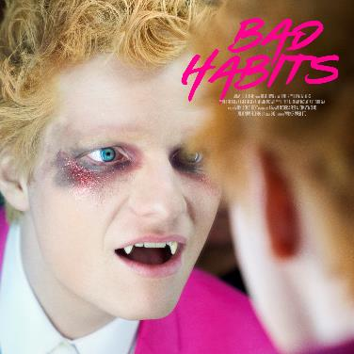
DOWNLOAD COVER ART + OTHER ASSETS HERE
Today, global superstar Ed Sheeran has confirmed his official return with the announcement of his brand-new single ‘Bad Habits’, out everywhere June 25th via Atlantic Records (pre-order here).

Sheeran hinted at his return to music last week in a now viral clip alongside actress and close friend Courtney Cox. In addition to this, Sheeran has also unveiled the single’s accompanying artwork that reveals him as a vampire character, which he has been teasing on his social channels recently, including in overnight posts featuring a string of London landmark projections, including the Tate Modern (download landmark projection imagery here).

Commenting on his comeback, Ed Sheeran says: “I’ve been working away in the studio over recent months and I can’t wait for you to hear ‘Bad Habits.’ I always aim to push myself and my music in new directions and hopefully you’ll hear that on the new single. Feels great to be back!”

The announcement follows the recent news of Ed performing live from Ipswich Town’s Portman Road football stadium in Suffolk, England, on June 25th for TikTok’s UEFA Euro 2020 show. The upcoming set - directed by Ed’s long-term collaborator, Emil Nava, and streaming globally on TikTok (@edsheeran) starting at 4pm ET/9pm BST - will include a host of fan favorites in addition to Ed’s first-ever live performance of ‘Bad Habits’.

‘Bad Habits’ will mark Sheeran’s first official release since 2019’s Platinum-certified, GRAMMY-nominated ‘No.6 Collaborations Project,’ which includes the multi-platinum, chart-topping hits “I Don’t Care (with Justin Bieber)” and “Beautiful People (feat. Khalid),” and features guest appearances from the likes of Travis Scott, Bruno Mars, Cardi B and more.

Further details will follow.

About Ed Sheeran:

Ed Sheeran is an era-defining artist. From record-breaking sales across his recorded music and live performances, and a plethora of award wins to his name, the British singer-songwriter is the boundless talent behind some of the biggest songs in history. The four-time GRAMMY award winner has consistently resonated with fans across the world with his peerless songcraft and exceptional music palate. With four multiplatinum, critically acclaimed albums under his belt – ‘+’ (2011), ‘x’ (2014), ‘÷’ (2017) and ‘No.6 Collaborations Project’ (2019) - Sheeran has amassed more than 60 billion streams and sold over 50 million albums, globally to date; he is also one of only six artists to have three songs – “Thinking Out Loud,” “Perfect,” and “Shape Of You” - earn RIAA Diamond-certification, for sales equivalents exceeding 10 million in the US alone. An unparalleled live performer, Sheeran’s most recent, two-year ÷ world tour made history becoming the most-attended and highest-grossing tour of all time.

For more information please contact:
Glenn Fukushima - GlennFukushima@elektra.com
Jason Davis - Jason.Davis@atlanticrecords.com

