ED SHEERAN AND TAYLOR SWIFT TEAM-UP FOR A REIMAGINED VERSION OF “THE JOKER AND THE QUEEN”

EMIL NAVA-DIRECTED OFFICIAL MUSIC VIDEO REUNITES CHARACTERS FIRST FEATURED IN THE GLOBAL SUPERSTARS’ 2012 COLLABORATION
“EVERYTHING HAS CHANGED”

“THE JOKER AND THE QUEEN” FEAT. TAYLOR SWIFT
OUT NOW ON ATLANTIC RECORDS
LISTEN HERE / WATCH HERE
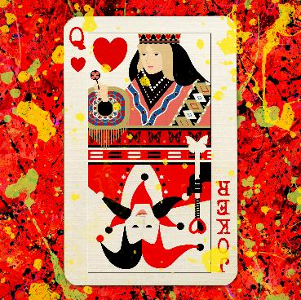

DOWNLOAD PRESS IMAGES AND SINGLE ART HERE

Global superstars Ed Sheeran and Taylor Swift reunite for a beautifully reimagined version of Sheeran’s “The Joker And The Queen,” available now across all DSP’s (listen HERE). Sharing a friendship that spans well over a decade, today marks Ed and Taylor’s fourth official collaboration to date, following “Everything Has Changed” (2012), “End Game” (2017) and “Run (Taylor’s Version)” (2021).

At the time of writing the original version of “The Joker and the Queen” for his blockbuster album ‘=’, Ed immediately thought of Taylor as the perfect guest voice for the track and later reached out to invite her to record her vocals. Written by Ed Sheeran, Taylor Swift, Johnny McDaid, Fred Gibson and Sam Roman and produced by Ed Sheeran, FRED, Johnny McDaid and ROMANS, the track glimmers with hushed vocals, delicate piano notes and sweeping string arrangements, provided by Ed’s brother, Matthew.

The accompanying Emil Nava-directed official video (watch HERE) brims with nostalgia as continues the storyline from the iconic “Everything Has Changed” video – Ed and Taylor’s previous collaboration, released in 2012. Ten years on, the video – featuring the original actors - captures the coming-of-age story of the now 18-year-olds, Ava and Jack, as they head to university and embark on new adventures.

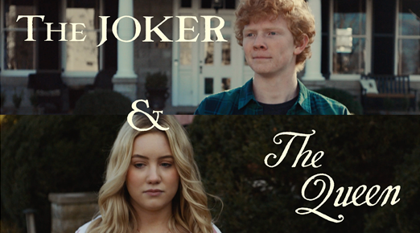
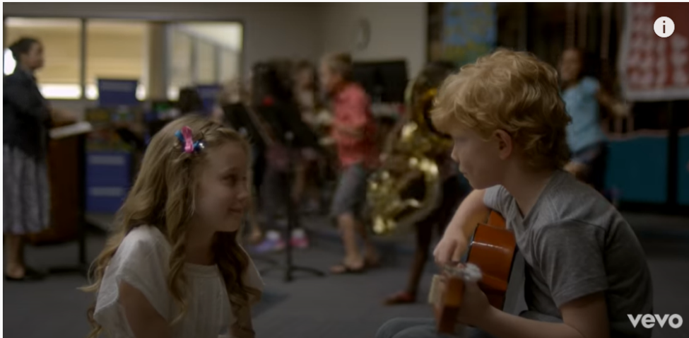

The original version of ‘The Joker And The Queen’ is featured on Sheeran’s latest album ‘=’ which debuted at #1 on the Billboard 200 upon its release in October. Marking his fourth consecutive chart-topping full length, ‘=’ is highlighted by lead single “Bad Habits” – currently nominated for Song of the Year at the upcoming 64th GRAMMY Awards – and its follow-up “Shivers.” The latter stands at #1 at Hot AC for the second consecutive week and #6 on the Top 40 chart. Both songs simultaneously sit in the Top 15 on the Billboard Hot 100, with “Shivers” at #7 and “Bad Habits” at #13.

This week, Sheeran opened the 2022 BRIT Awards with an epic performance of ‘”Bad Habits” that included UK rockers Bring Me The Horizon. The night also saw him perform “The Joker And The Queen” and take home the award for Songwriter of the Year.

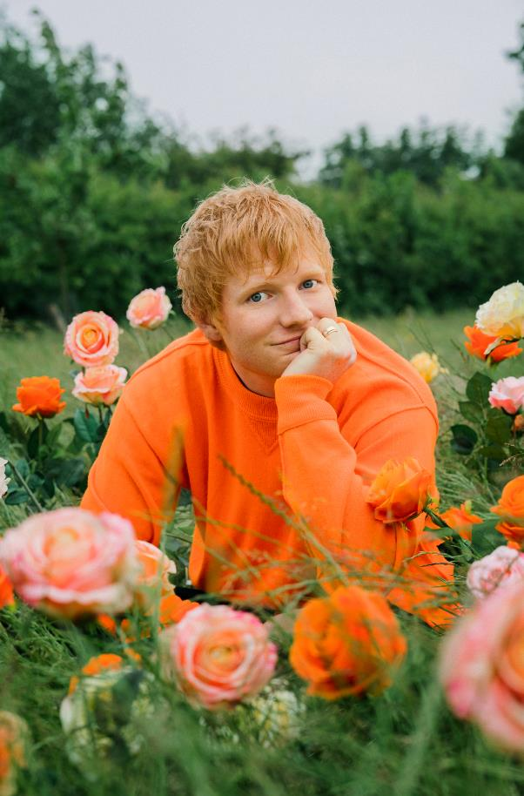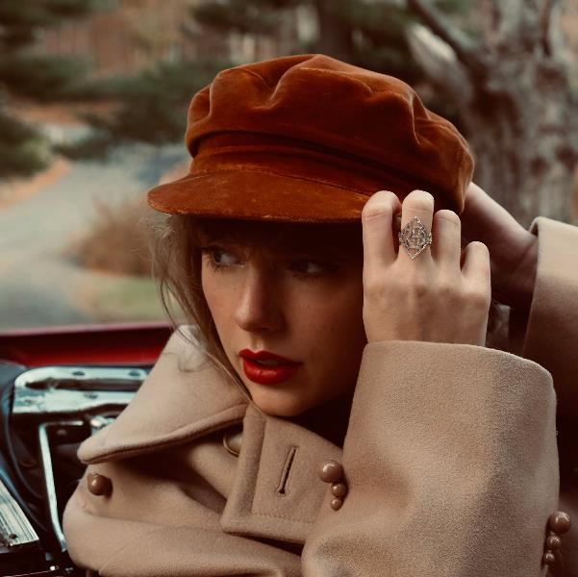

About Ed Sheeran
Ed Sheeran is an era-defining artist. From record-breaking sales across his recorded music and live performances, and a plethora of award wins to his name, the British singer-songwriter is the boundless talent behind some of the biggest songs in history. The 4x GRAMMY award winner has consistently resonated with fans across the world with his peerless songcraft and exceptional music palate. With four multiplatinum, critically acclaimed albums under his belt – ‘+’ (2011), ‘x’ (2014), ‘÷’ (2017) and ‘No.6 Collaborations Project’ (2019) - Sheeran has amassed more than 60 billion streams and sold over 50 million albums, globally to date; he is also one of only six artists to have three songs – “Thinking Out Loud,” “Perfect,” and “Shape Of You” - earn RIAA Diamond-certification, for sales equivalents exceeding 10 million in the US alone. An unparalleled live performer, Sheeran’s most recent, two-year ÷ world tour made history becoming the most-attended and highest-grossing tour of all time. This fall, Sheeran released ‘=’, the fourth installment of his symbol album series, highlighted by the hit singles “Shivers” and “Bad Habits,” which recently received a GRAMMY nomination for “Song of the Year.” Debuting at #1 on the Billboard 200, ‘=’ is Sheeran’s fourth consecutive full length release to top the chart after its first week. A global phenomenon, ‘=’ has also gone to #1 in 19 countries around the world.

About Taylor Swift
11x GRAMMY winner, Taylor Swift is the first female artist ever to win the music industry’s highest honor, the GRAMMY Award for Album of the Year – three times! She is a singer, songwriter, musician, producer and director, Billboard’s first-ever Woman of the Decade recipient along with being the youngest-ever Woman of the Year honoree and the only artist to have been awarded that title twice. Taylor is the American Music Awards’ Artist of the Decade, the only artist in history to have four consecutive albums sell over one million copies in their week of release (Speak Now, RED, 1989 and reputation) and is the only artist ever to have ten albums each sell at least 500,000 copies in a single week (Fearless, Speak Now, Red, 1989, reputation, Lover, folklore, evermore, Fearless (Taylor’s Version), Red (Taylor’s Version)). She is a two-time BRIT recipient having won International Female Solo Artist of the Year in 2015 and the Global Icon Award in 2021. Additionally, Taylor is the first and only female artist in the 21st century to score eight #1 studio albums in the UK.

For all press inquiries, please contact:
Glenn Fukushima - GlennFukushima@elektra.com
Jason Davis - Jason.Davis@atlanticrecords.com

