ELLA HENDERSON AND AJ MITCHELL ‘BLAME IT ON THE MISTLETOE’
BRAND-NEW SONG FOR THE HOLIDAYS

LISTEN HERE

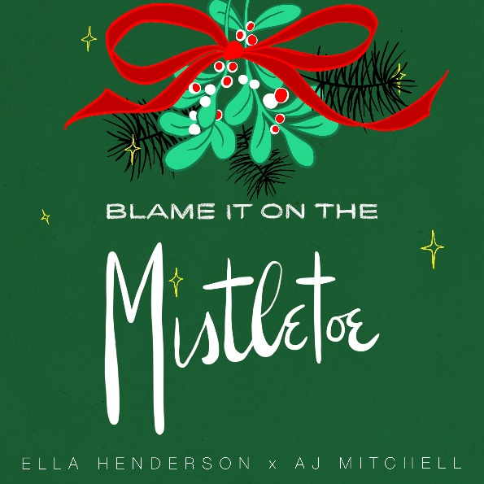

UK Multi-platinum selling vocalist and songwriter, Ella Henderson, has teamed up with US pop phenom, AJ Mitchell, for a brand-new holiday song, ‘Blame It On The Mistletoe’, available now via Atlantic Records / Major Toms / Asylum. Listen HERE.

Penned by Ella alongside producer Tre Jean-Marie (Mabel, Joy Crookes, Little Mix), ‘Blame It On The Mistletoe’ is an infectious track about taking a chance on love during the holiday season, destined to be a festive playlist staple for years to come.

Ella says: “Writing and recording this song was a lot of fun, and having AJ involved is amazing! I wanted to share something festive with my fans to sign off 2020. Sending so much love to everyone at this time and wishing you all Happy Holidays.”

AJ says: “I’m not just getting socks for Christmas this year, because I also get to drop my very first Christmas record. I’m so excited to be a part of this amazing song with Ella and I know this will be one that comes around every Christmas.”

‘Blame It On The Mistletoe’ rounds off an incredible year for Ella, who, at only 24, has achieved a UK No. 1 album, six UK Top 10s, two BRIT Award nominations, over 716 million global streams and become one of the UK’s most in-demand talents, this year alone, collaborating with the likes of Julia Michaels, Justin Tranter, MNEK, Nathan Dawes, KSI and Roger Sanchez.

Connect with Ella:
Facebook / Twitter / Instagram / YouTube

Connect with AJ:
Facebook / Twitter / Instagram / YouTube

For more information please contact:
paige.rosoff@atlanticrecords.com

