ED SHEERAN RELEASES NEW SINGLE “SHIVERS”
ALONGSIDE OFFICIAL VIDEO DIRECTED BY DAVE MEYERS

LISTEN HERE // WATCH HERE

FIRST LIVE TELEVISED PERFORMANCE OF “SHIVERS” AIRS TONIGHT FROM THE 2021 NFL KICKOFF IN TAMPA, FL AIRING NATIONALLY ON NBC

“BAD HABITS” PROVES TO BE ONE OF THE BIGGEST SONGS OF THE SUMMER!
4 NOMINATIONS AT 2021 MTV VMAS INCLUDING VIDEO OF THE YEAR,
NEW PEAK OF #2 ON BILLBOARD HOT 100, #3 AT TOP 40 RADIO, 4TH CONSECUTIVE WEEK AT #1 AT HOT AC RADIO & STILL RISING

NEW ALBUM ‘=’ OUT EVERYWHERE OCTOBER 29 VIA ATLANTIC RECORDS
PRE-ORDER HERE

Multiple GRAMMY-winning Ed Sheeran has released his new single, “Shivers,” alongside the official music video, which sees Sheeran once again teaming up with acclaimed director Dave Meyers, who he previously collaborated with on the cinematic music video for “Bad Habits.” LISTEN HERE // WATCH HERE

“Shivers” is the second official single to be released from Sheeran’s highly anticipated new album ‘=’, set for release on October 29 via Atlantic Records. Produced by Sheeran, Steve Mac and FRED, the hook-laden song, and its accompanying video, both harness the euphoria of what it feels like to fall in love, with the electric Dave Meyers-directed visual – co-starring AnnaSophia Robb - unfolding over several high-energy, metaphorical frames.

Sheeran will perform “Shivers” for the first time on national television at tonight’s 2021 NFL Kickoff, ahead of the season opening game between the defending Super Bowl champion Tampa Bay Buccaneers and Dallas Cowboys, airing live on NBC. (check local listings)

Announced last month, ‘=’ – the fourth instalment in Sheeran’s symbol album series – is the global superstar’s most accomplished work yet; the evolution of an artist who continues to tread new ground. A body of tracks that were made over a four-year period following his seminal ‘÷’ (Divide) album era, thematically, ‘=’ finds Ed taking stock of his life and the people in it as he explores the varying degrees of love (‘The Joker And The Queen’, ‘First Times’, ‘2step'), loss (‘Visiting Hours’), resilience (‘Can’t Stop The Rain’) and fatherhood (‘Sandman’, ‘Leave Your Life’), while also processing his reality and career (‘Tides’). Sonically, ‘=’ encapsulates Ed’s versatile musical palette, spanning signature, guitar-led tracks and world-class balladry to weightier, euphoric production moments, as first showcased on this summer’s emphatic comeback song, ‘Bad Habits’.

“‘=’ (Equals) is a really personal record and one that means a lot to me. My life changed greatly over the past few years – I got married, became a father, experienced loss, and I reflect on these topics over the course of the album. I see it as my coming-of-age record, and I can’t wait to share this next chapter with you.”

In June, Sheeran released the album’s lead single, ‘Bad Habits’, which continues its ascent on the US charts – with a new peak of #2 on the Billboard Hot 100, #3 at Top 40 radio and climbing, and 4 consecutive weeks at #1 at Hot AC radio - while the companion music video has amassed over 150 million views & received 4 nominations at this year’s MTV Video Music Awards, including the coveted “Video of the Year.”

In his native UK, the track has spent an astonishing 10 consecutive weeks and counting at #1 – the longest running since 2019 - and is the fastest track to reach half a million sales this year. Most recently, Sheeran played an intimate fan show at London’s O2 Shepherds Bush Empire on September 2 to celebrate the 10th anniversary of his debut album ‘+’.

For all press inquiries, please contact:
Glenn Fukushima - GlennFukushima@elektra.com
Jason Davis - Jason.Davis@atlanticrecords.com

* * *

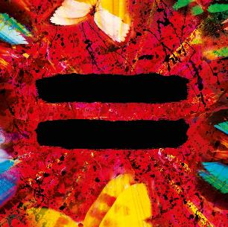

‘=’ Official Tracklist:
1. Tides
2. Shivers
3. First Times
4. Bad Habits
5. Overpass Graffiti
6. The Joker And The Queen
7. Leave Your Life
8. Collide
9. 2step
10. Stop The Rain
11. Love In Slow Motion
12. Visiting Hours
13. Sandman
14. Be Right Now

* * *
DOWNLOAD NEW PRESS IMAGES & ALBUM ARTWORK HERE

PRESS IMAGE PHOTO CREDIT: DAN MARTENSEN

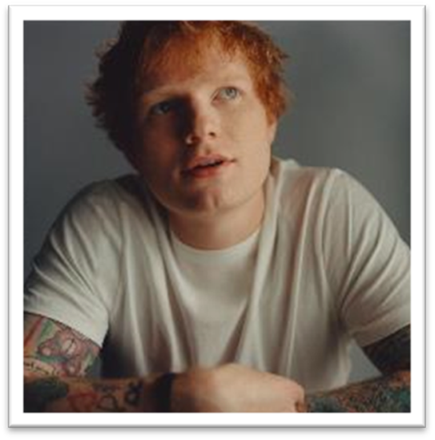
ABOUT ED SHEERAN:
Ed Sheeran is an era-defining artist. From record-breaking sales across his recorded music and live performances, and a plethora of award wins to his name, the British singer-songwriter is the boundless talent behind some of the biggest songs in history. The four-time GRAMMY award winner has consistently resonated with fans across the world with his peerless songcraft and exceptional music palate. With four multiplatinum, critically acclaimed albums under his belt – ‘+’ (2011), ‘x’ (2014), ‘÷’ (2017) and ‘No.6 Collaborations Project’ (2019) - Sheeran has amassed more than 60 billion streams and sold over 50 million albums, globally to date; he is also one of only six artists to have three songs – “Thinking Out Loud,” “Perfect,” and “Shape Of You” - earn RIAA Diamond-certification, for sales equivalents exceeding 10 million in the US alone. An unparalleled live performer, Sheeran’s most recent, two-year ÷ world tour made history becoming the most-attended and highest-grossing tour of all time.

# # #

