ELECTRIC GUEST TAPS LATIN SUPERSTARS DARELL + RVSSIAN FOR BRAND NEW FLIP ON “FREESTYLE”

ALL-STAR COLLABORATION ARRIVES ALONGSIDE OFFICIAL MUSIC VIDEO STARRING THE ARTISTS SHOT IN MIAMI + CALIFORNIA

BUY/STREAM “FREESTYLE” (FEAT. DARELL & RVSSIAN): HERE
WATCH OFFICIAL MUSIC VIDEO: HERE

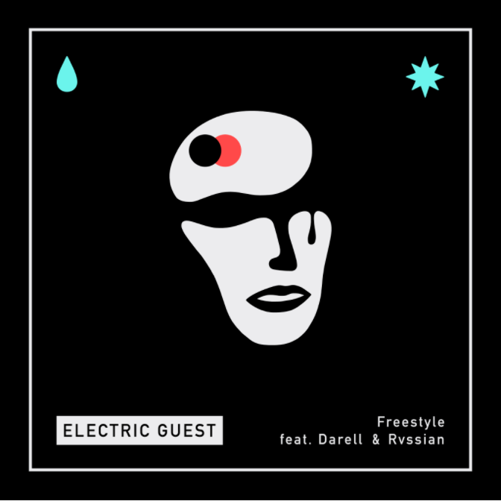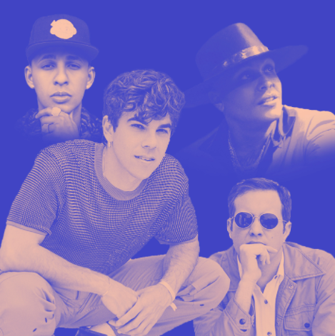
download hi-res artwork | download hi-res composite image

Acclaimed indie-pop duo Electric Guest have teamed up with Puerto Rican reggaeton artist Darell and Jamaican producer Rvssian for today’s release of “Freestyle (feat. Darell & Rvssian)” – listen HERE.

The high-energy collaboration finds the Latin superstars lending their signature reggaeton spin to the track, originally featured on Electric Guest’s 2019 album KIN. The new version of “Freestyle” also arrives with a brand-new music video featuring the artists in their respective cities of Miami and Los Angeles – watch HERE.

The origins of the collaboration stem in large part from lead singer Asa Taccone’s desire to dive deeper into his Puerto Rican roots (courtesy of his father). While Puerto Rican culture and their heritage has always been celebrated by his family, Asa has long wanted to embrace this more within his music.

In the months before the pandemic, Asa’s father – who was directing John Leguizamo’s Broadway show ‘Latin History for Morons’ – came to an Electric Guest show in New York, bringing Leguizamo with him. They talked afterwards and encouraged him to explore the culture more.

Around that time, Electric Guest was looking to revisit album track “Freestyle” and considering releasing a new version with an added verse from a featured artist.

As Asa explains: “Freestyle was the last song we wrote for the album. It took us forever because we couldn’t figure out the chorus melody. We ended up doing a session with Ne-Yo at a studio in L.A. We sat down and played him the instrumental and he immediately started humming… after about 10 minutes we had the chorus that had eluded me for months.

But the song kind of slipped under the radar. We had always wanted to do a video for it and possibly get a feature, but Covid hit while we were on tour and like the rest of the world, our cycle ground to a halt and we never really got around to it.”

Asa has long been a fan of Darell and Rvssian’s music, so having them featured on a new version of the track felt like the perfect way to dip his toes into the Latin sound. After sending the song their way with the hopes of just a verse, he and bandmate Matthew Compton were sent back a fully-formed, almost entirely new version of the track that the Puerto Rican rapper and Jamaican producer had recorded in Miami.

“It was a totally different format… really their own take on it,” Asa shared. “I think everyone felt the same which was like, ‘Well that is… kind of a better version!’”

Speaking on their collaboration, Rvssian shares: “Remixing the song was fun because I had changed the production from one genre to another. And having Darell add his Latin touch on the vocals… this created a nice fusion.”

Darell adds: “When Rvssian hit me up to participate in this collab, I wasn’t sure what to expect. The end result I feel gives great vibes. For me, it’s always a pleasure to keep growing the culture and blending musical worlds together.”

On the making of the video, Asa shared: “The crew came up from Miami and - even though we were in masks - it was definitely a party on set. I think that vibe translated into the video… riding that horse was equal parts terrifying and fun.”

Electric Guest’s third album KIN was released in 2019, featuring standout tracks, “Dollar,” “Play With Me,” and “More.” The LP was met with critical acclaim, with Associated Press declaring “KIN is a breezy confection of fiendishly clever pop hooks augmented by some computer wizardry.” Uproxx also praised the project as “a masterclass in modern pop that’s anchored by real, genuine emotion.”

The band supported the album with a massive run throughout Europe and the United States, including back-to-back sold-out New York shows at Webster Hall and Music Hall of Williamsburg – with the latter added by overwhelming popular demand.

TIME included “More” in their ‘5 Best Songs of the Week,’ proclaiming it “a retro-inflected electro-pop tune that rings sweet and sincere.” The high-energy music video for the track was directed by Joe Weil (Kendrick Lamar, YG, Khalid) and premiered on People. In the exclusive premiere of the video for fan favorite, “Play With Me,” PAPER declared the visual: “part R&B music video parody + part fantasia — more music videos should tread this fine line, honestly.”

“Dollar” came accompanied by an equally feel-good music video, directed by The Lonely Island’s Jorma Taccone and co-starring a fully operational hovercraft DeLorean. That visual had its exclusive debut via Complex, which wrote, “[‘Dollar’] is representative of the duo's goal of entering this latest era with a desire to make straight up, unapologetic pop.”

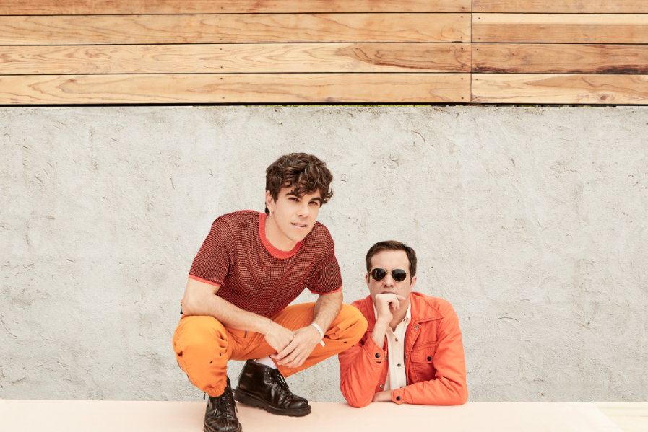
*Download hi-res images here*

CONNECT WITH ELECTRIC GUEST:
OFFICIAL I FACEBOOK I TWITTER I INSTAGRAM I YOUTUBE

CONTACT:
LIBBY.KOBER@ATLANTICRECORDS.COM

