FOR IMMEDIATE RELEASE

OCTOBER 18, 2019

ELECTRIC GUEST RELEASES NEW ALBUM KIN

NEW LP FULL OF WARM, ELECTRO-POP GROOVES ARRIVES ALONGSIDE UNFORGETTABLE, DANCE-FILLED MUSIC VIDEO FOR STANDOUT SINGLE “MORE”

ACCLAIMED POP DUO HITS THE ROAD FOR KIN WORLD TOUR
AFTER SOLD-OUT NYC SHOW AT ROUGH TRADE & INTIMATE ROSE BAR SESSION

WATCH “MORE” VIDEO HERE
LISTEN TO KIN ALBUM HERE
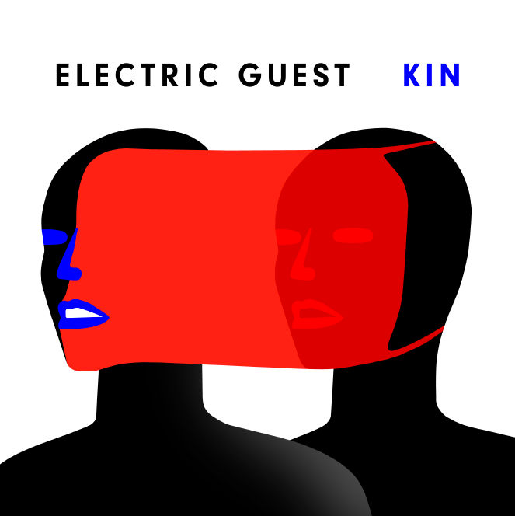

Today, electro-pop duo Electric Guest releases their highly-anticipated new album KIN. The already critically acclaimed 11-track collection is available now via Atlantic Records at all digital music retailers and streaming services HERE.

“We called the album KIN because at a certain age you look around you and realize that everyone in your life is your chosen family,” says Asa Taccone. “All the random weirdos and stragglers have exited the building and you’re left with this wonderful group of humans that are your family. The making of the album was the same: only friends pretty much. From calling my father at 2am to ask him to help with me lyrics, to the artwork and videos, to the musicians that played on the record: everyone was kin.”

KIN arrives today alongside a high-energy, captivating new music video, watch HERE. The visual premiered on PEOPLE.com and stars front man Asa Taccone giving his most charismatic performance yet. Filmed in a Los Angeles warehouse with their actual friends and family, Asa and Matthew embraced the one-take concept of director Joe Weil (Kendrick Lamar, YG, Khalid). They effortlessly dip in and out of reality, gliding between different music video sets as Taccone dances alluring choreography.

“My family flew down from the Bay Area and were on the sidelines for each take cheering me on,” says Taccone of the video. “My loud ass sister would be like, ‘you got this baby boy!’ hella loud during the dance takes. That’s why I’m grinning so much.”

Electric Guest celebrated their album release week in NYC with a jampacked show at Brooklyn’s Rough Trade and an intimate and exclusive Rose Bar session at the Gramercy Park Hotel. The duo will continue their KIN WORLD TOUR on October 28th; for full itinerary and tickets, visit https://electricguestmusic.com/tour.

KIN has already been met with critical acclaim with Associated Press declaring “the third time will be the charm for Electric Guest. Their third album, KIN, is a breezy confection of fiendishly clever pop hooks augmented by some computer wizardry. Its shards of quirky audio asides, its retro feel and yet very current sound is where the music really shines.”

KIN is highlighted by the standout tracks, “Dollar,” “Play With Me,” and “More.” The thought-provoking “More” received critical acclaim upon release last month, with TIME naming it among its “5 Best Songs of the Week,” proclaiming it “a retro-inflected electro-pop tune that rings sweet and sincere.” Billboard also praised the single, writing, “‘More’ uses a cheery rhythm to disguise the melancholic, yet still hopeful lyrics of not knowing what to do with your life.”

Meanwhile, “Play With Me” arrived alongside a spectacular and bizarre R&B fantasy visual, streaming HERE. “Play With Me” is “a tribute to the over the top music videos (Electric Guest) loved as a kid,” wrote PAPER in its exclusive video premiere.

KIN was initially heralded this summer by the soulful first single, “Dollar,” which came accompanied by a feel-good music video, directed by The Lonely Island’s Jorma Taccone and co-starring a fully operational hovercraft DeLorean. The visual had its exclusive debut via Complex, which wrote, “[‘Dollar’] is representative of the duo's goal of entering this latest era with a desire to make straight up, unapologetic pop.”

KIN marks Electric Guest’s first new LP in two years as well as the duo’s first new music since Taccone earned a 2019 GRAMMY® Award for co-writing and co-producing Portugal. The Man’s worldwide smash single, “Feel It Still.” Co-produced by Lars Stalfors (St. Vincent, HEALTH, Foster the People), the album sees Taccone and Compton pushing modern pop towards their own unique worldview, melding sunshine soul grooves and sugar candy hooks with ambitious production and a subversive lyrical power.

Electric Guest’s contributions to the modern pop landscape don’t stop with “Feel It Still.” Taccone and Compton recently joined forces with Carly Rae Jepson to co-write and co-produce “Feels Right (Feat. Electric Guest),” the only feature on the pop star’s critically acclaimed new album DEDICATED. Both extremely collaborative creators, Taccone and Compton have recent credits on tracks for artists including Cold War Kids, Amine, and Melvv.

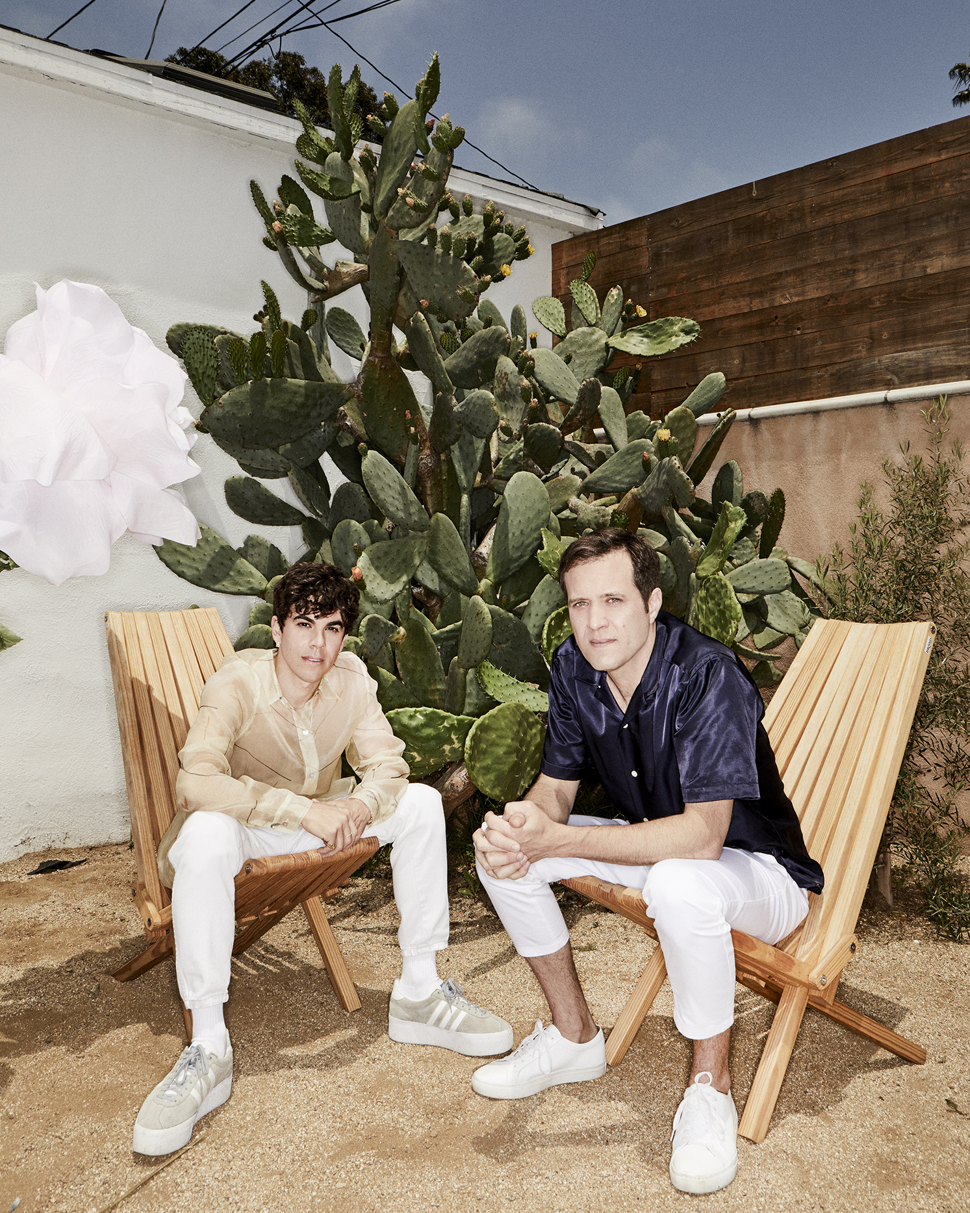

CONNECT WITH ELECTRIC GUEST:
OFFICIAL I FACEBOOK I TWITTER I INSTAGRAM I YOUTUBE

CONTACT:
CHELSEY NORTHERN – NATIONAL
CHELSEY.NORTHERN@ATLANTICRECORDS.COM

LIBBY KOBER – TOUR/ONLINE
LIBBY.KOBER@ATLANTICRECORDS.COM
ELECTRIC GUEST
KIN WORLD TOUR 2019/2020

OCTOBER
28 – Seattle, WA - The Showbox *
29 – Vancouver, BC – Imperial *
30 – Portland, OR – Wonder Ballroom *

NOVEMBER
1 – San Francisco, CA – Regency Ballroom *
2 – Los Angeles, CA – The Regent * SOLD OUT
18 – Borgerhout, Belgium – Trix **
19 – Reims, France – La Cartonnerie Club †
20 – Nimes, France – Le Paloma †
21 – Bordeaux, France – Rock School Barbey †
23 – Paris, France – Café De La Danse †
24 – Amsterdam, Netherlands – Bitterzoet
26 – Hamburg, Germany – Molotow **
27 – Berlin, Germany – Musik & Frieden – Blue Room **
29 – Erlangen, Germany – PULS Festival 2019 (Indoor)
30 – Munich, Germany – PULS Festival 2019 (Indoor)

DECEMBER
2 – London, UK – Village Underground **
3 – Manchester, UK – The Deaf Institute **
4 – Glasgow, UK – King Tuts **
5 – Leeds, UK – Belgrave Music Hall **

JANUARY 2020
28 – Las Vegas, NV – The Bunkhouse Saloon #
29 – Albuquerque, NM – Launchpad #
31 – Austin, TX – The Mohawk #

FEBRUARY 2020
1 – Houston, TX – White Oak Music Hall Downstairs #
2 – Dallas, TX – Trees #
4 – Nashville, TN – Exit / In #
5 – Charlotte, NC – Visulite Theatre #
7 – Washington, DC – 9:30 Club #
8 – Philadelphia, PA – Union Transfer #
10 – Cambridge, MA – The Sinclair #
11 – New York, NY – Webster Hall #
14 – Toronto, ON – The Mod Club #
16 – Columbus, OH – A&R Bar #
17 – Chicago, IL – Metro #
18 – Minneapolis, MN – Fine Line #
19 – Lawrence, KS – Granada Theater #
21 – Denver, CO – The Summit #
22 – Salt Lake City, UT – Urban Lounge #
24 – Phoenix, AZ – The Crescent Ballroom #
25 – San Diego, CA – Music Box #

w/Special Guests Wafia * w/Special Guests Petrie **
w/Special Guests Joanna † w/Special Guests Soleima #

###

