FOR IMMEDIATE RELEASE
SEPTEMBER 27, 2019

ELECTRIC GUEST RELEASE NEW SONG + VIDEO “PLAY WITH ME”
FROM FORTHCOMING ALBUM KIN DUE OCTOBER 18TH

VIBEY, ELECTRO-POP TRACK OUT NOW ALONGSIDE
BIZARRE, R&B FANTASY VISUAL
WATCH/LISTEN TO “PLAY WITH ME” HERE
PRE-ORDER KIN HERE

Today, acclaimed pop duo Electric Guest has released a new song called “Play With Me” from their forthcoming album KIN, due October 18th. The vibey track comes alongside a new video that premiered on PAPER today and is now streaming on the duo’s official YouTube channel. Watch HERE. Listen HERE.

“The song ‘Play With Me’ is about liking someone past the point you should. I grew up in the era of over-the-top, melodramatic music videos so this is my homage to the R&B videos that I loved so much as a kid.” – Asa Taccone

Edited at no cost by friend of Electric Guest, Akiva Shaffer (The Lonely Island, Pen15, The Watch, I Think You Should Leave with Tim Robinson), the visual for “Play With Me” was a last-minute project shot unexpectedly in a $38 million dollar mansion in Los Angeles. Taccone and Shaffer worked together on the edit of the video at Shaffer’s office, which is a revolving door of other production companies, whose team members would weigh in on the process. “Most of the feedback was about how we needed to linger on the speedo shots longer…” says Taccone.

“Play With Me” is the third release from Electric Guest’s forthcoming album KIN and follows current single, “More,” which was praised by TIME as “a retro-inflected electro-pop tune that rings sweet and sincere. Taccone’s lilting falsetto is a comforting topline over bouncy, catchy production.” “More” is now accompanied by colorful and thought-provoking new visual animated by TOON53 (Marshmello, Aloe Blacc, Radio Disney Awards). The official video for “More” is currently in production.

Electric Guest kicked off KIN with the July release of feel-good track “Dollar,” which was named by Apple Music’s Beats 1 as Zane Lowe’s World Record and came accompanied by an undeniably fun music video, directed by The Lonely Island’s Jorma Taccone and co-starring a fully operational hovercraft DeLorean.

KIN marks Electric Guest’s first LP in two years as well as the duo’s first new music since Taccone earned a 2019 GRAMMY® Award for co-writing and co-producing Portugal. The Man’s worldwide smash single, “Feel It Still.” Co-produced by Lars Stalfors (St. Vincent, HEALTH, Foster the People), the album sees Taccone and Compton pushing modern pop towards their own unique worldview, melding sunshine soul grooves and sugar candy hooks with ambitious production and a subversive lyrical power. The intriguing album artwork is the creation of Electric Guest’s longtime friend and collaborator Elevator Teeth.
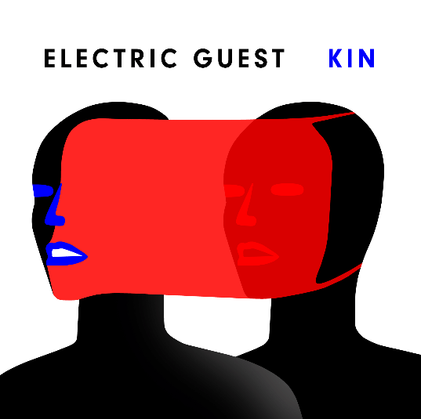
*Download hi-res image here*

In support of KIN, Electric Guest will soon embark on their KIN WORLD TOUR, a massive global headline run, with special guests Wafia, Petrie, Joanna, and Soleima. The magnetic pair will bring their impressive, high-energy live show to cities throughout North America and Europe, kicking off at The Showbox in Seattle, WA on October 28th. During album release week, Electric Guest will play an already sold-out headline show at Brooklyn’s Rough Trade NYC on October 15th (full tour itinerary below).

For every ticket to the KIN WORLD TOUR sold, $1 will go to Stand for Children, an organization focused on ensuring all students receive a high quality, relevant education, especially those whose boundless potential is overlooked and under-tapped because of their skin color, zip code, first language, or disability. For more ticket information, please visit electricguestmusic.com.

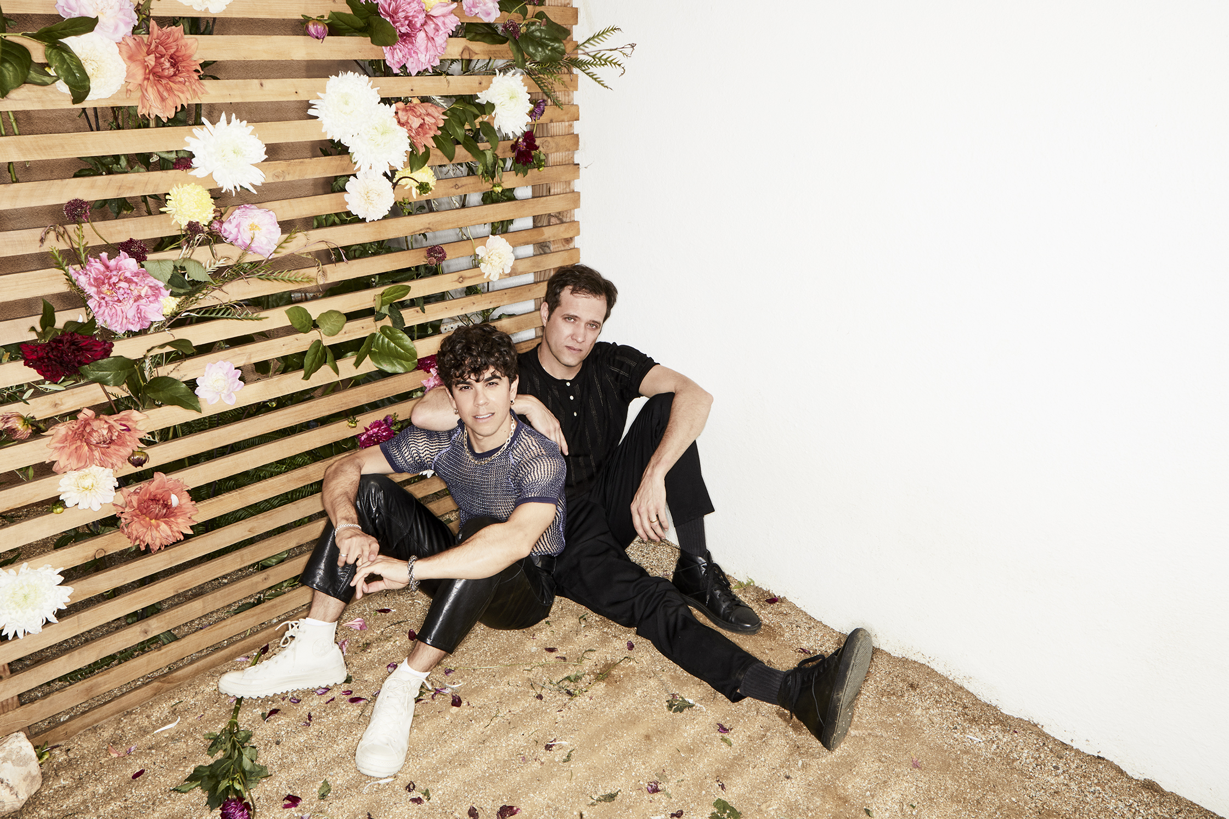
*Download hi-res image here*

CONNECT WITH ELECTRIC GUEST:
OFFICIAL I FACEBOOK I TWITTER I INSTAGRAM I YOUTUBE

CONTACT:
CHELSEY.NORTHERN@ATLANTICRECORDS.COM (NATIONAL)
LIBBY.KOBER@ATLANTICRECORDS.COM (TOUR/ONLINE)

ELECTRIC GUEST KIN WORLD TOUR
With Special Guests Wafia ^ / Petrie * / Joanna > / Soleima #

October
15 – Brooklyn, NY – Rough Trade NYC (SOLD OUT)
28 – Seattle, WA - The Showbox ^
29 – Vancouver, BC – Imperial ^
30 – Portland, OR – Wonder Ballroom ^

November
1 – San Francisco, CA – Regency Ballroom ^
2 – Los Angeles, CA – The Regent ^
3 – San Diego, CA – The Irenic ^
18 – Antwerp, Belgium – Trix *
19 – Reims, France – La Cartonnerie Club >
20 – Nimes, France – Le Paloma >
21 – Bordeaux, France – Rock School Barbey >
23 – Paris, France – Café De La Danse >
24 – Amsterdam, Netherlands – Bitterzoet
26 – Hamburg, Germany – Molotow *
27 – Berlin, Germany – Musik & Frieden – Blue Room *
29 – Erlangen, Germany – PULS Festival 2019 (Indoor)
30 – Munich, Germany – PULS Festival 2019 (Indoor)

December
2 – London, UK – Village Underground *
3 – Manchester, UK – The Deaf Institute *
4 – Glasgow, UK – King Tuts *
5 – Leeds, UK – Belgrave Music Hall *

January
28 – Las Vegas, NV – The Bunkhouse Saloon #
29 – Albuquerque, NM – Launchpad #
31 – Austin, TX – The Mohawk #

February
Feb 1 – Houston, TX – White Oak Music Hall Downstairs #
Feb 2 – Dallas, TX – Trees #
Feb 4 – Nashville, TN – Exit / In #
Feb 5 – Charlotte, NC – Visulite Theatre #
Feb 7 – Washington, DC – 9:30 Club #
Feb 8 – Philadelphia, PA – Union Transfer #
Feb 10 – Cambridge, MA – The Sinclair #
Feb 11 – New York, NY – Webster Hall #
Feb 14 – Toronto, ON – The Mod Club #
Feb 16 – Columbus, OH – The Basement #
Feb 17 – Chicago, IL – Metro #
Feb 18 – Minneapolis, MN – Fine Line #
Feb 19 – Lawrence, KS – Granada Theater #
Feb 21 – Denver, CO – The Summit #
Feb 22 – Salt Lake City, UT – Urban Lounge #
Feb 24 – Phoenix, AZ – The Crescent Ballroom #

# # #

