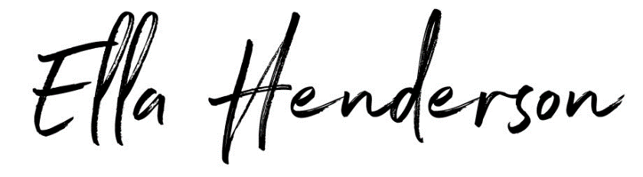
ANNOUNCES DETAILS OF LONG-AWAITED SECOND ALBUM ‘EVERYTHING I DIDN’T SAY’
ARRIVING MARCH 11 2022
AVAILABLE TO PRE-ORDER NOW

RELEASES POWERFUL NEW SINGLE ‘BRAVE’
LISTEN | WATCH

TOURING WITH THE SCRIPT IN MAY AND JUNE 2022
TICKETS AVAILABLE NOW

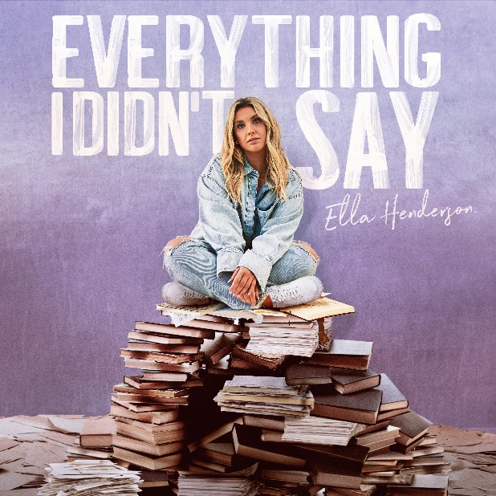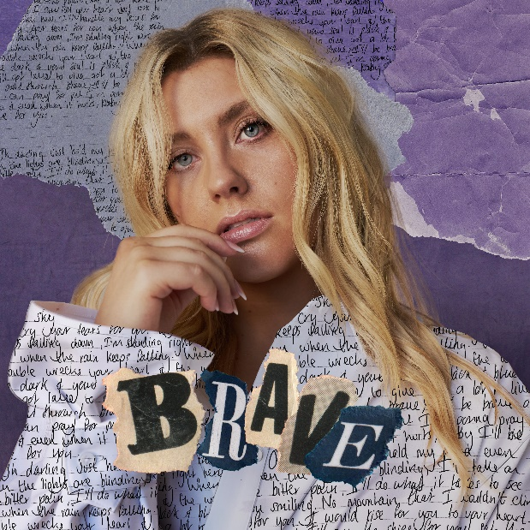
DL press photo

Ella Henderson today announces details of her long-awaited second album, ‘Everything I Didn’t Say’ – a diaristic, 16-track record and first since the extraordinary breakthrough success of her Platinum-selling, UK No. 1 debut album, ‘Chapter One’. Pre-order HERE.

Arriving on March 11th via Atlantic Records/Major Toms/Asylum, ‘Everything I Didn’t Say’ will include Ella’s fifth UK Top 10, ‘Let’s Go Home Together’ with Tom Grennan, and new single ‘Brave’ - a powerful track about shaking the stigma of needing help and embracing someone’s support for you when you need them most. Written by Ella, alongside GRAMMY® Award-nominee Jennifer Decilveo (Miley Cyrus, Demi Lovato, MARINA) and producer Jordan Riley (Mabel, RAY BLK, Sigrid), the song arrives accompanied by a heartfelt official video – directed by Plum Stupple-Harris – in which the poignant lyrics accompany the story of a single mother struggling to cope with the rigors of everyday life.

Listen here: https://lnk.to/EH-Brave | Watch here: https://youtu.be/JTK1nC8ptkA

With its candor and vulnerability, ‘Brave’ forms a fitting entry point to ‘Everything I Didn’t Say’. Capturing the eight years of life experience gained since her last LP, the album is an unfiltered story of both personal and artistic growth. Written with the relatability that initially catapulted Ella to stardom in 2012, the album traces feelings of heartbreak, love and self-worth.

Ella says: “I’m so excited to finally share the news that my second album ‘Everything I Didn’t Say’ is coming in March! I know it’s been a long time coming but I wanted to take the time to really follow my heart and vision, to create something that fully represented me, who I am today and what I stand for. I am so ready to finally share this body of work! It’s all here… the good, the bad, the ugly! This record means absolutely everything to me.”

The release of ‘Brave’ follows a landmark 2021 for Ella which, alongside the resounding chart success of ‘Let’s Go Home Together’, saw her perform in the star-studded KSI Show alongside Yungblud and Anne-Marie, join forces with French DJ duo Ofenbach (‘Hurricane’), perform the National Anthem at Wembley Stadium to open the Women’s FA Cup Final and take to the stage at the Paralympic Team GB Homecoming Celebration, performing ‘Risk It All’ – her collaboration with House Gospel Choir and Just Kiddin. She also recently wrote ‘Follow Me’ - a blockbuster collaboration between Rita Ora and acclaimed DJ/producer, Sam Feldt.

Newly announced as an ambassador for the Teenage Cancer Trust, Ella also continues to use her platform to support causes close to her heart, taking part in last year’s BBC Children in Need fundraising launch, supporting Mind’s ‘Join the Fight for Mental Health’ campaign and performing during Attitude Magazine’s virtual ‘Pride at Home’ festival, benefitting LGBTQ causes via the Attitude Magazine Foundation.

Fans can also catch Ella performing as the special guest on The Script’s UK Greatest Hits Tour through May and June 2022. Tickets for the tour - which includes a huge London show at The O2 – are on sale now. Please see below for full listings.

May 2022
Thu 19 – M&S Bank Arena, Liverpool
Fri 20 – First Direct Arena, Leeds
Sat 21 – AO Arena, Manchester
Mon 23 – Motorpoint Arena, Cardiff
Tue 24 – Motorpoint Arena, Nottingham
Thu 26 – P & J Live, Aberdeen
Fri 27 – SEC – The SSE Hydro, Glasgow
Sat 28 – Utilita Arena, Newcastle
Mon 30 – Brighton Centre, Brighton
Tue 31 – Bournemouth Int’nl Centre, Bournemouth

June 2022
Thu 02 – Sheffield Arena, Sheffield
Fri 03 - Utilita Arena, Birmingham
Sat 04 – The O2 Arena, London

CONNECT WITH ELLA HENDERSON
Facebook | Twitter | Instagram | YouTube | TikTok

Press contact: Paige.rosoff@atlanticrecords.com

