AVA MAX
PREMIERES ELECTRIFYING NEW MUSIC VIDEO FOR SINGLE
“MY HEAD & MY HEART”

PERFORMING TRACK TONIGHT ON JIMMY KIMMEL LIVE!

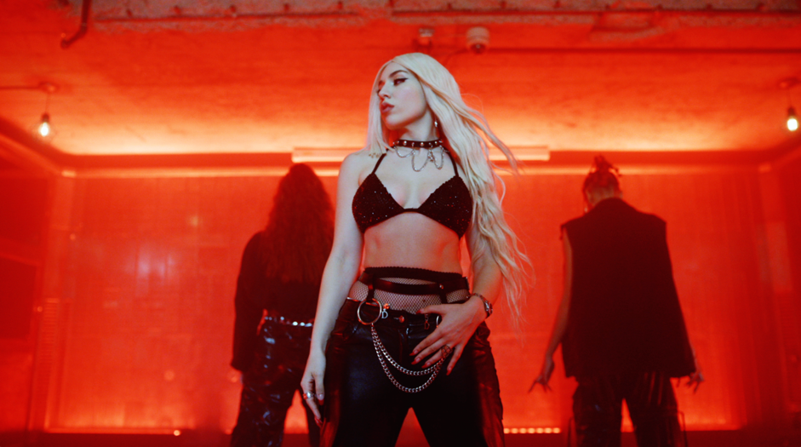

Global pop sensation Ava Max today dropped a vibrant and explosive new music video for her latest club-ready single, “My Head & My Heart”! In the video, Ava takes us on a fast-paced, exhilarating, dance-filled journey directed by co-directed by Charm La’Donna and Emil Nava. The single recently skyrocketed into the Top 40 at Pop Radio and is currently positioned at #16. Ava will perform the track tonight on Jimmy Kimmel Live!

Watch “My Head & My Heart” HERE

Of the video, Ava Max says “This is hands down my favorite music video I’ve ever done. For the first time, I think my fans will see the true me on the screen and we are just getting started! Come DANCE with me!”

Her last platinum single “Kings & Queens” is currently #2 on the Hot AC Chart with over 848 Million streams globally. The smash hit “King’s & Queens” previously held #1 on the Hot AC chart for 7 straight weeks and peaked at #2 on Top 40.

Ava Max is the daughter of Albanian immigrants and has grinded since grade school, exploding in the music world on a global scale with her 2018 triple-platinum smash “Sweet but Psycho.” Streamed over 2.1 billion times by 2020, the song clinched a spot in the Top 10 of the Billboard Hot 100 for three weeks. Ava Max only accelerated this rapid rise to pop superstardom with the gold-selling “So Am I” [806 Million Global Streams], “Salt” [1.5 Billion Global Streams], and “Kings & Queens” [678 Million Global Streams] and “Who’s Laughing Now” [225 Million Global Streams]. In the middle of this whirlwind, she pieced together her 2020 full-length debut album, Heaven & Hell.

“Another sweaty, shimmering dance banger. Thanks for this, Ava.” – Billboard

“This is pop at its most shimmery and divine” – Wonderland

“Ava Max Claims Her Throne…” – Rolling Stone

FOLLOW AVA MAX:
Website | Instagram | Facebook | Twitter | TikTok | YouTube | Spotify | Apple Music

PRESS CONTACTS:
DPR
Carleen Donovan
carleen@theoriel.co
Amanda Brophy
amanda@theoriel.co
Micaela Cohen
micaela@theoriel.co

Atlantic Records
Andrew George
andrew.george@atlanticrecords.com

