FOR IMMEDIATE RELEASE
MAY 7, 2021

KRANIUM REMIXES “TOXIC” WITH GERMAN R&B STAR ROLA
STREAM HERE

ON THE HEELS OF “GAL POLICY (LUCAS SECON & JXNV$ RIO FUNK REMIX)”
STREAM HERE | WATCH HERE

TOXIC EP AVAILABLE NOW HERE

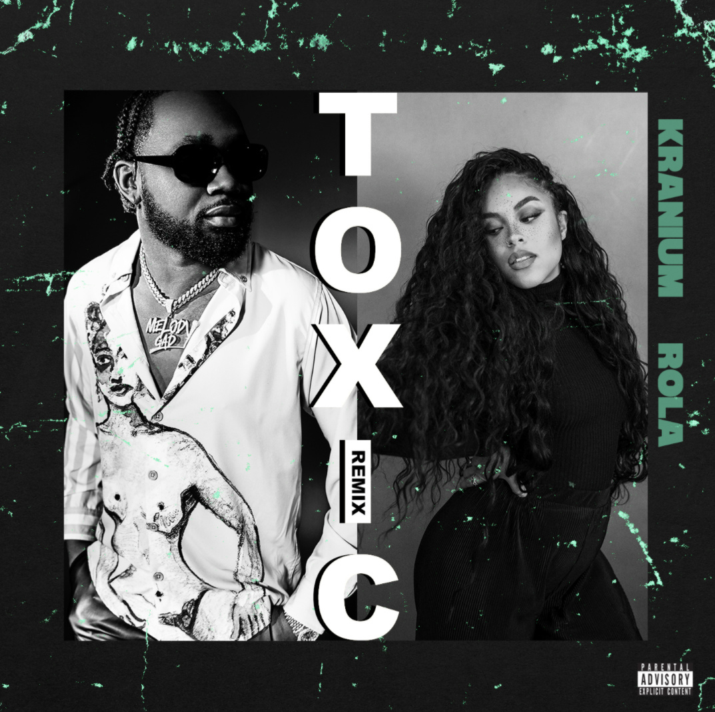
DOWNLOAD HI-RES COVER ART

Dancehall’s superstar Kranium teams up with German R&B star Rola for a new “Toxic” remix, available to stream HERE. The remix quickly followed the recent “Gal Policy (Lucas Secon & JXNV$ Rio Funk Remix)” (stream HERE and watch HERE), which was met with a special Brazilian twist, to light up the dancefloors around the world. Kranium tapped buzzing New Zealand female rapper JessB for “Toxic” remix in early April (stream HERE and watch HERE) , and the week prior’s “Toxic” remix featuring buzzing New Zealand female rapper JessB. Released earlier this year, the original song came as the title track of his latest EP, Toxic. The 5-track project hit #1 on the Apple Music Reggae chart and debuted at #27 on the Billboard Reggae Chart. Listen to “Toxic” Remix now via all digital retailers and streaming platforms HERE.

ABOUT KRANIUM
Global entertainer Kranium is taking dancehall music and his unique sound worldwide by delivering a simmering sonic cocktail of Reggae, R&B, Hip-Hop, and Soul. His music has streamed over half-a-billion times to date, and his talent is praised by the likes of Hypebeast, The Fader, Dancehall Mag, and Complex – with claims that “If there's anything Kranium seems to get right each time, it's the formula for making another hit." As a successful performing artist, Kranium has managed to bring the dancehall culture to stages where some artists have never been – territories ranging from the Caribbean to the Middle East to the South Pacific.

In a very short time, Kranium has established himself as one of the hottest international dancehall artists with hits like “Nobody Has to Know,” “Lifestyle,” and “History.” He started to record in New York around 2008, earning the name Kranium for his ability to record songs “straight off the head” with no pen or paper, catapulting his career from New York’s underground dancehall scene to performing on BET to then signing to Atlantic Records. “Nobody Has To Know”’s widespread success has helped Kranium make history as the first New York-based dancehall artist to score a major international hit since Shaggy. Far from a one-hit-wonder, Kranium followed up his initial success with songs like “Can’t Believe” Feat Ty Dolla $ign & Wiz Kid and, “We Can” Feat Tory Lanez which went on to accumulate over 9 million audio streams on Spotify alone while peaking at #12 on the Reggae Charts.

In 2019, Kranium unveiled his debut album, Midnight Sparks to the world. The album saw Kranium continuing to craft a simmering sonic cocktail of reggae, R&B, hip-hop, and soul, including superstar features from the likes of AJ Tracey, Mahalia, Burna Boy, and longtime collaborator Ty Dolla $ign. The album showcases fiery singles as “So Me Move,” “Just The Style (Feat. Alkaline),” and “In Charge.” Kranium’s noteworthy debut was followed in 2020 with the release of “Gal Policy,” a summer anthem that’s still taking over the dancefloors today. The lyric video has over 25 million views to date and helped to set the tone for this latest EP release. This year, Kranium has unleashed Toxic, his most personal project yet, which featured “Gal Policy”, “Through The Window”, and the street chune “Block Traffic” ft. Rytikal.

ABOUT ROLA
First record deal at sixteen and Rihanna support tour at seventeen, band breakup at eighteen. Afterwards technical diploma at the school for fashion and clothing and since this year own model label ("Tillilli"), singer on Cro's "MTV Unplugged" tour, on albums by Moses P., Marvin Game and Manuellsen, plus a handful of solo releases own fist. No question.

Columbia Deutschland-Signing Rola has already experienced a lot in her life and was able to gain a lot of experience: with major labels, with producers, as an entrepreneur and musician. The 27-year-old, who was born in Ghana and came to Frankfurt at the age of three, will soon be releasing her first album on the Sony Music label. A first single is already available: "Trumanshow".

“The camera is everywhere these days,” she explains. “All of them put on their own 'Trumanshow' with snaps and Insta-Stories. Often it's not just fun and self-expression, but a lot of work and hustle. “Musically, the R & B / Pop track is filled with the good spirit of the nineties - the era that musically shaped ROLA's youth. The heyday of TLC, Destiny's Child, and Missy Elliot. But “Trumanshow” is so much more: the piece combines state-of-the-art production, sophisticated. In other words, it's a bloody hit.
# # #

CONNECT WITH KRANIUM
OFFICIAL | TWITTER | INSTAGRAM | FACEBOOK

CONNECT WITH ROLA
INSTAGRAM | SPOTIFY | FACEBOOK | YOUTUBE

FOR PRESS INQUIRIES
SYDNEY MARGETSON | SYDNEY.MARGETSON@ATLANTICRECORDS.COM

