FOR IMMEDIATE RELEASE
OCTOBER 30, 2017

FRIGHTENED RABBIT ANNOUNCE “THE MIDNIGHT ORGAN FIGHT”
10TH ANNIVERSARY TOUR

SCOTTISH ROCK BAND SET TO PERFORM THEIR SEMINAL ALBUM IN ITS ENTIRETY FOR THE FIRST TIME EVER

NORTH AMERICAN DATES KICK OFF ON FEBRUARY 16TH IN CHICAGO, IL

TICKETS ON SALE THIS FRIDAY, NOVEMBER 3RD

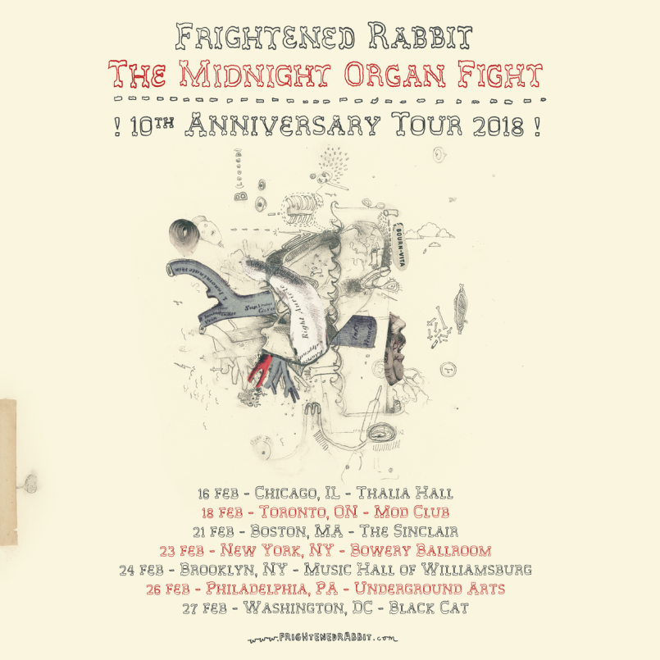
*Download Hi-Res Images HERE*

Canvasback Music/Atlantic recording group Frightened Rabbit have announced details for a special North American tour commemorating the 10 year anniversary of their seminal album “THE MIDNIGHT ORGAN FIGHT.” The run of dates – which will see the band performing the album in its entirety for the first time ever - kick off at Chicago’s Thalia Hall on February 16th (see attached itinerary). Wintersleep will support on select dates and tickets are available for pre-sale on Wednesday, November 1 at 10am Local Time, with general on-sale beginning on Friday, November 3 at 10am Local Time. For more information, please visit http://frightenedrabbit.com/shows/.

Frightened Rabbit’s Scott Hutchison explains: “This album holds a dear place in our collective heart. It was the one that allowed us to believe that we could do this band thing. Really do it. It's the one that made the people in front of us SING. Really sing. It's the album I still talk about most with people I meet at our shows. The wee bugger will not go away, and we are alright with that.”

Upon its release in 2008, “THE MIDNIGHT ORGAN FIGHT” received a raft of critical acclaim. The Line of Best Fit named it the Album of the Year. Mojo and Q each gave the album an impressive four stars. Pitchfork rated it an 8.1, writing, “The key here is Scott’s urgent-yet-emotive songwriting. Midnight Organ Fight is full of rousing barnburners that flicker with soul, ballads that ache with masculine vulnerability…” The release was equally embraced by the music community. Death Cab For Cutie’s Nick Harmer enthused, “It's lyrically perfect with words that hit you right in the heart. And coupled with Scott Hutchison's vocals, the whole thing just kills me.”

Frightened Rabbit recently wrapped up a US tour supporting Broken Social Scene that coincided with the release of their “RECORDED SONGS” EP. Produced by Frightened Rabbit and recorded by the band’s own Andy Monaghan, the three track EP is highlighted by “How It Gets In,” a beautiful duet featuring acclaimed singer-songwriter Julien Baker.

*****

Frightened Rabbit’s fifth studio album “PAINTING OF A PANIC ATTACK” – produced by The National’s Aaron Dessner - enjoyed a Top 25 debut on the Soundscan/Billboard 200 chart upon its release last year, peaking at #2 on iTunes’ Alternative chart and #8 overall. The album’s lead single “Get Out” scored Top 10 success on FMQB’s Triple A chart, and garnered the band a pair of national television appearance, performing on CBS’ “Late Show with Stephen Colbert” and “Late Late Show with James Corden.” The song’s emotionally provocative, companion video made its premiere on NPR’s All Songs Considered and received a raft of praise from influential sites, including Pitchfork, Stereogum, and Consequence of Sound, among others. The video – beautifully shot in Kiev –can be viewed at the band’s official YouTube channel (www.youtube.com/frightenedrabbit).

“PAINTING OF A PANIC ATTACK” follows 2013’s major label debut “PEDESTRIAN VERSE,” which earned a Top 10 debut in the UK as well as critical acclaim from a wide spectrum of American press, with praise coming from mainstream outlets like Rolling Stone and Time as well tastemaker blogs like Pitchfork and Stereogum. The band’s emotionally charged live shows have earned a devoted fanbase, which includes bands like Death Cab For Cutie and The National – both of whom have handpicked Frightened Rabbit to support them on extensive tours.

Frightened Rabbit
Scott Hutchison (lead vocals/rhythm guitar), Grant Hutchison (drums), Billy Kennedy (bass), Andy Monaghan (guitar/keys) and Simon Liddell (guitar/keys)

Website - http://www.frightenedrabbit.com/
Facebook - https://www.facebook.com/frightenedrabbit
Twitter - https://twitter.com/FRabbits
Instagram - @frabbits

(TOUR ITINERARY ATTACHED)

FRIGHTENED RABBIT
“THE MIDNIGHT ORGAN FIGHT“
10TH ANNIVERSARY TOUR 2018
Wintersleep supporting except dates noted *

FEBRUARY

16 Chicago, IL Thalia Hall
18 Toronto, ON Mod Club*
21 Boston, MA The Sinclair
23 New York, NY Bowery Ballroom
24 Brooklyn, NY Music Hall of Williamsburg
26 Philadelphia, PA Underground Arts
27 Washington, DC Black Cat

PRESS CONTACTS:

Glenn Fukushima (National) Ilana Gold (Online/Tour)
Glenn.Fukushima@atlanticrecords.com Ilana.Gold@atlanticrecords.com

