**FOR IMMEDIATE RELEASE**

**MAY 15, 2017**

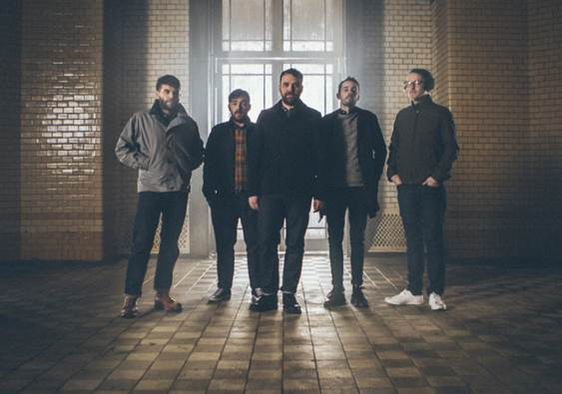

**FRIGHTENED RABBIT ANNOUNCE FALL TOUR WITH**

**BROKEN SOCIAL SCENE**

**DATES BEGIN ON SEPTEMBER 22 AT ATLANTA’S TABERNACLE**

**TICKETS GO ONSALE MAY 17 AT 10AM LOCAL**

**UPCOMING NORTH AMERICAN RUN KICKS OFF AT LOS ANGELES’ GREEK THEATER**

**WITH BAND OF HORSES ON MAY 28,**

**FOLLOWED BY HEADLINE SHOWS AND FESTIVAL STOPS**

**SCOTTISH INDIE BAND’S ACCLAIMED STUDIO ALBUM**

**“PAINTING OF A PANIC ATTACK” AVAILABLE NOW**

Canvasback Music/Atlantic recording group Frightened Rabbit have unveiled details for their fall U.S. tour with Broken Social Scene. The dates kicks off at Tabernacle in Atlanta, GA on September 22nd, with all tickets going on sale starting Wednesday, May 17th at 10am local time. For more information, please visit <http://frightenedrabbit.com/shows/>.

The tour, which supports Frightened Rabbit’s latest studio album “*PAINTING OF A PANIC ATTACK*,” follows a run of North American performances that begin later this month with a stop at The Greek Theater in Los Angeles, CA on May 25th, supporting Band Of Horses. The Scottish indie band also has a number of headlining shows – highlighted by a stop at Brooklyn Steel in Brooklyn, NY on May 30th - and festivals, including BottleRock Napa Valley (May 26th), Boston Calling (May28), and Houston’s Free Press Summer Festival (June 3rd) - see attached itinerary.

*****

Frightened Rabbit’s fifth studio album *“PAINTING OF A PANIC ATTACK”* – produced by The National’s Aaron Dessner - enjoyed a Top 25 debut on the Soundscan/Billboard 200 chart upon its release last year, peaking at #2 on iTunes’ Alternative chart and #8 overall. The album’s lead single “Get Out” scored Top 10 success on FMQB’s Triple A chart, and garnered the band a pair of national television appearance, performing on CBS’ “Late Show with Stephen Colbert” and “Late Late Show with James Corden.” The song’s emotionally provocative, companion video made its premiere on *NPR’s All Songs Considered* and received a raft of praise from influential sites, including *Pitchfork*, *Stereogum*, and *Consequence of Sound,* among others. The video – beautifully shot in Kiev –can be viewed at the band’s official YouTube channel ([www.youtube.com/frightenedrabbit](http://www.youtube.com/frightenedrabbit)).

*“PAINTING OF A PANIC ATTACK”* follows 2013’s major label debut *“PEDESTRIAN VERSE*,” which earned a Top 10 debut in the UK as well as critical acclaim from a wide spectrum of American press, with praise coming from mainstream outlets like *Rolling Stone* and *Time* as well tastemaker blogs like *Pitchfork* and *Stereogum*. The band’s emotionally charged live shows have earned a devoted fanbase, which includes bands like Death Cab For Cutie and The National – both of whom have handpicked Frightened Rabbit to support them on extensive tours.

**Frightened Rabbit**

**Scott Hutchison** (lead vocals/rhythm guitar), **Grant Hutchison** (drums), **Billy Kennedy** (bass), **Andy Monaghan** (guitar/keys) and **Simon Liddell** (guitar/keys)

Website - <http://www.frightenedrabbit.com/>

Facebook - <https://www.facebook.com/frightenedrabbit>

Twitter - <https://twitter.com/FRabbits>

Instagram - @frabbits

(TOUR ITINERARY ATTACHED)

**FRIGHTENED RABBIT**

**NORTH AMERICAN TOUR 2016**

**MAY**

25 Los Angeles, CA Greek Theatre #

26 Napa, CA BottleRock Napa Valley^

28 Boston, MA Boston Calling ^

29 Toronto, ON Danforth Music Hall

30 Brooklyn, NY Brooklyn Steel

31 Washington, DC 9:30 Club

**JUNE**

1 Philadelphia, PA Union Transfer

3 Houston, TX Free Press Summer Festival^

**SEPTEMBER**

22 Atlanta, GA Tabernacle *

24 St. Louis, MO The Pageant *

26 Des Moines, IA Hoyt Sherman *

27 Milwaukee, WI Pabst Theater *

28 St. Paul, MN The Palace *

29 Chicago, IL Aragon Ballroom *

30 Detroit, MI The Fillmore *

**OCTOBER**

1 Pittsburgh, PA Byham Theater *

5 Portland, ME State Theatre *

6 New Haven, CT College Street *

#= with Band of Horses

^ = Festival

*= with Broken Social Scene

**PRESS CONTACTS:**

Glenn Fukushima (National) Ilana Gold (Online/Tour)

[Glenn.Fukushima@atlanticrecords.com](mailto:Glenn.Fukushima@atlanticrecords.com) [Ilana.Gold@atlanticrecords.com](mailto:Ilana.Gold@atlanticrecords.com)