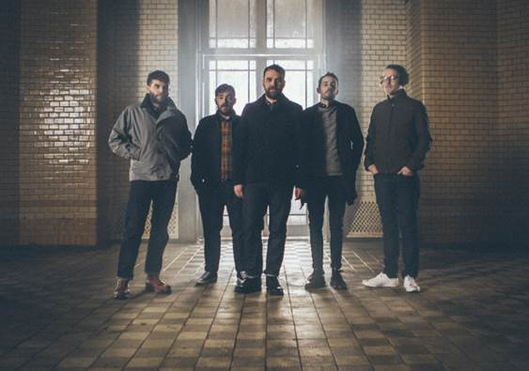

**FRIGHTENED RABBIT ANNOUNCES**

**FALL US HEADLINING TOUR**

**DATES BEGIN IN SEPTEMBER AND INCLUDE SETS AT AUSTIN CITY LIMITS, LOUFEST, MIDPOINT MUSIC FESTIVAL AND MORE**

**UPCOMING SUMMER FESTIVALS INCLUDE LOLLAPALOOZA, NEWPORT FOLK FESTIVAL AND GLASTONBURY**

**LEAD SINGLE “GET OUT” GOES TOP 10**

**RECENTLY RELEASED ALBUM “PAINTING OF A PANIC ATTACK” AVAILABLE NOW**

**WATCH LIVE ACOUSTIC VERSION OF ALBUM TRACK “DIE LIKE A RICH BOY” HERE -** <https://youtu.be/JGxyCs30tfU>

Canvasback Music/Atlantic recording group Frightened Rabbit have unveiled details for their fall headlining tour. The cross-country trek kicks off in Omaha, NE on September 8th and features a number of festival stops, including performances at Loufest in St. Louis, MO, Midpoint Music Festival in Cincinnati, OH, and Austin City Limits in Austin, TX (see attached itinerary). Tickets for the band’s headline dates will be available to fans via a mailing list-only pre-sale starting on Wednesday, June 15th at 10am local time, with the general on-sale beginning Friday, June 17th at 10am local time. For more information about mailing list sign-up and tickets, please visit <http://frightenedrabbit.com/shows/>.

The fall tour, which supports Frightened Rabbit’s recently released album “*PAINTING OF A PANIC ATTACK*,” follows a packed summer schedule that includes headlining shows and festival sets throughout the UK and Europe. The Scottish band plays Glastonbury, Latitude, and T in the Park back in the UK before returning to North America for their first performance at the historic Newport Folk Festival, a major slot at Lollapalooza in Chicago, as well as a set at Osheaga Festival in Montreal, the band’s first Canadian show of the cycle. Frightened Rabbit recently wrapped up an extensive stateside tour – their first in nearly three years – that included sold out shows in Portland, OR, Detroit, MI, Los Angeles, CA and more.

Released in April, Frightened Rabbit’s fifth studio album *“PAINTING OF A PANIC ATTACK”* – produced by The National’s Aaron Dessner - enjoyed a Top 25 debut on the Soundscan/Billboard 200 chart, and peaked at #2 on iTunes’ Alternative chart and #8 overall. The album’s lead single “Get Out” has already gone Top 10 on FMQB’s Triple A chart with over 2.5 million streams on Spotify. The band recently performed the song on CBS’ “The Late Late Show with James Corden,” following the U.S. television debut of [“Get Out” on CBS’ “The Late Show with Stephen Colbert”](https://www.youtube.com/watch?v=He3NQMBGaDk) back in March. The song’s emotionally provocative, companion video made its premiere on *NPR’s All Songs Considered* and received a raft of praise from influential sites, including *Pitchfork*, *Stereogum*, and *Consequence of Sound,* among others. The video – beautifully shot in Kiev –can be viewed at the band’s official YouTube channel ([www.youtube.com/frightenedrabbit](http://www.youtube.com/frightenedrabbit)).

In conjunction with this tour announcement, the band has also unveiled a raw and haunting live acoustic version of album closer “Die Like A Rich Boy” <https://youtu.be/JGxyCs30tfU>.

Aaron Dessner says of “Die Like A Rich Boy”: *“It feels like a completely classic song, but it’s also a distillation of everything Scott has ever written about. It’s so gracefully constructed and realized, and it’s not trying to be anything other than what it is. I wish I could write a song like that.”*

**Frightened Rabbit**

**Scott Hutchison** (lead vocals/rhythm guitar), **Grant Hutchison** (drums), **Billy Kennedy** (bass), **Andy Monaghan** (guitar/keys) and **Simon Liddell** (guitar/keys)

Website - <http://www.frightenedrabbit.com/>

Facebook - <https://www.facebook.com/frightenedrabbit>

Twitter - <https://twitter.com/FRabbits>

Instagram - @frabbits

(TOUR ITINERARY ATTACHED)

**FRIGHTENED RABBIT**

**TOUR 2016**

**JUNE**

23 Belfast, UK Titanic Belfast

24 Glastonbury, UK Glastonbury Festival

24-26 Beuningen, NL Down The Rabbit Hole

27 Dachau, DE Rathausplatz

28 Berlin, DE Zitadelle

30 Rotselaar, BE Rock Werchter Festival

**JULY**

02-03 Rotselaar, BE Rock Werchter Festival

08 T in The Park, UK T in The Park

14-16 Southwold, UK Latitude Festival

22 Portland, ME Port City Music Hall*

23 Newport, RI Newport Folk Festival

24 Millvale, PA Mr. Smalls Theatre

28 Chicago, IL Thalia Hall ^

29 Chicago, IL Lollapalooza

30 Montreal, QC Osheaga Festival

**AUGUST**

13 Haldern, DE Haldern Pop Festival

20 Konstanz, DE Rock am See Festival

**SEPTEMBER**

02 Swansea, UK Singleton Park

08 Omaha, NE The Slowdown

09 Lawrence, KS The Granada Theatre

10 St.Louis, MO LouFest

12 Charlotte, NC The Neighborhood Theatre

13 Baltimore, MD Ramshead Live! ~

14 Charlottesville, VA Jefferson Theatre

16 Madison, WI Majestic Live

17 Minneapolis, MN Festival Palomino

19 Cleveland, OH Beachland Ballroom

20 Grand Rapids, MI Pyramid Scheme

22 Champaign, IL Pygmalion Festival

24 Cincinnati, OH Midpoint Music Festival

26 Nashville, TN Marathon Music Works*

27 Birmingham, AL Saturn*

30 Austin, TX Austin City Limits Festival

**NOVEMBER**

30 Manchester, UK Cathedral

**DECEMBER**

01 Birmingham, UK Library

02 Leeds, UK Stylus

03 Norwich, UK Arts Centre

05 Brighton, UK Concorde 2

06 Portsmouth, UK Wedgewood Rooms

07 London, UK Roundhouse

09 Bristol, UK Trinity

10 Nottingham, UK Rescue Rooms

12 Newcastle, UK Riverside

^ = with Mothers

* = with Julien Baker

~ = with Lucy Dacus

**PRESS CONTACTS:**

Glenn Fukushima (National) Ilana Gold (Online/Tour)

[Glenn.Fukushima@atlanticrecords.com](mailto:Glenn.Fukushima@atlanticrecords.com) [Ilana.Gold@atlanticrecords.com](mailto:Ilana.Gold@atlanticrecords.com)