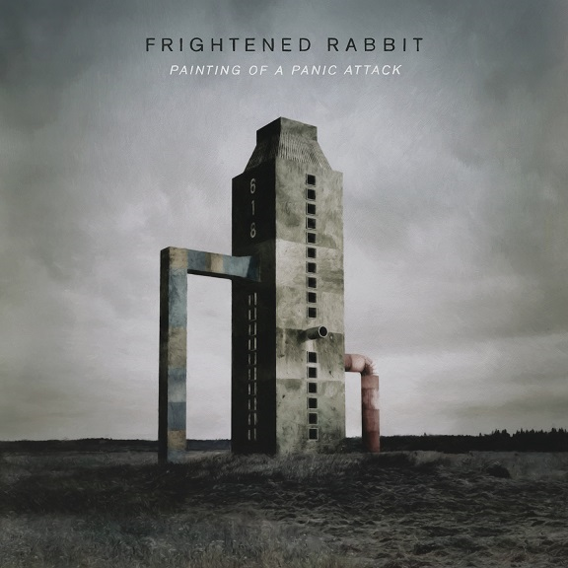
For Immediate Release
February 19, 2016

FRIGHTENED RABBIT ANNOUNCE THE RELEASE OF
“PAINTING OF A PANIC ATTACK”

CRITICALLY ACCLAIMED SCOTTISH BAND’S FIFTH STUDIO ALBUM PRODUCED BY AARON DESSNER OF THE NATIONAL

U.S. HEADLINING TOUR KICKS OFF ON APRIL 21ST

“PAINTING OF A PANIC ATTACK” ARRIVES APRIL 8TH

Canvasback Music/Atlantic recording group Frightened Rabbit have announced details for their eagerly awaited fifth studio album. Titled “PAINTING OF A PANIC ATTACK,” the album was produced by Aaron Dessner of The National and is set to arrive on April 8th.
Dessner – a longtime fan of Frightened Rabbit - had this to say about the record and frontman Scott Hutchison: “Great songwriters touch a nerve, and I think Scott really touches a nerve with these songs. To me, lyrically, this album is a step above anything he’s written before.”
“PAINTING OF A PANIC ATTACK” is available for pre-order now at all digital retailers (see links below). All pre-orders include an immediate download of the album opener “Death Dream” (https://youtu.be/YYLZrCuhu_0) as an instant gratification track. Pre-orders through the Frightened Rabbit store also get access to exclusive pre-sale tickets for Frightened Rabbit’s upcoming U.S. tour. For more information, please visit http://smarturl.it/FrabbitStore.
Announced on Pitchfork this morning, the cross-country trek is the critically acclaimed Scottish band’s first stateside tour in nearly three years, and kicks off on April 21st at the Wonder Ballroom in Portland, OR. Highlights include stops at New York City’s Terminal 5 on May 5th and Los Angeles’ Fonda Theatre on May 24th as well as a performance at Atlanta’s Shaky Knees Music Festival on May 15th and Sasquatch! on May 29th (full itinerary below). General on-sale begins on February 26th at 10AM local time, with the aforementioned pre-sale beginning on Wednesday, February 24th at 10AM local time. For more information, please visit [TK].
“PAINTING OF A PANIC ATTACK” was recorded at Dessner’s Brooklyn studio - where The National also recorded The National’s “HIGH VIOLET” and “TROUBLE WILL FIND ME” - and at Dreamland Studio in Woodstock, NY in the summer of 2015. Much of the album is indebted lyrically to Los Angeles, where frontman Scott Hutchison moved to from Scotland in 2014 Tracks such as “Get Out,” the lead single which chronicles an addictive and obsessive love, and “Still Want To Be Here,” telling of his struggle with adjusting to life in LA, perfectly encapsulate the mindset of the Frightened Rabbit frontman since the band’s last release. And, of the album closer “Die Like A Rich Boy,” Dessner says, “[It] feels like a completely classic song, but it’s also a distillation of everything Scott has ever written about. It’s so gracefully constructed and realized, and it’s not trying to be anything other than what it is. I wish I could write a song like that” (full track listing below).
“PAINTING OF A PANIC ATTACK” follows 2013’s major label debut “PEDESTRIAN VERSE” which saw the band land their highest ever charting, hitting the Top 10 in the UK. The band also received critical acclaim from a wide spectrum of American press, with praise coming from mainstream outlets like Rolling Stone and Time as well tastemaker blogs like Pitchfork and Stereogum. The band’s emotionally charged live shows have earned a devoted fanbase, which includes bands like Death Cab For Cutie and The National – both of whom have handpicked Frightened Rabbit to support them on extensive tours. National television appearances include performances on “Late Night with Jimmy Fallon,” “Conan,” and “The Late Show with David Letterman.”
Frightened Rabbit are: Scott Hutchison (lead vocals/rhythm guitar), Grant Hutchison (drums), Billy Kennedy (bass), Andy Monaghan (guitar/keys) and Simon Liddell (guitar/keys)

Website - http://www.frightenedrabbit.com/
Facebook - https://www.facebook.com/frightenedrabbit
Twitter - https://twitter.com/FRabbits
Instagram - @frabbits

PRE-ORDER/STREAMING LINKS
http://smarturl.it/POAPA.Spotify
http://smarturl.it/POAPA.Amazon
http://smarturl.it/POAPA.iTunes
http://smarturl.it/POAPA.GooglePlay
http://smarturl.it/FrabbitStore

(TRACK LISTING AND TOUR ITINERARY ATTACHED)
FRIGHTENED RABBIT
“Painting Of A Panic Attack”
Available April 8, 2016
(Canvasback Music/Atlantic)

- Death Dream
- Get Out
- I Wish I Was Sober
- Woke Up Hurting
- Little Drum
- Still Want To Be Here
- An Otherwise Disappointing Life
- Break
- Blood Under The Bridge
- 400 Bones
- Lump Street
- Die Like A Rich Boy

FRIGHTENED RABBIT
U.S. TOUR 2016
(Caveman supporting on all dates)

APRIL
21 Portland, OR Wonder Ballroom
22 Boise, ID Knitting Factory
23 Salt Lake City, UT The Complex
24 Denver, CO Ogden Theatre
27 Minneapolis, MN Varsity Theater
28 Milwaukee, WI Pabst Theater
29 Indianapolis, IN The Vogue
30 Detroit, MI St. Andrews Hall

MAY
2 Columbus, OH Newport Music Hall
3 Louisville, KY Headliners Music Hall
5 New York, NY Terminal 5
6 Philadelphia, PA Electric Factory
7 New Haven, CT College Street Music Hall
8 Washington, D.C. 930 Club
9 Boston, MA House of Blues
12 Saxapahaw, NC Haw River Ballroom
13 Knoxville, TN The International
15 Atlanta, GA Shaky Knees Music Festival
17 San Antonio, TX Paper Tiger
18 Dallas, TX Granada Theatre
20 Phoenix, AZ The Crescent Ballroom
21 Solana Beach, CA Belly Up Tavern
24 Los Angeles, CA The Fonda Theatre
26 San Francisco, CA The Regency Ballroom
27 Sacramento, CA Ace of Spades
27-30 George, WA Sasquatch! Festival

CONTACT:
Glenn Fukushima (National) Ilana Gold (Online/Tour)
818.238.6833 212.707.2749
Glenn.Fukushima@atlanticrecords.com Ilana.Gold@atlanticrecords.com

