FOR IMMEDIATE RELEASE
SEPTEMBER 15, 2017

FRIGHTENED RABBIT RELEASE “RECORDED SONGS” EP

SCOTTISH ROCK BAND OFFERS UP THREE BRAND NEW RECORDINGS
INCLUDING A COLLABORATION
WITH ACCLAIMED SINGER-SONGWRITER JULIEN BAKER

NORTH AMERICAN TOUR SUPPORTING BROKEN SOCIAL SCENE KICKS OFF
ON SEPTEMBER 22 AT ATLANTA’S TABERNACLE

DOWNLOAD/STREAM “RECORDED SONGS” HERE:
http://ad.gt/recordedsongs

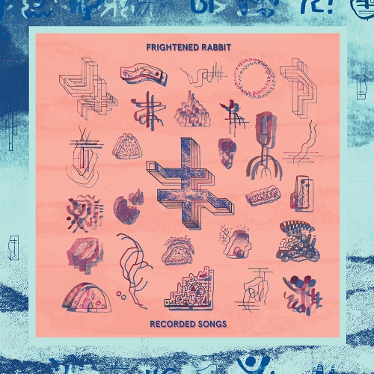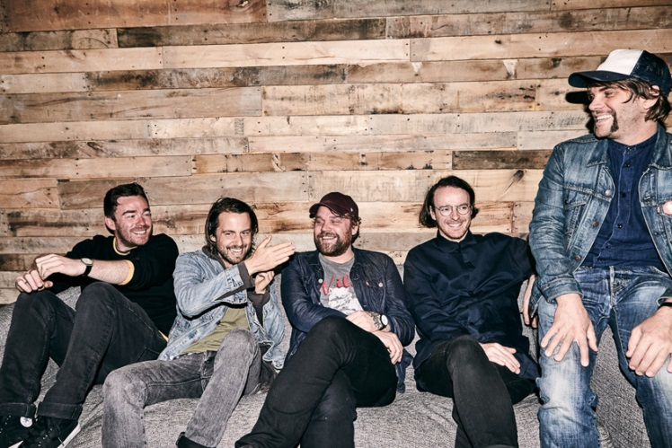
*DOWNLOAD HI-RES IMAGES HERE*

Canvasback Music/Atlantic recording group Frightened Rabbit have released a collection of three brand new recordings. The “RECORDED SONGS” EP arrives at all digital retailers and streaming services today, with a vinyl release set for November 24.
Frightened Rabbit’s Scott Hutchison explains: “These three songs seemed to exist happily next to one another, so it made sense to place them on an EP instead of wedging them into an album on which they didn't fit. These are not B-sides or ‘bonus tracks.’ These are songs that still fill us with the same feelings that our albums can, and I'm happy that they now have a place to live.”

Produced by Frightened Rabbit and recorded by the band’s own Andy Monaghan, “RECORDED SONGS” includes “Roadless” - written while making their most recent full length release, “PAINTING OF A PANIC ATTACK” – as well as a more recent composition “Rained On.” “How It Gets In” is a beautiful duet featuring acclaimed singer-songwriter Julien Baker, who has previously toured with Frightened Rabbit. The release of “RECORDED SONGS” coincides with the Scottish rock band’s North American tour supporting Broken Social Scene. The dates kick off at Tabernacle in Atlanta, GA, on September 22, and continue into early October (see attached itinerary).
*****
Frightened Rabbit’s fifth studio album “PAINTING OF A PANIC ATTACK” – produced by The National’s Aaron Dessner - enjoyed a Top 25 debut on the Soundscan/Billboard 200 chart upon its release last year, peaking at #2 on iTunes’ Alternative chart and #8 overall. The album’s lead single “Get Out” scored Top 10 success on FMQB’s Triple A chart, and garnered the band a pair of national television appearance, performing on CBS’ “Late Show with Stephen Colbert” and “Late Late Show with James Corden.” The song’s emotionally provocative, companion video made its premiere on NPR’s All Songs Considered and received a raft of praise from influential sites, including Pitchfork, Stereogum, and Consequence of Sound, among others. The video – beautifully shot in Kiev –can be viewed at the band’s official YouTube channel (www.youtube.com/frightenedrabbit).
“PAINTING OF A PANIC ATTACK” follows 2013’s major label debut “PEDESTRIAN VERSE,” which earned a Top 10 debut in the UK as well as critical acclaim from a wide spectrum of American press, with praise coming from mainstream outlets like Rolling Stone and Time as well tastemaker blogs like Pitchfork and Stereogum. The band’s emotionally charged live shows have earned a devoted fanbase, which includes bands like Death Cab For Cutie and The National – both of whom have handpicked Frightened Rabbit to support them on extensive tours.

Frightened Rabbit
Scott Hutchison (lead vocals/rhythm guitar), Grant Hutchison (drums), Billy Kennedy (bass), Andy Monaghan (guitar/keys) and Simon Liddell (guitar/keys)
Website - http://www.frightenedrabbit.com/
Facebook - https://www.facebook.com/frightenedrabbit
Twitter - https://twitter.com/FRabbits
Instagram - @frabbits

(TOUR ITINERARY ATTACHED)

FRIGHTENED RABBIT
NORTH AMERICAN TOUR 2017
Supporting Broken Social Scene

SEPTEMBER
22 Atlanta, GA Tabernacle
24 St. Louis, MO The Pageant
26 Des Moines, IA Hoyt Sherman
27 Milwaukee, WI Pabst Theater
28 St. Paul, MN The Palace
29 Chicago, IL Aragon Ballroom
30 Detroit, MI The Fillmore

OCTOBER
1 Pittsburgh, PA Byham Theater
3 Philadelphia, PA The Fillmore
5 Portland, ME State Theatre
6 New Haven, CT College Street
7 Boston, MA House of Blues

PRESS CONTACTS:

Glenn Fukushima (National) Ilana Gold (Online/Tour)
Glenn.Fukushima@atlanticrecords.com Ilana.Gold@atlanticrecords.com

