FOR IMMEDIATE RELEASE
SEPTEMBER 13th, 2019

BETCHA SHARES HIGHLY ANTICIPATED DEBUT EP FALLING

HIGHLIGHTS INCLUDE SUCH FAN FAVORITES AS “LUCY LUCY,”
“COINCIDENTAL,” AND “FALLING”

HEADLINE U.S. TOUR KICKS OFF OCTOBER 17TH IN NYC

FALLING AVAILABLE NOW AT ALL DSPS AND STREAMING SERVICES

DOWNLOAD/STREAM FALLING EP: https://atlantic.lnk.to/Falling_EP
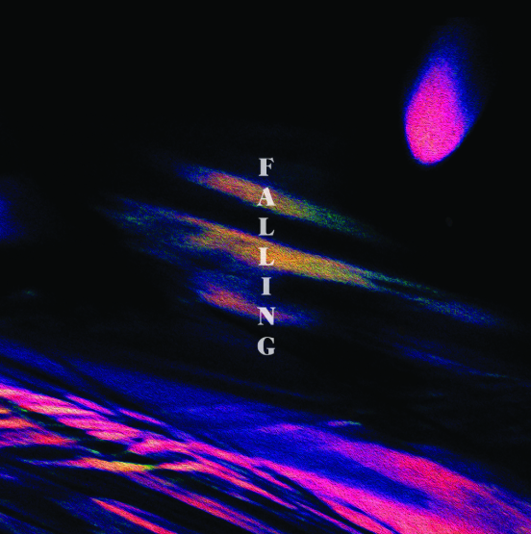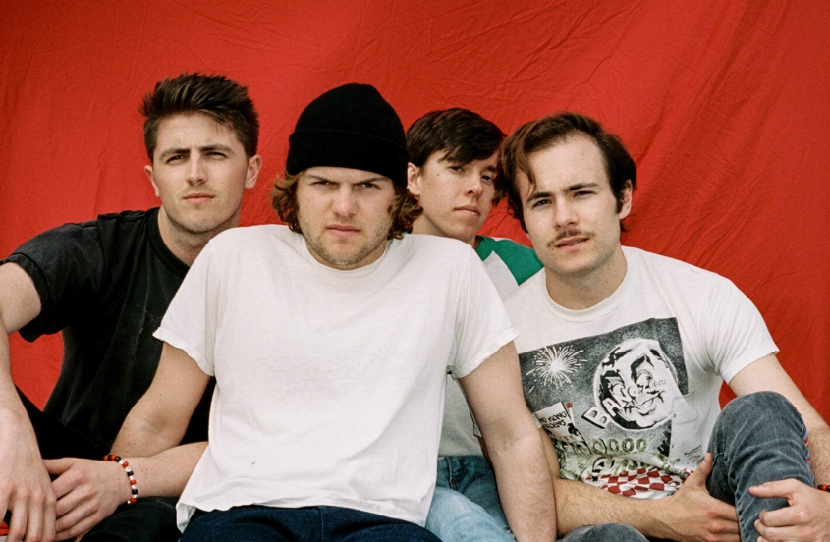
DOWNLOAD ARTWORK | DOWNLOAD PRESS PHOTOS
Atlantic Records has announced the release of FALLING, the eagerly anticipated debut EP from Nashville-based rock band Betcha. The seven-track compilation includes such fan favorites as “Lucy Lucy,” “Coincidental,” and the ebullient title track, in addition to previously unreleased highlights “Swim Naked” and “I Don’t Wanna Die.” FALLING is available now via all digital music retailers and streaming services HERE.

Betcha has quickly drawn wide-ranging critical applause for their idiosyncratic fusion of sweetly stoned rock, alternative electronica, and punchy pop anthems. “Betcha is one of those bands you should get to know,” raved Baeble. “They are carving their own path and have a distinctness to their sound.” Ones To Watch hailed “Lucy Lucy” as an “alternative rock banger with vintage vibes,” while further commending the band for “a dynamic sound that spans across alternative rock and pop.”

Known for an irrepressible stage presence honed on countless local stages and national tours alongside such like-minded acts as KALEO, NEEDTOBREATHE, and Judah The Lion, Betcha will celebrate FALLING with a major U.S. headline tour. The dates get underway October 17th at New York City’s Berlin and then travel into early November (see itinerary below). In addition, Betcha will support UK-based singer-songwriter Sam Fender at an upcoming show at Harrisburg, PA’s XL Live, set for October 19th and presented by Harrisburg University. For complete details and ticket information, please visit betchaband.com.

The tried-and-true configuration of a four-piece rock band has long unlocked an endless array of possibilities. Betcha breathe new life into this traditional ideal with tight songcraft, sharp lyricism, and ceaselessly spirited sonic creativity. The quartet – Charlie Greene (vocals, guitar), Ben Booth (lead guitar), Taylor Dubray (bass, keys), and Chase Wofford (drums) – first united at Nashville’s Belmont University, winning a school-sponsored “Battle of the Bands” whilst still known as Wilder. Fueled by support from GRAMMY® Award-winning producer Jacquire King (Kings of Leon, Kaleo), the band recorded a series of demos that ultimately saw them signed to the legendary Atlantic Records roster. In 2018, they rechristened themselves as Betcha – an amalgamation of the first letters of each member’s name (Ben, Taylor, Charlie, and Chase) – and moved into a shared house in Nashville where they still hang out, writing, recording, and pushing their unique strain of 21st century rock music further than ever before.

“We used to practice in a cold garage, plug in, and play,” says Booth. “Now, we try to switch up our creative process, so it’s not just bass, guitar, drums, and electric instruments. We’re incorporating more electronic-based ethereal elements. We really transitioned from Wilder to Betcha, and we’re grinding to make the best music possible no matter what is. It’s all under the umbrella of who we are.”

“Betcha is something you can listen to in any type of mood,” says Greene. “If you’re getting ready to hit the highway and need to fucking jam out, you can blast Betcha. If you’re feeling down and need something to vibe out to in your room, you can blast Betcha. We’re never going to limit ourselves. That’s our mindset, and it takes all of us to achieve it.”

CONNECT WITH BETCHA
OFFICIAL | FACEBOOK | INSTAGRAM | TWITTER | YOUTUBE

BETCHA
FALLING
(Atlantic Records)
https://atlantic.lnk.to/Falling_EP
TRACKLISTING

- Falling
- California
- Coincidental
- Lucy Lucy
- Swim Naked
- Losing My Mind
- I Don't Wanna Die

# # #

BETCHA
U.S. TOUR 2019

OCTOBER
17 - New York, NY – Berlin
19 - Harrisburg, PA - XL Live *
21 - Nashville, TN - The Basement
22 - Birmingham, AL - The Nick
23 - Athens, GA - Caledonia Lounge
24 - Atlanta, GA - Vinyl
28 - Columbus, OH - Rumba Cafe
29 - Pontiac, MI - The Pike Room

NOVEMBER
1 - Indianapolis, IN - Hi-Fi
2 - St. Louis, MO - Duck Room at Blueberry Hill
4 - Chicago, IL - Schubas
6 - Milwaukee, WI - The Back Room at Collectivo Coffee
7 - Minneapolis, MN - 7th Street Entry

* w/Sam Fender

# # #

