FOR IMMEDIATE RELEASE
JUNE 25TH, 2020

GRAMMY-NOMINATED GLOBAL SUPERSTAR BURNA BOY
RETURNS WITH JOYFUL NEW SINGLE “WONDERFUL”

FIRST SINGLE FROM UPCOMING ALBUM TWICE AS TALL
DUE FOR RELEASE LATER THIS SUMMER

LISTEN HERE

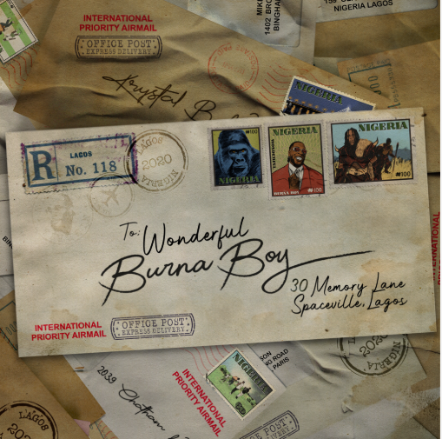
DOWNLOAD HI-RES ARTWORK HERE
VIEW ANNOTATED LYRICS HERE

GRAMMY/BRITs-nominee and 2019 BET Awards Best International Act winner BURNA BOY has made a glorious return with “Wonderful”, the first official single from his forthcoming 4th studio album Twice As Tall arriving later this summer. Listen now.

With a powerful acapella intro and bouncing energy throughout, the song serves as a musical representation of Burna’s personal journey and growth during the transition from his 2019 GRAMMY-nominated album African Giant to the upcoming Twice As Tall. The song boasts a beautiful message of growth, pride, perseverance, true hustle and soaking in the wonderful things the world can offer us.

“It’s important for me to show that music is a uniting force that transcends state lines, barriers and borders. This song is about the ‘wonders’ of seeing the impact of my music on people’s lives as they shared their joy, pain and pleasure with me while I toured the world,” says Burna Boy. “It serves as a note that no matter how far you go, or how hard you work; you must be ready to come home, the pandemic forced us all to take refuge in our homes. Above all, Africa is home, it is the motherland to all people. For us to truly matter, Africa has to matter.”

Burna Boy continues into 2020 after wrapping an extremely successful 2019. His GRAMMY-nominated album (Best World Music Album), AFRICAN GIANT, saw incredible critical acclaim at its release and now adorns a galore of ‘best of’ lists – including Pitchfork’s 50 Best Albums of 2019, NPR’s Best Albums of 2019, Billboard’s 50 Best Albums of 2019, Rolling Stone’s 50 Best Albums of 2019, Complex’s Best Albums of 2019, and many more. He was also named Apple Music's Up Next Artist.

The Nigerian star made his U.S. late night television debut on Jimmy Kimmel Live! followed by appearances on The Daily Show with Trevor Noah and The Tonight Show Starring Jimmy Fallon. He also appeared on NPR’s Tiny Desk, performing four live songs including his global hit “Ye.”

At the 2019 BET Awards Burna Boy won Best International Artist in addition to receiving an in-depth profile piece with the Wall Street Journal which explores how the Nigerian star is finding success on his own terms in the United States. He also had an extensive year of live performances, travelling across North America on his The African Giant Returns Tour with sold-out stops in Toronto, New York, and LA through September, spending an additional two months for its European leg from Paris through Leicester, and had two fiery live sets at both weekends of Coachella.

ABOUT BURNA BOY
Burna Boy was born in Port Harcourt City and started producing music when he was ten years old. After graduating from school, Burna relocated to London for university. After two years, he dropped out and moved back to Nigeria to pursue his passion. A creative by the name of LeriQ allocated studio space for Burna to record and produce. His father always listened to dancehall and reggae music, an early influence and integral part of his musical style. Burna's grandfather managed Fela Kuti for the first 15 years of his career, a relationship that would come to shape Burna's sound and his understanding of himself as an artist that represents Nigeria, and more broadly Africa, to the world. Burna Boy classifies his own music as Afro-fusion, a genre he coined.

CONNECT WITH BURNA BOY
TWITTER | FACEBOOK | INSTAGRAM | YOUTUBE

For additional press assets, visit press.atlanticrecords.com/burna-boy

PRESS CONTACTS
Corey Brewer | Corey.Brewer@atlanticrecords.com
Selam Belay | Selam.Belay@atlanticrecords.com

