FOR IMMEDIATE RELEASE

SEPTEMBER 24, 2021

**Forest Blakk shares new single “Fall Into Me”**

**New track co-written with Rob Thomas ARRIVES ALONGSIDE AN ENDEARING JAMES Fitzgerald-DIRECTEd MUSIC VIDEO**

**Smash hit “If You Love Her” certified Gold in US & Platinum in Canada**

[DOWNLOAD HIGH-RES ARTWORK HERE](http://press.atlanticrecords.com/forest-blakk/)

**WATCH/STREAM “FALL INTO ME”:** <https://forestblakk.lnk.to/FallIntoMePR>

Singer/songwriter **Forest Blakk** has officially released his moving new single, **“Fall Into Me,”** co-penned with multiple-GRAMMY® Award-winning **Matchbox Twenty** front man **Rob Thomas** – available now via **Atlantic** **Records**. The song, also co-written by **Gregg** **Wattenberg** (**John** **Legend**, **O.A.R.**), is a beautifully candid and soaring ode to love, complimented by a touching companion visual directed by **James Fitzgerald**.

*“I wrote ‘****Fall Into Me****’ with my dear friends,* ***Rob******Thomas*** *and* ***Gregg******Wattenberg****. It happened to be my birthday that day and much like a table of gifts, the melodies and words were pouring out one after the other. As it often happens in a session, I was talking to the guys about what I had gone through over the past couple of years and how heartbreak had led me to find an indescribable love with my girlfriend. I suppose nothing is indescribable when you have 3 songwriters on a call.*

*‘****Fall Into Me****,’ is pure, honest, and as genuine as it gets. It's our love story on display for all those out there to witness. And if nothing else, I hope this song reminds you that love stories do exist. Just be ready to fall at any moment!”*

*­*- **FOREST BLAKK**

“**Fall Into Me**” arrives on the heels of Blakk’s smash hit “**If You Love Her**,” which has amassed over 160 million total global streams to date and was just certified Gold in the United States (along with Platinum in his native Canada). The single earned Blakk his official US chart debut on **Billboard**’s **Emerging Artists** chart, his national US TV debut on **ABC**’s **Live with Kelly & Ryan,** top 30 placement on the Hot AC radio chart & also saw the singer/songwriter pair up with **Meghan** **Trainor** for a stunning duet version.

Highlighted as one of **PEOPLE Magazine**’s *“talented emerging artists making their mark on the musical landscape in 2021”* and deemed an *“artist on the rise”* by **Billboard**, Blakk made his debut with his 2018 EP ***Minutes*** and follow-up 2020 sophomore EP ***Sideways*** – the latter of which saw Blakk collaborate with the likes of **Will** **IDAP** (**Train**, **Florida** **Georgia** **Line**), **Nick Long** (**King Princess**), **Carl Ryden** (**Ricky Martin**, **David Guetta**), **Ollie** **Green** (**Freya** **Ridings**, **Gavin** **James**) & more to tell a love story through an incredibly realistic and candid lens. The 6-track collection featured singles “**I Wish I Knew**” (deemed an *“introspective look at love and love lost”* by **American Songwriter**) and uplifting anthem of resilience “**Put Your Hands Up**,” which debuted on an episode of **ABC**’s ***Grey’s Anatomy***. A compelling live performer, Blakk has toured extensively supporting **NEEDTOBREATHE**, **Gavin James** & more.

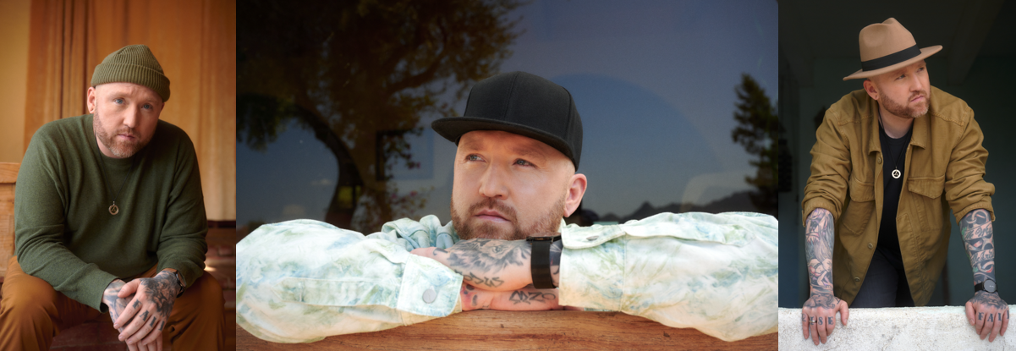

CREDIT: BENJAMIN ASKINAS – [DOWNLOAD HIGH-RES HERE](http://press.atlanticrecords.com/forest-blakk/)

**CONNECT WITH FOREST BLAKK:**

[TWITTER](https://twitter.com/forestblakk) | [FACEBOOK](https://www.facebook.com/forestblakk) | [INSTAGRAM](https://www.instagram.com/forestblakk) | [YOUTUBE](https://www.youtube.com/channel/UC9vKX9Hz5dGVrhD5v3-UnAQ) | [FORESTBLAKK.COM](http://forestblakk.com/)

**CONTACT:**

[ted.sullivan@atlanticrecords.com](mailto:ted.sullivan@atlanticrecords.com)