FOR IMMEDIATE RELEASE
APRIL 9, 2021

Forest Blakk & Meghan Trainor duet on “If You Love Her”

Smash single continues to climb Hot AC Radio chart,
over 1 million weekly streams for 19 consecutive weeks!

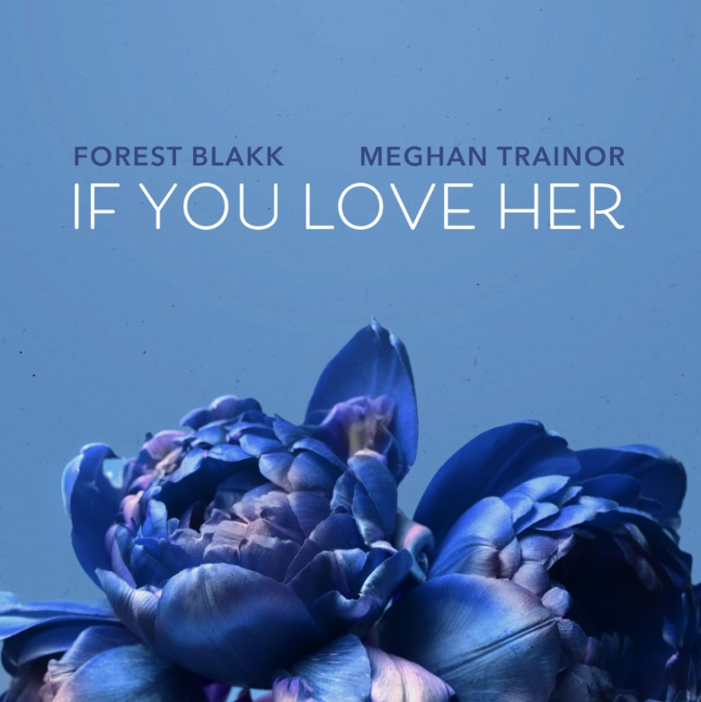
DOWNLOAD HIGH-RES ARTWORK HERE

STREAM “IF YOU LOVE HER” (FEAT. MEGHAN TRAINOR): https://forestblakk.lnk.to/IYLH-MTPR

Singer/songwriter Forest Blakk has teamed up with GRAMMY®-winning superstar Meghan Trainor for a showstopping duet version of his hit single “If You Love Her” – available now via Atlantic Records. The single, which arrived in September alongside a moving James Fitzgerald-directed video (watch here), has become a runaway success with over 67 million total global streams and boasting over 1 million weekly streams domestically for the past consecutive 19 weeks. “If You Love Her” also earned Blakk his official US chart debut on Billboard’s Emerging Artists chart and is continuing its ascend into the top 30 of the Hot AC radio chart this week at #26.

Highlighted as one of PEOPLE Magazine’s “talented emerging artists making their mark on the musical landscape in 2021” and deemed an “artist on the rise” by Billboard, Blakk made his debut with his 2018 EP Minutes and follow-up 2020 sophomore EP Sideways – the latter of which saw Blakk collaborate with the likes of Will IDAP (Train, Florida Georgia Line), Nick Long (King Princess), Carl Ryden (Ricky Martin, David Guetta), Ollie Green (Freya Ridings, Gavin James) & more to tell a love story through an incredibly realistic and candid lens. The 6-track collection featured singles “I Wish I Knew” (deemed an “introspective look at love and love lost” by American Songwriter) and uplifting anthem of resilience “Put Your Hands Up,” which debuted on an episode of ABC’s Grey’s Anatomy. A compelling live performer, Blakk has toured extensively supporting NEEDTOBREATHE, Gavin James and is set to re-join The Goo Goo Dolls alongside Lifehouse for their “Miracle Pill Summer Tour” in 2021.

About Meghan Trainor:
Meghan Trainor first made history in 2014 with her diamond-certified smash single “All About That Bass.” Since then, the award-winning singer, songwriter, and multi-instrumentalist has garnered a GRAMMY® for Best New Artist, achieved eight multi-platinum singles and two platinum albums, sold out three world tours, penned multi-platinum hits for peers across pop and country, and received countless industry awards and nominations. Expanding her influence on pop culture, she starred on FOX’s hit series THE FOUR: Battle for Stardom for two seasons and on the superstar coaching panel of ITV's The Voice UK alongside Sir Tom Jones, will.i.am, and Olly Murs. She kicked off 2020 with the release of her third full-length album, Treat Myself (Epic Records), which includes the platinum smash “No Excuses” as well as blockbuster anthems and collaborations such as “Nice To Meet Ya” (feat. Nicki Minaj), “Genetics” (feat. Pussycat Dolls), “After You” (feat. AJ Mitchell), and “Wave” (feat. Mike Sabath). In July, she released Treat Myself Deluxe, which featured three new original tracks, including “Make You Dance,” and two acoustic recordings of fan favorites. At the end of 2020 she released her first-ever Christmas album, A Very Trainor Christmas, featuring the #1 holiday radio single “White Christmas”.

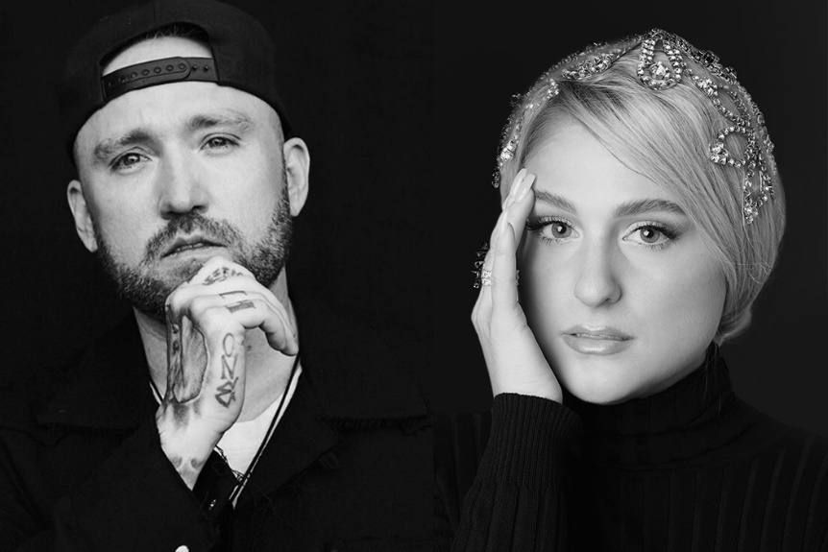
DOWNLOAD HIGH-RES IMAGE HERE

CONNECT WITH FOREST BLAKK:
TWITTER | FACEBOOK | INSTAGRAM | YOUTUBE | FORESTBLAKK.COM

CONTACT:
ted.sullivan@atlanticrecords.com

