FOR IMMEDIATE RELEASE

DECEMBER 1, 2021

**Forest Blakk SPREADS CHRISTMAS CHEER IN “SING ALONG WITH ME” VIDEO**

**ROB THOMAS CO-pENNED SINGLE “FALL INTO ME” CONTINUES TO STREAM 1M+ GLOBALLY PER WEEK**

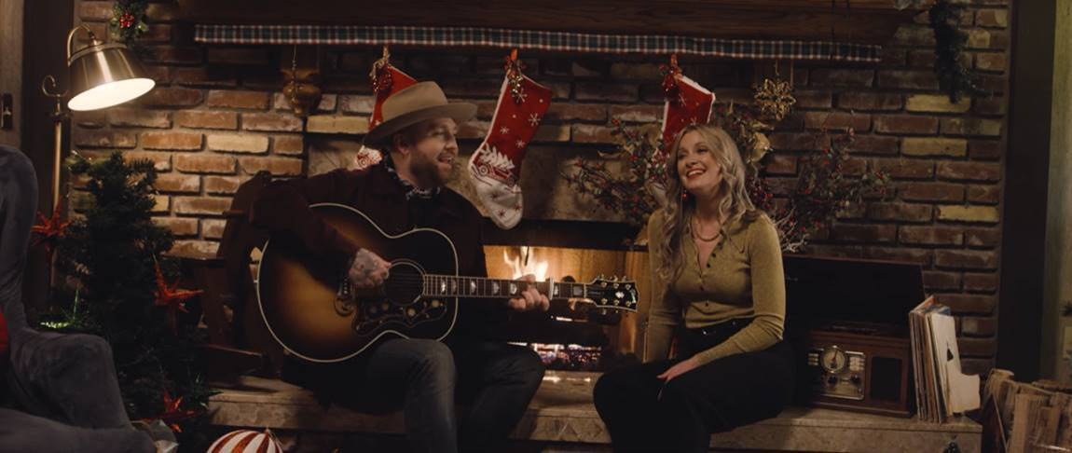

**STREAM/DOWNLOAD “SING ALONG WITH ME”:** <https://forestblakk.lnk.to/SingAlongWithMeVideo>

Singer/songwriter **Forest Blakk** has unveiled the intimate new music video for his Christmas single, **“Sing Along With Me,”** which finds Forest singing with his girlfriend, **Tooley Jones**, who also adds her vocals to the charming new song co-written by Forest and **Davis Holmes Naish**.

**“Sing Along With Me”** arrives as Forest’s previous single, **“Fall Into Me,”** continues to pick up steam. The track, which was co-penned by Forest alongside **Matchbox Twenty** front man **Rob Thomas** and **Gregg** **Wattenberg** (**John** **Legend**, **O.A.R.**) is currently being streamed over 1 million times globally each week.

Also preceding his new Christmas single is Blakk’s smash hit “**If You Love Her**,” which has amassed over 188 million total global streams to date and was just certified Gold in the United States (along with Platinum in his native Canada). The single earned Blakk his official US chart debut on **Billboard**’s **Emerging Artists** chart, his national US TV debut on **ABC**’s **Live with Kelly & Ryan,** top 30 placement on the Hot AC radio chart & also saw the singer/songwriter pair up with **Meghan** **Trainor** for a stunning duet version.

Highlighted as one of **PEOPLE Magazine**’s *“talented emerging artists making their mark on the musical landscape in 2021”* and deemed an *“artist on the rise”* by **Billboard**, Blakk made his debut with his 2018 EP ***Minutes*** and follow-up 2020 sophomore EP ***Sideways*** – the latter of which saw Blakk collaborate with the likes of **Will** **IDAP** (**Train**, **Florida** **Georgia** **Line**), **Nick Long** (**King Princess**), **Carl Ryden** (**Ricky Martin**, **David Guetta**), **Ollie** **Green** (**Freya** **Ridings**, **Gavin** **James**) & more to tell a love story through an incredibly realistic and candid lens. The 6-track collection featured singles “**I Wish I Knew**” (deemed an *“introspective look at love and love lost”* by **American Songwriter**) and uplifting anthem of resilience “**Put Your Hands Up**,” which debuted on an episode of **ABC**’s ***Grey’s Anatomy***. A compelling live performer, Blakk has toured extensively supporting **NEEDTOBREATHE**, **Gavin James** & more.

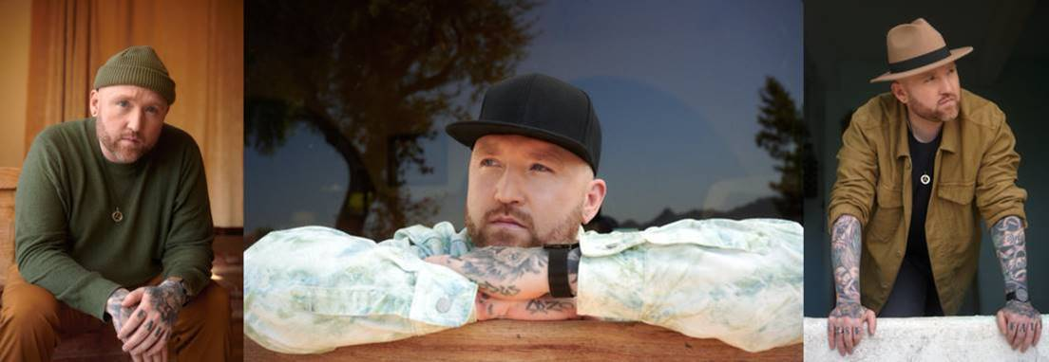

CREDIT: BENJAMIN ASKINAS – [DOWNLOAD HIGH-RES HERE](http://press.atlanticrecords.com/forest-blakk/)

**CONNECT WITH FOREST BLAKK:**

[TWITTER](https://twitter.com/forestblakk) | [FACEBOOK](https://www.facebook.com/forestblakk) | [INSTAGRAM](https://www.instagram.com/forestblakk) | [YOUTUBE](https://www.youtube.com/channel/UC9vKX9Hz5dGVrhD5v3-UnAQ) | [FORESTBLAKK.COM](http://forestblakk.com/)

**CONTACT:**

[ted.sullivan@atlanticrecords.com](mailto:ted.sullivan@atlanticrecords.com)