FOR IMMEDIATE RELEASE

OCTOBER 30, 2019

GOODY GRACE RECRUITS BLINK 182 FOR “SCUMBAG”

ACCLAIMED SINGER/SONGWRITER/PRODUCER UNVEILS HIGHLY-ANTICIPATED NEW SINGLE + VIDEO

GOODY TO JOIN CHARLOTTE LAWRENCE ON THE ROAD THIS FALL

“SCUMBAG” AVAILABLE NOW VIA ATLANTIC RECORDS

STREAM/DOWNLOAD | WATCH OFFICIAL VIDEO
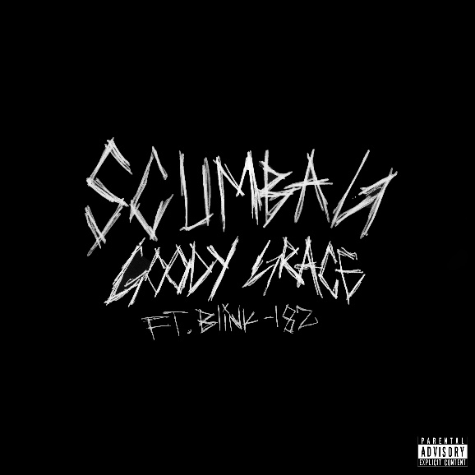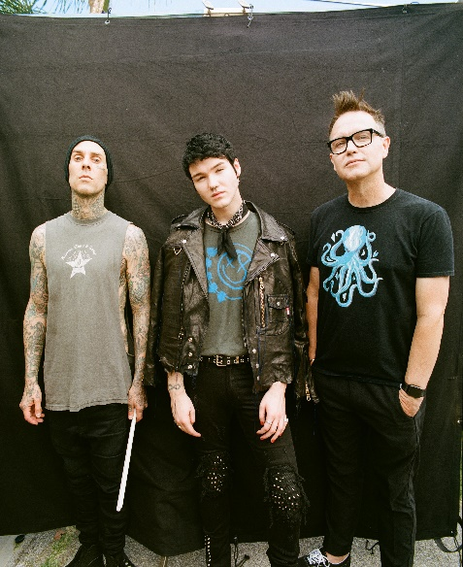
DOWNLOAD ARTWORK | DOWNLOAD PHOTO

“[Goody has] a signature “cinematic” style, encompassing pop, punk, hip-hop, and folk and nodding to influences as diverse as David Lynch, Danzig, Morrissey, and Watchmen.”
-BILLBOARD

“Symbolic of a modern-day punk rocker, Grace displays originality and unique style on all levels.”
-FLAUNT

“Like the man himself, [Grace’s] songs carry a charming simplicity…he’s fast approaching the top of alt-pop…”
-ALTERNATIVE PRESS

Acclaimed Canadian singer/songwriter/producer Goody Grace has teamed up with pop-punk icons Blink 182 for the eagerly-awaited new single, “Scumbag” – available today at all DSPs and streaming services HERE. The addicting new single pairs clean guitar and a signature Travis Barker drum beat as Goody trades vocals with Mark Hoppus over production from multi-platinum production duo The Futuristics (Lil Wayne, Halsey, G-Eazy). “Scumbag” is joined by an official companion video starring Goody, Mark Hoppus, and Travis Barker - now streaming at Goody Grace’s official YouTube HERE.

“Blink-182 is the reason I started playing guitar when I was a kid. Their music helped me through my entire childhood & teenage years and Icouldn’t be more honored to have them on a song of mine,” says Goody, “Travis Barker reached out to me last Fall to open for Blink in Las Vegas and we’ve became great friends since then. I hope ‘Scumbag’ can be the anthem for people’s lives such as Blink’s entire discography is for me.”

A lifelong Blink 182 fan, this dream collaboration came to be after Goody joined Blink for handful of dates on their summer tour and Las Vegas residency, providing guest vocals for their classic song, “Adam’s Song.” It was after these performances that he left with a renewed perspective. “Those shows caused a big shift, because I was a little lost,” Goody admits, “It was so motivational. I took a step back and thought, ‘Whoa, I’m opening for one of my favorite bands ever. If music got me here, I wonder where it could get me if I worked even harder.”

Goody Grace also made his bones as an electrifying live performer, touring the globe both as headliner and alongside G-Eazy, Jesse Rutherford, Hoodie Allen, LANY, and Anne-Marie, not to mention show-stealing appearances at such top festivals as Bonnaroo, Lollapalooza, and Firefly. Goody will soon join close friend and labelmate Charlotte Lawrence on her nationwide headline tour this Fall (full itinerary below). For tickets and more information, please visit: http://goodygrace.com/

ABOUT GOODY GRACE
Watched over by Halloween, The Smiths, and The Beatles posters and with a Misfits button perennially fastened to his jacket, Goody Grace first concocted an artful hybrid of pop, punk, hip-hop, and folk back in his Selkirk, Manitoba childhood bedroom—roughly 3,170 miles from Los Angeles. Raised by a single mom and grandmother, he hopped on a plane for the first time in 2015 and left the snowy forests of Canada behind in order to record under the Southern California sunshine. Within a few years’ time, Goody’s dreams came true to the tune of 100 million-plus streams and tours alongside everyone from Jesse Rutherford to Blink-182.

Goody’s 2018 debut INFINITE EP boasted “Two Shots” [feat. gnash], which has clocked 44 million-plus streams to date. He maintained momentum on a string of singles throughout the following year, including “Too High” [feat. Jesse Rutherford] and “Girls In The Suburbs Singing In Smiths Songs” [feat. G-Eazy]. Between tours alongside Hoodie Allen, LANY, and Anne-Marie, he lit up stages at Bonnaroo, Lollapalooza, and Firefly. Not to mention, he garnered praise from Billboard, Ones To Watch, and Alternative Press who claimed, “In a time dominated by genre-smearing artists looking to make the next wild and weird hit, artists can get lost in the obsession to be the most unique. Goody Grace is an artist who actually sticks out of the crowd, because he isn’t trying to.”

GOODY GRACE LIVE DATES

NOVEMBER
7 – Atlanta, GA – Vinyl
8 – Nashville, TN – The Cowan
9 – Chicago, IL – Subterranean
11 – Columbus, OH – A&R Music Bar
13 - Toronto, ON – Velvet Underground
14 – Boston, MA – Brighton Music Hall
15 – Philadelphia, PA – The Foundry
16 – Washington, DC – U Street Music Hall
18 – New York, NY – Webster Hall
21 – San Diego, CA – House of Blues - San Diego
23 – Los Angeles, CA – The Fonda Theatre

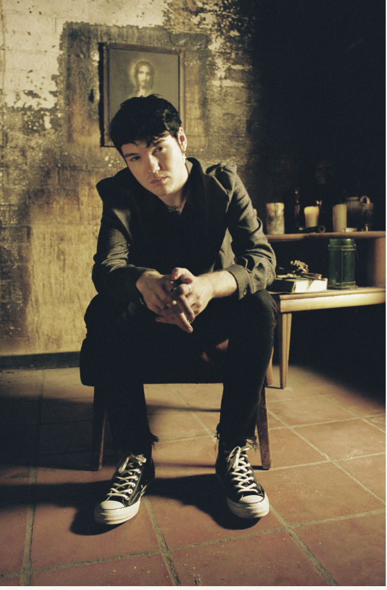

CONNECT WITH GOODY GRACE
OFFICIAL | TWITTER | FACEBOOK | YOUTUBE | INSTAGRAM | PRESS ASSETS

FOR PRESS INQUIRIES, PLEASE CONTACT:
Jessica Nall / Jessica.Nall@atlanticrecords.com
Jason Davis / Jason.Davis@atlanticrecords.com
Chandler Owen (Tour) / Chandler.Owen@atlanticrecords.com

# # #

