FOR IMMEDIATE RELEASE
DECEMBER 22, 2017

GUCCI MANE IS “EL GATO: THE HUMAN GLACIER”

SUPERSTAR RAPPER FINISHES AMAZING YEAR WITH NEW STREET ALBUM

COLLECTION PRODUCED BY SOUTHSIDE

“I GET THE BAG (FEAT. MIGOS)” CERTIFIED PLATINUM BY THE RIAA

NEW YEAR’S EVE LIVE CELEBRATIONS SET FOR MINNEAPOLIS AND LAS VEGAS

THE AUTOBIGRAPHY OF GUCCI MANE AMONG THE YEAR’S BIGGEST BEST-SELLERS

“EL GATO: THE HUMAN GLACIER” ARRIVES EVERYWHERE TODAY

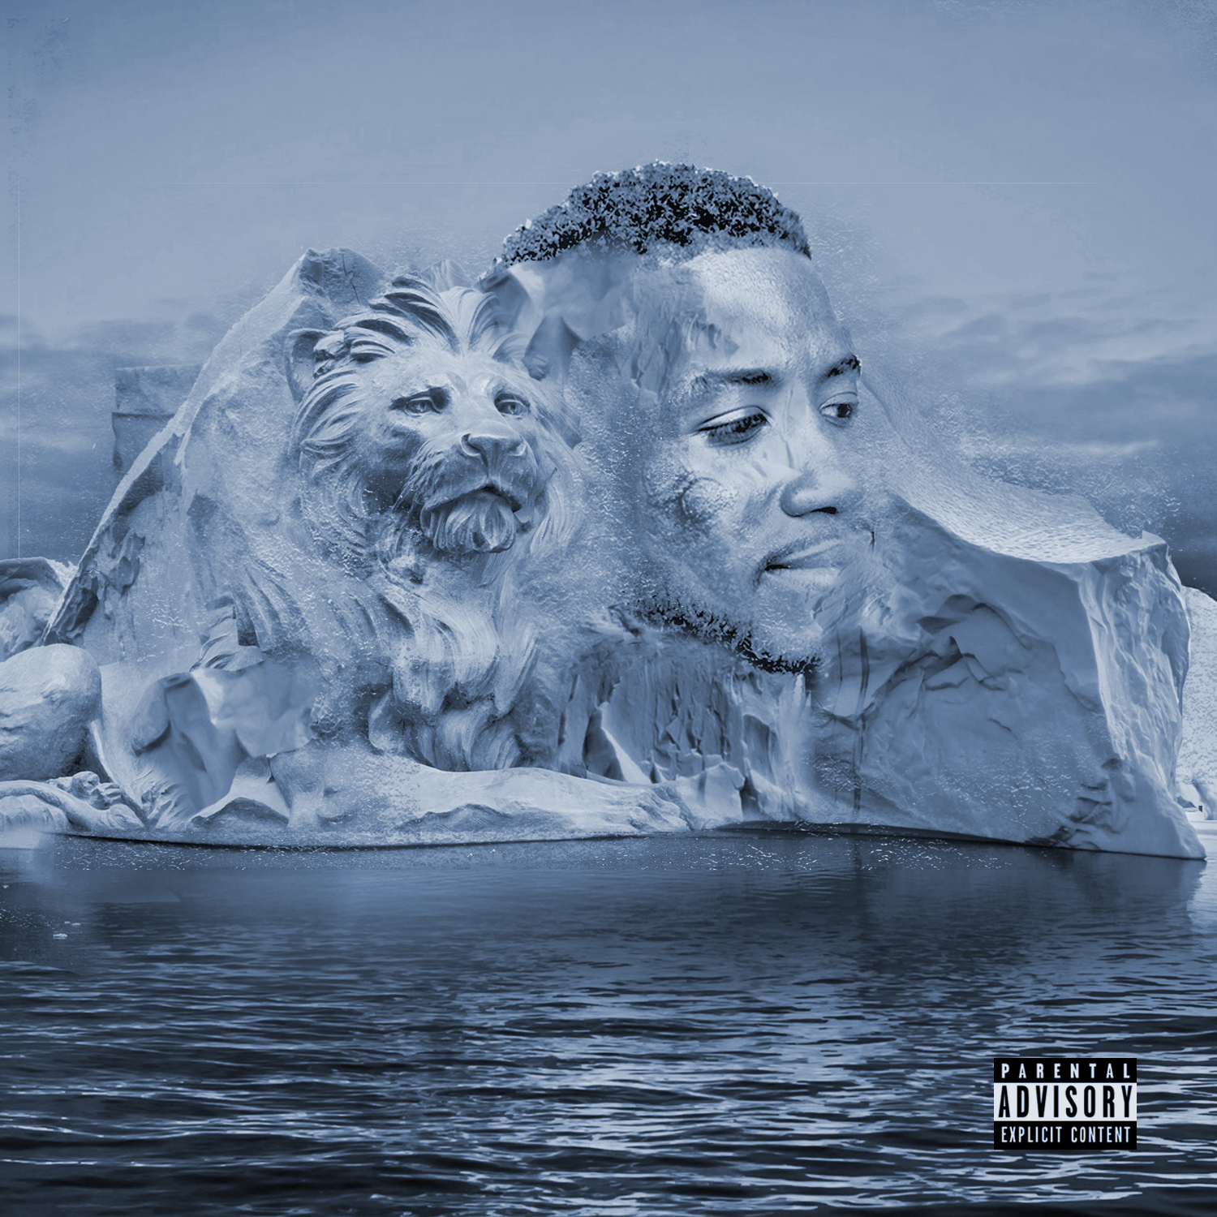

Atlantic recording artist Gucci Mane will wrap up his incredible 2017 with the release of an eagerly anticipated new street album. “EL GATO: THE HUMAN GLACIER” arrives everywhere today, Friday, December 22nd.

“EL GATO: THE HUMAN GLACIER” was heralded last week in a series of tweets from Gucci Mane himself, earning a wide range of media attention from outlets including Billboard, HipHopDX, XXL, HotNewHipHop, Rap-Up, and High Snobiety. The 11-track collection was produced by Southside (Kodak Black, Future) and executive produced by Guwop a.k.a. El Gato (track listing attached).

“EL GATO: THE HUMAN GLACIER” arrives hot on the heels of Gucci Mane’s most recent album, “MR. DAVIS, available now in stores and online. “MR. DAVIS” – which made an explosive chart debut upon its October release, entering the Top Rap Albums chart at #1 and the SoundScan/Billboard 200 at #2, marking Gucci Mane’s fourth top 10 album thus far – includes the epic hit single, “I Get The Bag (Ft. Migos),” recently certified platinum by the RIAA and joined by a massively popular companion video, now boasting over 197 million views at Gucci Mane’s official YouTube channel alone. Gucci Mane and Migos recently united for a major league live TV performance of “I Get The Bag” as part of ABC’s Jimmy Kimmel Live! Mercedes-Benz Concert Series, streaming HERE.

Additional companion visuals have followed, including “Enormous (Feat. Ty Dolla $ign)” (currently with 2.5 million views) and “Curve (Ft. The Weeknd),” now with over 5 million YouTube views.

“MR. DAVIS” followed the May 2017 release of “DROPTOPWOP,” highlighted by the blockbuster single, “Met Gala (Feat. Offset).” Produced by Metro Boomin, the mixtape has been included on a number of year-end lists, among them Noisey’s “The 100 Best Albums of 2017” and Complex’s “The Best Albums of 2017” which hailed the collection as Gucci Mane’s “most darkly compelling collection songs in years – and easily his tightest project.”

In addition to his busy recording schedule, Gucci Mane has spent much of 2017 on the road, including his first-ever U.S. headline trek, this spring’s sold out “TRAPGOD TOUR.” Gucci Mane further joined The Weeknd, as special guest on the blockbuster “Legend of the Fall” arena tour and also lit up a number of top festivals, including Indio, CA’s Coachella Valley Music & Arts Festival, Texas’ 2017 JMBLYA, Long Island, NY’s Billboard Hot 100 Music Festival, and the inaugural “RapCaviar Live” event in Atlanta, inspired by Spotify’s hugely popular hip-hop playlist.

Gucci Mane will complete his jam-packed 2017 with a pair of year-ending concerts, set for Minneapolis, MN’s SNOWTA NYE (December 30th) and Las Vegas, NV’s TAO Nightclub (December 31st). For details and updates, please visit www.guccimaneonline.com/tour.

A true multi-platform superstar, Gucci Mane recently published his extraordinary memoir, The Autobiography of Gucci Mane (Simon & Schuster), earning critical applause from coast to coast while also landing on the New York Times Best-Sellers list. GQ hailed the tome as “a cautionary tale that ends in triumph…There are scenes from Gucci Mane’s new autobiography that seem better fit for a gripping Oscar drama than for the story of a guy who recently won his first MTV Video Music Award for a guest spot on a Fifth Harmony song.” “Better than any urban novella,” raved Newsweek, “the book is an exemplary account of the life and times of Radric Davis from Bessemer, Alabama – otherwise known as Gucci Mane.” “The Autobiography of Gucci Mane is about growth, resilience and how no matter the setback,” declared Essence. “Many of us reading this would not be able to handle it but the many lessons Gucci Mane endured and shared in this autobiography can be valued by us all.”

As if all that weren’t enough, Gucci Mane recently launched his DELANTIC clothing line, which honors his middle name. The inspiration for the line comes from the traditions and culture of Gucci’s “trapping grounds” of East Atlanta, GA. For Gucci Mane, DELANTIC represents independence – as a business, as an aspiration, and as a culture.

Gucci Mane has made a number of high profile TV appearances in recent months, including Comedy Central’s The Daily Show with Trevor Noah, The BET Hip Hop Awards, and an exclusive interview on MTV News. In addition, BET’s 10-episode reality series Gucci Mane & Keyshia Ka’Oir: The Mane Event followed the hip-hop power couple as they prepared for what proved the most extravagant celebrity marriage ceremony of the season. The show received the highest ratings for a premiere in BET history. For more information re: Gucci Mane & Keyshia Ka’Oir: The Mane Event, please visit BET.com.

Additionally this year, Gucci Mane joined Fifth Harmony for the worldwide hit single, “Down (Feat. Gucci Mane).” Gucci Mane and Fifth Harmony made a series of high profile TV performances supporting the single, including ABC’s Good Morning America and NBC’s The Tonight Show Starring Jimmy Fallon and the MTV Video Music Awards. What’s more, “Down (Feat. Gucci Mane)“ was this year’s MTV Video Music Award winner for “Best Pop Video” following its Teen Choice Awards 2017 triumph as “Choice Song: Group.”

For more news and information, please visit: www.instagram.com/laflare1017, https://twitter.com/gucci1017, www.facebook.com/guccimane, https://www.snapchat.com (@guwopsnaps), www.youtube.com/guccimane, and www.atlanticrecords.com.

# # #

CONTACT:
Ashley Kalmanowitz
212.707.2051
Ashley.Kalmanowitz@atlanticrecords.com

# # #

GUCCI MANE
“EL GATO: THE HUMAN GLACIER”
(Atlantic Records)
AVAILABLE FRIDAY, DECEMBER 22ND
Tracklist:

- Rich Ass Junkie
- Peepin Out The Blinds
- Dickriders
- Mall
- Side EFX
- TYT
- Sea Sick
- Smiling In The Drought
- El Gat’s Revenge
- Strep Throat
- Southside And Guwop (Outro)

# # #

