GUCCI MANE AND POOH SHIESTY TEAM UP FOR “LIKE 34 & 8”

STREAM HERE | WATCH HERE

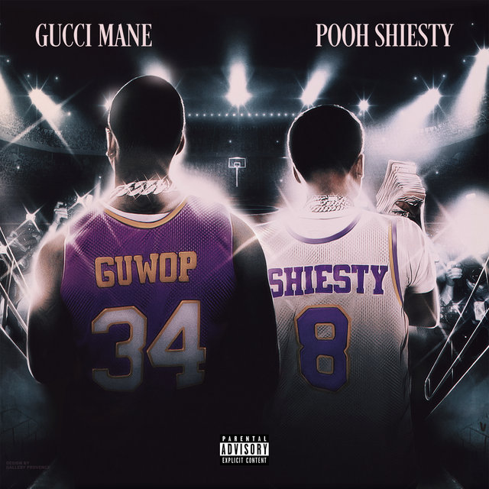

Gucci Mane and 1017 Global Records’ Platinum-selling Pooh Shiesty have teamed up for “Like 34 & 8.” Paying homage to Shaq and Kobe, the track shows the dynamic pair collaborating again. Stream “Like 34 & 8” at DSPs and streaming services HERE, and watch its accompanying music video HERE.

Gucci Mane recently announced the upcoming release of his highly-anticipated album ICE DADDY, due just in time for Father’s Day on June 18th.. Pre-orders for the 17-track ICE DADDY are available now HERE.

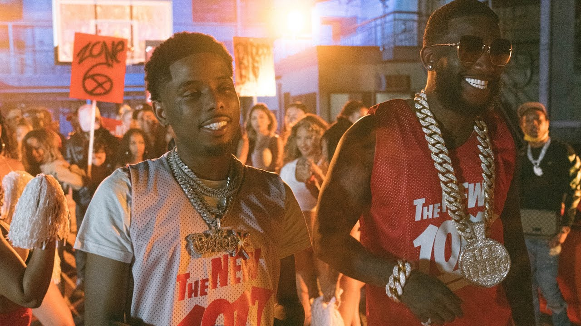

“Like 34 & 8” follows Gucci Mane’s release of “Shit Crazy (Feat. Big 30)” and his first-ever greatest hits collection: TRAP GOD CLASSICS: I AM MY ONLY COMPETITION. TRAP GOD CLASSICS: I AM MY ONLY COMPETITION compiles 28 of Gucci Mane’s biggest tracks and worldwide fan favorites, including such smashes as the 4x RIAA platinum certified “I Get The Bag (Feat. Migos),” the 3x platinum “Both (Feat. Drake),” and the 3x RIAA platinum certified blockbuster, “Wake Up In The Sky,” alongside Bruno Mars and Kodak Black.

Widely regarded as one of the most influential rappers of the past decade, Gucci Mane has more Top 10 albums on Billboard’s “Top Rap Albums” chart than any other hip-hop artist in history. His most recent releases, compilation mixtapes SO ICY GANG, VOL. 1 and GUCCI MANE PRESENTS: SO ICY SUMMER highlighted by “Both Sides (Feat. Lil Baby)” and “Still Remember (Feat. Pooh Shiesty)”, follow last winter’s release of EAST ATLANTA SANTA 3, the final installment of his EAST ATLANTA SANTA series featuring tracks like “She Miss Me (Feat. Rich The Kid)” and “Tony (Feat. Quavo).” 2019 also saw the release of WOPTOBER II, Gucci’s 15th studio album and monumental 101st project overall. The LP made a top 10 debut on the SoundScan/Billboard 200 upon its October release – Gucci’s seventh top 10 debut thus far – fueled by a string of singles/videos including “Richer Than Errybody (Feat. YoungBoy Never Broke Again & DaBaby)” and “Big Booty (Feat. Megan Thee Stallion).” WOPTOBER II in turn followed the June release of the smash mixtape, DELUSIONS OF GRANDEUR, highlighted by the summer anthems, “Love Thru The Computer (Feat. Justin Bieber),” “Backwards (Feat. Meek Mill),” and “Proud Of You.” The prolific icon’s many other career highlights include such classic albums as 2018’s EVIL GENIUS, 2017’s EL GATO: THE HUMAN GLACIER, and that same year’s RIAA gold certified MR. DAVIS, the latter highlighted by the 4x platinum hit single, “I Get The Bag (Feat. Migos),” joined by a massively popular companion video now boasting 500 million views at Gucci Mane’s official YouTube channel alone. Gucci Mane also released the follow-up to his New York Times bestselling book, The Autobiography of Gucci Mane; The Gucci Mane Guide to Greatness is out now.

Along with new releases from Gucci Mane himself, the seasoned A&R is taking his eye for the next big thing to his own record label, The New 1017, in partnership with Atlantic Records. The New 1017 launched with the signing of fellow Atlanta rapper Foogiano, who was soon followed by further hand-chosen additions of artists Pooh Shiesty, Enchanting, and Big Scarr. Compilation mixtape GUCCI MANE PRESENTS: SO ICY SUMMER introduced the fresh crew with collaborations, solo tracks, and features from some of The New 1017’s signees. After just a few months, The New 1017 crew has already seen major success with Pooh Shiesty and Foogiano featured on Rolling Stone’s Breakthrough 25 chart as the 3rd and 5th fastest rising artists of the month of July 2020, respectively, and Big Scarr as #1 in the month of April 2021.

