FOR IMMEDIATE RELEASE

FEBRUARY 9, 2021

**GOODY GRACE ANNOUNCES** ***‘DON’T FORGET WHERE YOU CAME FROM’* OUT FEBRUARY 26TH**

**UPCOMING FULL-LENGTH PROJECT FROM CANADIAN SINGER/SONGWRITER/PRODUCER HERALDED BY NEW SONG, “GRAPE SWISHER,”**

**ALONGSIDE CINEMATIC COMPANION VISUAL DIRECTED BY KOURTNEY TYNDALL**

*“it’s been a long time coming but i’m finally excited to announce my upcoming full length project. this is a culmination of the last 7 years of following my dreams & working with some of my idols along the way. DON’T FORGET WHERE YOU CAME FROM. FEBRUARY 26th. ∞"*

***– Goody Grace***

[**WATCH *DON’T FORGET WHERE YOU CAME FROM* TRAILER: PART 1**](https://nam04.safelinks.protection.outlook.com/?url=https%3A%2F%2Fwww.youtube.com%2Fwatch%3Fv%3DvZOnn5X5vME&data=04%7C01%7CBrian.Sommer%40atlanticrecords.com%7Ca99e6854e485470f5b3108d8cd21e912%7C8367939002ec4ba1ad3d69da3fdd637e%7C0%7C0%7C637484892825208133%7CUnknown%7CTWFpbGZsb3d8eyJWIjoiMC4wLjAwMDAiLCJQIjoiV2luMzIiLCJBTiI6Ik1haWwiLCJXVCI6Mn0%3D%7C1000&sdata=owA6kDpHNU7ypx%2F5kZwk%2Bdin7mhwRUKdhoFkvqviobI%3D&reserved=0)

[***PRE-SAVE DON’T FORGET WHERE YOU CAME FROM***](https://nam04.safelinks.protection.outlook.com/?url=https%3A%2F%2Fgoodygrace.lnk.to%2FDFWYCFpresaveAW&data=04%7C01%7CBrian.Sommer%40atlanticrecords.com%7Ca99e6854e485470f5b3108d8cd21e912%7C8367939002ec4ba1ad3d69da3fdd637e%7C0%7C0%7C637484892825218129%7CUnknown%7CTWFpbGZsb3d8eyJWIjoiMC4wLjAwMDAiLCJQIjoiV2luMzIiLCJBTiI6Ik1haWwiLCJXVCI6Mn0%3D%7C1000&sdata=ySKgmBLugHBRwRSiS3Ud4%2BjFUBXJCLmKSTdZhF%2BVZfY%3D&reserved=0)

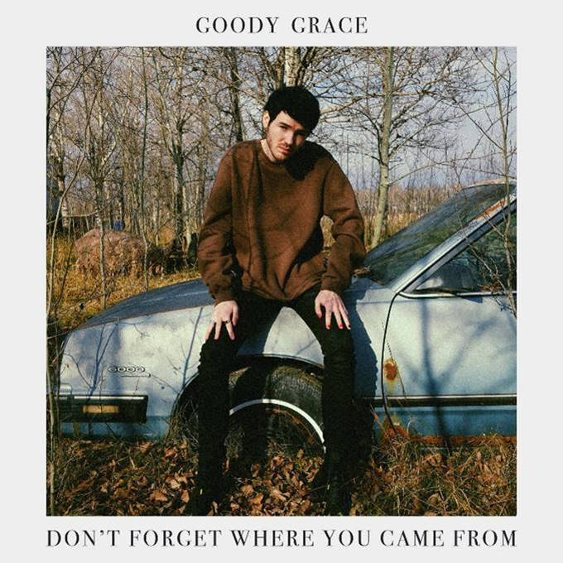

[DOWNLOAD ARTWORK HERE](https://nam04.safelinks.protection.outlook.com/?url=http%3A%2F%2Fpress.atlanticrecords.com%2Fgoody-grace%2F&data=04%7C01%7CBrian.Sommer%40atlanticrecords.com%7Ca99e6854e485470f5b3108d8cd21e912%7C8367939002ec4ba1ad3d69da3fdd637e%7C0%7C0%7C637484892825218129%7CUnknown%7CTWFpbGZsb3d8eyJWIjoiMC4wLjAwMDAiLCJQIjoiV2luMzIiLCJBTiI6Ik1haWwiLCJXVCI6Mn0%3D%7C1000&sdata=PVI2YX9Ml4pVzVpN6nqbwIu1rBNVqJ145p4TMsmWWQU%3D&reserved=0)

*“[Goody has] a signature “cinematic” style, encompassing pop, punk, hip-hop, and folk and nodding to influences as diverse as David Lynch, Danzig, Morrissey, and Watchmen.”*

***-BILLBOARD***

*“[Goody Grace] effortlessly combines stunning indie vocals with upbeat trap rhythms for a unique experience sure to set the stage for a bright musical future … fast approaching the top of alt-pop…”*

*-****ALTERNATIVE PRESS***

*“Symbolic of a modern-day punk rocker, Grace displays originality and unique style on all levels.”*

*-*[***FLAUNT***](https://nam04.safelinks.protection.outlook.com/?url=https%3A%2F%2Fwww.flaunt.com%2Fcontent%2Fweekend-recall-goody-grace&data=04%7C01%7CBrian.Sommer%40atlanticrecords.com%7Ca99e6854e485470f5b3108d8cd21e912%7C8367939002ec4ba1ad3d69da3fdd637e%7C0%7C0%7C637484892825228121%7CUnknown%7CTWFpbGZsb3d8eyJWIjoiMC4wLjAwMDAiLCJQIjoiV2luMzIiLCJBTiI6Ik1haWwiLCJXVCI6Mn0%3D%7C1000&sdata=TTXPO8wEidtbsyM4xrbaOp4e3nVjLOCIPUg7x04HROI%3D&reserved=0)

[**“GRAPE SWISHER”**](https://nam04.safelinks.protection.outlook.com/?url=https%3A%2F%2Fwww.youtube.com%2Fwatch%3Fv%3D2Ta-M48Axxc&data=04%7C01%7CBrian.Sommer%40atlanticrecords.com%7Ca99e6854e485470f5b3108d8cd21e912%7C8367939002ec4ba1ad3d69da3fdd637e%7C0%7C0%7C637484892825228121%7CUnknown%7CTWFpbGZsb3d8eyJWIjoiMC4wLjAwMDAiLCJQIjoiV2luMzIiLCJBTiI6Ik1haWwiLCJXVCI6Mn0%3D%7C1000&sdata=unhbgAmaOgpqJ5Qf327P8FLqu05P85jBCGR4buZYjeI%3D&reserved=0)

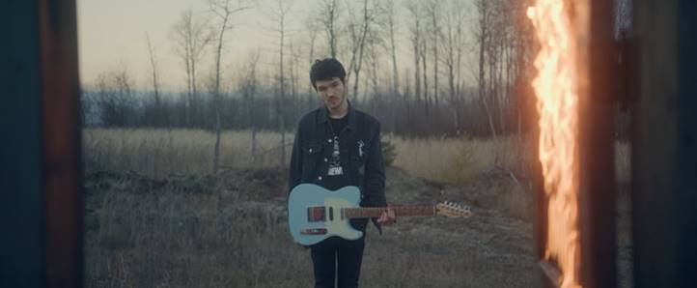

**“**[**WINTER (FEAT. BURNA BOY)**](https://nam04.safelinks.protection.outlook.com/?url=https%3A%2F%2Fwww.youtube.com%2Fwatch%3Fv%3D7x3RQ6R0my0&data=04%7C01%7CBrian.Sommer%40atlanticrecords.com%7Ca99e6854e485470f5b3108d8cd21e912%7C8367939002ec4ba1ad3d69da3fdd637e%7C0%7C0%7C637484892825238117%7CUnknown%7CTWFpbGZsb3d8eyJWIjoiMC4wLjAwMDAiLCJQIjoiV2luMzIiLCJBTiI6Ik1haWwiLCJXVCI6Mn0%3D%7C1000&sdata=x8qyNcaytweWPtaPhrmm1rmHhRueKQtzIsVQj1SZ8XM%3D&reserved=0)**”**



**“**[**NOTHING GOOD (FEAT. G-EAZY & JUICY J)**](https://nam04.safelinks.protection.outlook.com/?url=https%3A%2F%2Fwww.youtube.com%2Fwatch%3Fv%3DAemkMbDeREM&data=04%7C01%7CBrian.Sommer%40atlanticrecords.com%7Ca99e6854e485470f5b3108d8cd21e912%7C8367939002ec4ba1ad3d69da3fdd637e%7C0%7C0%7C637484892825238117%7CUnknown%7CTWFpbGZsb3d8eyJWIjoiMC4wLjAwMDAiLCJQIjoiV2luMzIiLCJBTiI6Ik1haWwiLCJXVCI6Mn0%3D%7C1000&sdata=Un159VEnMiBH4EkBVmN4bvzQijF%2BFzSxf0YBs9lPfHo%3D&reserved=0)**”**



[**“USED TO BE”**](https://nam04.safelinks.protection.outlook.com/?url=https%3A%2F%2Fwww.youtube.com%2Fwatch%3Fv%3DwHgK317SPbY&data=04%7C01%7CBrian.Sommer%40atlanticrecords.com%7Ca99e6854e485470f5b3108d8cd21e912%7C8367939002ec4ba1ad3d69da3fdd637e%7C0%7C0%7C637484892825248109%7CUnknown%7CTWFpbGZsb3d8eyJWIjoiMC4wLjAwMDAiLCJQIjoiV2luMzIiLCJBTiI6Ik1haWwiLCJXVCI6Mn0%3D%7C1000&sdata=En2k9VvtqDotj%2FP4n6m0JK%2Bp6AAerJd22nZ6fY0xcyQ%3D&reserved=0)



[**“SCUMBAG (FEAT. BLINK-182)”**](https://nam04.safelinks.protection.outlook.com/?url=https%3A%2F%2Fwww.youtube.com%2Fwatch%3Fv%3D2exCe3ExZNU&data=04%7C01%7CBrian.Sommer%40atlanticrecords.com%7Ca99e6854e485470f5b3108d8cd21e912%7C8367939002ec4ba1ad3d69da3fdd637e%7C0%7C0%7C637484892825258105%7CUnknown%7CTWFpbGZsb3d8eyJWIjoiMC4wLjAwMDAiLCJQIjoiV2luMzIiLCJBTiI6Ik1haWwiLCJXVCI6Mn0%3D%7C1000&sdata=Wv%2BWqY1%2FRmbgKhR97kapJFyOsk1n5hSTyPHnj9ZOjXE%3D&reserved=0)





[DOWNLOAD PRESS PHOTOS HERE](https://nam04.safelinks.protection.outlook.com/?url=http%3A%2F%2Fpress.atlanticrecords.com%2Fgoody-grace%2F&data=04%7C01%7CBrian.Sommer%40atlanticrecords.com%7Ca99e6854e485470f5b3108d8cd21e912%7C8367939002ec4ba1ad3d69da3fdd637e%7C0%7C0%7C637484892825258105%7CUnknown%7CTWFpbGZsb3d8eyJWIjoiMC4wLjAwMDAiLCJQIjoiV2luMzIiLCJBTiI6Ik1haWwiLCJXVCI6Mn0%3D%7C1000&sdata=0v5%2FmQAs749HhmdvQ594fplYur%2BIAJhlMVB49COjZB4%3D&reserved=0)

**CONNECT WITH GOODY GRACE**

[WEBSITE](https://nam04.safelinks.protection.outlook.com/?url=http%3A%2F%2Fwww.goodygrace.com%2F&data=04%7C01%7CBrian.Sommer%40atlanticrecords.com%7Ca99e6854e485470f5b3108d8cd21e912%7C8367939002ec4ba1ad3d69da3fdd637e%7C0%7C0%7C637484892825268105%7CUnknown%7CTWFpbGZsb3d8eyJWIjoiMC4wLjAwMDAiLCJQIjoiV2luMzIiLCJBTiI6Ik1haWwiLCJXVCI6Mn0%3D%7C1000&sdata=EAtXYOF36rDiFgl%2F5cnMHZu8Kr5Vt26nDr7jJegsFgU%3D&reserved=0) | [INSTAGRAM](https://nam04.safelinks.protection.outlook.com/?url=http%3A%2F%2Fwww.instagram.com%2Fgoodygrace&data=04%7C01%7CBrian.Sommer%40atlanticrecords.com%7Ca99e6854e485470f5b3108d8cd21e912%7C8367939002ec4ba1ad3d69da3fdd637e%7C0%7C0%7C637484892825268105%7CUnknown%7CTWFpbGZsb3d8eyJWIjoiMC4wLjAwMDAiLCJQIjoiV2luMzIiLCJBTiI6Ik1haWwiLCJXVCI6Mn0%3D%7C1000&sdata=8z9axDXPgf9nFlvvM%2BmJ4IhgD3VwGBSTTnq0JecN4YM%3D&reserved=0) | [TWITTER](https://nam04.safelinks.protection.outlook.com/?url=http%3A%2F%2Fwww.twitter.com%2Fgoodygrace&data=04%7C01%7CBrian.Sommer%40atlanticrecords.com%7Ca99e6854e485470f5b3108d8cd21e912%7C8367939002ec4ba1ad3d69da3fdd637e%7C0%7C0%7C637484892825278094%7CUnknown%7CTWFpbGZsb3d8eyJWIjoiMC4wLjAwMDAiLCJQIjoiV2luMzIiLCJBTiI6Ik1haWwiLCJXVCI6Mn0%3D%7C1000&sdata=1%2FQesUlhU4uzIoHfgsaDl7Z6HVZop6Psq3njEp6y87g%3D&reserved=0) | [FACEBOOK](https://nam04.safelinks.protection.outlook.com/?url=https%3A%2F%2Fwww.facebook.com%2FGoodyGraceMusic%2F&data=04%7C01%7CBrian.Sommer%40atlanticrecords.com%7Ca99e6854e485470f5b3108d8cd21e912%7C8367939002ec4ba1ad3d69da3fdd637e%7C0%7C0%7C637484892825278094%7CUnknown%7CTWFpbGZsb3d8eyJWIjoiMC4wLjAwMDAiLCJQIjoiV2luMzIiLCJBTiI6Ik1haWwiLCJXVCI6Mn0%3D%7C1000&sdata=nMRcfTh6xea%2FUch6xtW%2B9JPHC6jCGjPdIrt1RfAyUaE%3D&reserved=0) | [YOUTUBE](https://nam04.safelinks.protection.outlook.com/?url=https%3A%2F%2Fwww.youtube.com%2Fc%2FGoodyGrace&data=04%7C01%7CBrian.Sommer%40atlanticrecords.com%7Ca99e6854e485470f5b3108d8cd21e912%7C8367939002ec4ba1ad3d69da3fdd637e%7C0%7C0%7C637484892825288089%7CUnknown%7CTWFpbGZsb3d8eyJWIjoiMC4wLjAwMDAiLCJQIjoiV2luMzIiLCJBTiI6Ik1haWwiLCJXVCI6Mn0%3D%7C1000&sdata=%2BfweRtLKM37zu60kkpv3IrmC4BmbGpAHomXUYR2UR78%3D&reserved=0) | [PRESS ASSETS](https://nam04.safelinks.protection.outlook.com/?url=http%3A%2F%2Fpress.atlanticrecords.com%2Fgoody-grace%2F&data=04%7C01%7CBrian.Sommer%40atlanticrecords.com%7Ca99e6854e485470f5b3108d8cd21e912%7C8367939002ec4ba1ad3d69da3fdd637e%7C0%7C0%7C637484892825288089%7CUnknown%7CTWFpbGZsb3d8eyJWIjoiMC4wLjAwMDAiLCJQIjoiV2luMzIiLCJBTiI6Ik1haWwiLCJXVCI6Mn0%3D%7C1000&sdata=ag%2Ba36KBkn%2Fu2GlQ1oXvN7pLfqFwW7pqgJJXE6uXCUY%3D&reserved=0)

***

**FOR PRESS INQUIRIES, PLEASE CONTACT**

Jason Davis – [Jason.Davis@atlanticrecords.com](mailto:Jason.Davis@atlanticrecords.com)

Jessica Nall – [Jessica.Nall@atlanticrecords.com](mailto:Jessica.Nall@atlanticrecords.com)

# # #