FOR IMMEDIATE RELEASE

SEPTEMBER 30, 2021

**GOODY GRACE RELEASES *NOSTALGIA KILLS***

**ACCLAIMED SINGER/SONGWRITER/PRODUCER RELEASES REFLECTIVE NEW EP**

**STANDOUT TRACK “GEAR” ARRIVES TODAY ALONGSIDE**

**A GENY ANDREWS-DIRECTED VIDEO**

**NEW PROJECT FOLLOWS RECENT COLLABORATIONS WITH**

**G-EAZY, LOST KINGS AND MORE**

**NORTH AMERICAN HEADLINE “NOSTALGIA KILLS TOUR”**

**KICKS OFF OCTOBER 4TH IN NEW YORK, NY**

**LISTEN TO *NOSALGIA KILLS*** [**HERE**](http://goodygrace.lnk.to/NostalgiaKills)

**WATCH “GEAR”** [**HERE**](https://www.youtube.com/watch?v=5FqCJRfYBh4)

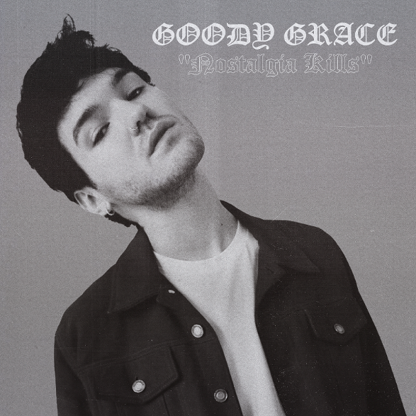

[DOWNLOAD ARTWORK HERE](https://press.atlanticrecords.com/goody-grace/)

*“In the age of viral fame and meme music, Goody Grace stands out as a rockstar in the truest sense of the term. He unapologetically makes the music he wants to make, stays true to his roots, is stylish as hell, and comes across as a genuine person while doing it.” -* [*LA WEEKLY*](https://nam04.safelinks.protection.outlook.com/?url=https%3A%2F%2Fwww.laweekly.com%2Fgoody-grace-is-genuinely-a-rockstar%2F&data=04%7C01%7CBrian.Sommer%40atlanticrecords.com%7Ca60a8878a8a2463d256408d973c4a6ba%7C8367939002ec4ba1ad3d69da3fdd637e%7C0%7C0%7C637668111915333949%7CUnknown%7CTWFpbGZsb3d8eyJWIjoiMC4wLjAwMDAiLCJQIjoiV2luMzIiLCJBTiI6Ik1haWwiLCJXVCI6Mn0%3D%7C1000&sdata=JXCra6v08Q5qK7Pi3YP97Lkf1gLAAr22UKadyc187Pw%3D&reserved=0)

Acclaimed singer-songwriter-producer **Goody Grace** has released his second project of the year, ***Nostalgia Kills****,* available now [HERE](http://goodygrace.lnk.to/NostalgiaKills) via Atlantic Records. The five-track collection includes lead single “[Hold Me In Moonlight](http://goodygrace.lnk.to/HMITM)” and standout track “Gear.” Co-produced by MINGO, “Gear” arrives today alongside a Geny Andrews-directed music video, streaming now [HERE](https://www.youtube.com/watch?v=5FqCJRfYBh4).

Goody will celebrate the release of *Nostalgia Kills* with a North American tour of the same name. The headline tour will kick off October 4th at New York’s Mercury Lounge. For complete details and ticket information, please visit [www.goodygrace.com](https://nam04.safelinks.protection.outlook.com/?url=http%3A%2F%2Fwww.goodygrace.com%2F&data=04%7C01%7CBrian.Sommer%40atlanticrecords.com%7Ca60a8878a8a2463d256408d973c4a6ba%7C8367939002ec4ba1ad3d69da3fdd637e%7C0%7C0%7C637668111915353935%7CUnknown%7CTWFpbGZsb3d8eyJWIjoiMC4wLjAwMDAiLCJQIjoiV2luMzIiLCJBTiI6Ik1haWwiLCJXVCI6Mn0%3D%7C1000&sdata=6Gox1Vz9mMKyDp9z%2FRxRm0Np7Fu0sK0OMPfHMIGcjg0%3D&reserved=0).

***Nostalgia Kills*** arrives mere months after the release of Goody’s debut full-length project, [***Don’t*** ***Forget Where You Came From***](https://nam04.safelinks.protection.outlook.com/?url=https%3A%2F%2Fgoodygrace.lnk.to%2FDFWYCFid&data=04%7C01%7CBrian.Sommer%40atlanticrecords.com%7Ca60a8878a8a2463d256408d973c4a6ba%7C8367939002ec4ba1ad3d69da3fdd637e%7C0%7C0%7C637668111915363930%7CUnknown%7CTWFpbGZsb3d8eyJWIjoiMC4wLjAwMDAiLCJQIjoiV2luMzIiLCJBTiI6Ik1haWwiLCJXVCI6Mn0%3D%7C1000&sdata=rB75bVOWo%2F89GpNcFDAUApW5AJ%2B0sdkC5mBAXzFyn28%3D&reserved=0). Equally inspired by his coming of age in remote Selkirk, Manitoba as it is fueled by a genre-blurring array of musical influences, the project included collaborations with several artists Goody has admired and grown close to throughout his career thus far, including his childhood heroes **blink-182**, **G-Eazy**, **Juicy J**, **Cigarettes After Sex**, **Burna Boy**, **Mr. Hudson**, **Anthony Fantano**, **Bakar**, and **Lexi Jayde**. Among its many highlights are standout singles ““[Winter (Ft. Burna Boy)](https://nam04.safelinks.protection.outlook.com/?url=https%3A%2F%2Fgoodygrace.lnk.to%2FWinterYA&data=04%7C01%7CBrian.Sommer%40atlanticrecords.com%7Ca60a8878a8a2463d256408d973c4a6ba%7C8367939002ec4ba1ad3d69da3fdd637e%7C0%7C0%7C637668111915363930%7CUnknown%7CTWFpbGZsb3d8eyJWIjoiMC4wLjAwMDAiLCJQIjoiV2luMzIiLCJBTiI6Ik1haWwiLCJXVCI6Mn0%3D%7C1000&sdata=b2vJ06VYnBk1PFgwyc5j%2FXx1budopHmexrQ%2B2mfDxw4%3D&reserved=0),” the vulnerable “[Used To Be](https://nam04.safelinks.protection.outlook.com/?url=https%3A%2F%2Fgoodygrace.lnk.to%2FUsedToBe&data=04%7C01%7CBrian.Sommer%40atlanticrecords.com%7Ca60a8878a8a2463d256408d973c4a6ba%7C8367939002ec4ba1ad3d69da3fdd637e%7C0%7C0%7C637668111915373927%7CUnknown%7CTWFpbGZsb3d8eyJWIjoiMC4wLjAwMDAiLCJQIjoiV2luMzIiLCJBTiI6Ik1haWwiLCJXVCI6Mn0%3D%7C1000&sdata=Nfsu%2BSNdprRta0qhUO%2FdXG9O%2FwxXMd%2FY4yWdB%2BF9AU8%3D&reserved=0),” the middle-finger-to-the-sky anthem “[If I Want To](https://nam04.safelinks.protection.outlook.com/?url=https%3A%2F%2Fgoodygrace.lnk.to%2FIfIWantToID&data=04%7C01%7CBrian.Sommer%40atlanticrecords.com%7Ca60a8878a8a2463d256408d973c4a6ba%7C8367939002ec4ba1ad3d69da3fdd637e%7C0%7C0%7C637668111915373927%7CUnknown%7CTWFpbGZsb3d8eyJWIjoiMC4wLjAwMDAiLCJQIjoiV2luMzIiLCJBTiI6Ik1haWwiLCJXVCI6Mn0%3D%7C1000&sdata=JOVbHORlW8IKRW5q4spJeHzcEHYvksRp169TUjnJGWo%3D&reserved=0),” and the star-studded “[Nothing Good (Feat. G-Eazy & Juicy J)](https://nam04.safelinks.protection.outlook.com/?url=https%3A%2F%2Fgoodygrace.lnk.to%2FNothingGoodID&data=04%7C01%7CBrian.Sommer%40atlanticrecords.com%7Ca60a8878a8a2463d256408d973c4a6ba%7C8367939002ec4ba1ad3d69da3fdd637e%7C0%7C0%7C637668111915383918%7CUnknown%7CTWFpbGZsb3d8eyJWIjoiMC4wLjAwMDAiLCJQIjoiV2luMzIiLCJBTiI6Ik1haWwiLCJXVCI6Mn0%3D%7C1000&sdata=EPRXLwccB0X84Toxk6oC3%2FrNF3FLaC2syb7iMWdbh6A%3D&reserved=0),” and “[On Repeat (Feat. Cigarettes After Sex & Lexi Jayde)](https://nam04.safelinks.protection.outlook.com/?url=https%3A%2F%2Fgoodygrace.lnk.to%2FOnRepeatVideo&data=04%7C01%7CBrian.Sommer%40atlanticrecords.com%7Ca60a8878a8a2463d256408d973c4a6ba%7C8367939002ec4ba1ad3d69da3fdd637e%7C0%7C0%7C637668111915393912%7CUnknown%7CTWFpbGZsb3d8eyJWIjoiMC4wLjAwMDAiLCJQIjoiV2luMzIiLCJBTiI6Ik1haWwiLCJXVCI6Mn0%3D%7C1000&sdata=1Nm7GxItPjGbWHRMv4VtIXajvcHL7%2B76gc%2BwJGFRhRo%3D&reserved=0),” the latter of which is joined by a lo-fi [companion video](https://nam04.safelinks.protection.outlook.com/?url=https%3A%2F%2Fgoodygrace.lnk.to%2FDFWYCF&data=04%7C01%7CBrian.Sommer%40atlanticrecords.com%7Ca60a8878a8a2463d256408d973c4a6ba%7C8367939002ec4ba1ad3d69da3fdd637e%7C0%7C0%7C637668111915393912%7CUnknown%7CTWFpbGZsb3d8eyJWIjoiMC4wLjAwMDAiLCJQIjoiV2luMzIiLCJBTiI6Ik1haWwiLCJXVCI6Mn0%3D%7C1000&sdata=BPNUstwOIthVdrZEBMT2%2FaX2HrTgLZUCOhuf20DUqWA%3D&reserved=0), directed by frequent visual collaborator Kyle Dunleavy (Jason Mraz, Breaking Benjamin).

Most recently, Goody teamed up with his good friend and frequent collaborator **G-Eazy** for their track “[Everything is Everything](https://www.youtube.com/watch?v=Bu-a7HAVp9c),” featured on G-Eazy’s recent album *These Things Happen Too*. The prolific artist was also featured on **Lost Kings**’ summer track “[Me Myself & Adderall](https://www.youtube.com/watch?v=aVbHywb1R8w).”

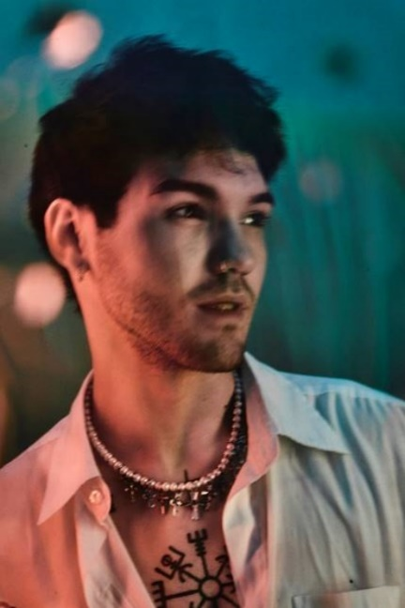

[DOWNLOAD PRESS PHOTOS](https://nam04.safelinks.protection.outlook.com/?url=https%3A%2F%2Fpress.atlanticrecords.com%2Fgoody-grace%2F&data=04%7C01%7CBrian.Sommer%40atlanticrecords.com%7Ca60a8878a8a2463d256408d973c4a6ba%7C8367939002ec4ba1ad3d69da3fdd637e%7C0%7C0%7C637668111915403906%7CUnknown%7CTWFpbGZsb3d8eyJWIjoiMC4wLjAwMDAiLCJQIjoiV2luMzIiLCJBTiI6Ik1haWwiLCJXVCI6Mn0%3D%7C1000&sdata=luSdc%2FJbtOcRxaco42h8alic%2BaElBbJye6Td83lBXHo%3D&reserved=0) // PHOTO CREDIT: JIMMY FONTAINE

***NOSTALGIA KILLS* EP TRACKLIST**

1. Gear
2. Sinner Dressed in Saint Laurent
3. Hold Me in the Moonlight
4. Just A Myth
5. Nostalgia Kills

***NOSTALGIA KILLS* TOUR 2021**

**OCTOBER**

4 – New York, NY – Mercury Lounge

6 – Chicago, IL – Subterranean

11 – San Diego, CA – The Casbah

12 – Los Angeles, CA – Teragram Ballroom

**WHAT PEOPLE ARE SAYING ABOUT GOODY GRACE:**

*“(Goody has) a signature ‘cinematic’ style, encompassing pop, punk, hip-hop, and folk and nodding to influences as diverse as David Lynch, Danzig, Morrissey, and Watchmen.”* - *BILLBOARD*

*“Fast approaching the top of alt-pop…(Goody Grace) effortlessly combines stunning indie vocals with upbeat trap rhythms for a unique experience sure to set the stage for a bright musical future.”* *- ALTERNATIVE PRESS*

*“Goody Grace is on the rise in the music world, with a unique style that can’t be easily defined or put into a single category…He sings angelically, plays a mean guitar, and raps with a lyrical grace beyond his years…his music and style only fit into a class all their own.” - LADYGUNN*

*“Symbolic of a modern-day punk rocker, Grace displays originality and unique style on all levels.” - FLAUNT*

*“Goody Grace is the perfect embodiment of the modern pop-star; a child of the internet generation that isn’t afraid to give the middle-finger to genre rules and just make the kind of music that feels genuine at the moment.” - SUBSTREAM*

*“Progressive and dark…Goody Grace encapsulates punk rock vibes that inextricably intertwine with his edgy vocals that make for a sonic experiment tiptoeing between alternative rock and R&B genres.” - ONES TO WATCH*

**CONNECT WITH GOODY GRACE**

[WEBSITE](https://nam04.safelinks.protection.outlook.com/?url=http%3A%2F%2Fwww.goodygrace.com%2F&data=04%7C01%7CBrian.Sommer%40atlanticrecords.com%7Ca60a8878a8a2463d256408d973c4a6ba%7C8367939002ec4ba1ad3d69da3fdd637e%7C0%7C0%7C637668111915403906%7CUnknown%7CTWFpbGZsb3d8eyJWIjoiMC4wLjAwMDAiLCJQIjoiV2luMzIiLCJBTiI6Ik1haWwiLCJXVCI6Mn0%3D%7C1000&sdata=ihld141XB8FficcWUT9Te60f0LdCAvhrHSe%2Fz7OXeA8%3D&reserved=0) | [INSTAGRAM](https://nam04.safelinks.protection.outlook.com/?url=http%3A%2F%2Fwww.instagram.com%2Fgoodygrace&data=04%7C01%7CBrian.Sommer%40atlanticrecords.com%7Ca60a8878a8a2463d256408d973c4a6ba%7C8367939002ec4ba1ad3d69da3fdd637e%7C0%7C0%7C637668111915413902%7CUnknown%7CTWFpbGZsb3d8eyJWIjoiMC4wLjAwMDAiLCJQIjoiV2luMzIiLCJBTiI6Ik1haWwiLCJXVCI6Mn0%3D%7C1000&sdata=RNuIPt74WIQM8P6qg5notB%2BKAxVWGK3VuMHiHTqGiMk%3D&reserved=0) | [TWITTER](https://nam04.safelinks.protection.outlook.com/?url=http%3A%2F%2Fwww.twitter.com%2Fgoodygrace&data=04%7C01%7CBrian.Sommer%40atlanticrecords.com%7Ca60a8878a8a2463d256408d973c4a6ba%7C8367939002ec4ba1ad3d69da3fdd637e%7C0%7C0%7C637668111915413902%7CUnknown%7CTWFpbGZsb3d8eyJWIjoiMC4wLjAwMDAiLCJQIjoiV2luMzIiLCJBTiI6Ik1haWwiLCJXVCI6Mn0%3D%7C1000&sdata=Z2jAJ0qu%2B9YnxEOHlXiUPB7no%2BvUuIcujpSNHQaadk8%3D&reserved=0) | [FACEBOOK](https://nam04.safelinks.protection.outlook.com/?url=https%3A%2F%2Fwww.facebook.com%2FGoodyGraceMusic%2F&data=04%7C01%7CBrian.Sommer%40atlanticrecords.com%7Ca60a8878a8a2463d256408d973c4a6ba%7C8367939002ec4ba1ad3d69da3fdd637e%7C0%7C0%7C637668111915423898%7CUnknown%7CTWFpbGZsb3d8eyJWIjoiMC4wLjAwMDAiLCJQIjoiV2luMzIiLCJBTiI6Ik1haWwiLCJXVCI6Mn0%3D%7C1000&sdata=CzUSTvMfaPefX47RvvpsnjqR%2BK9M2RyHblCSy16hdlM%3D&reserved=0) | [YOUTUBE](https://nam04.safelinks.protection.outlook.com/?url=https%3A%2F%2Fwww.youtube.com%2Fc%2FGoodyGrace&data=04%7C01%7CBrian.Sommer%40atlanticrecords.com%7Ca60a8878a8a2463d256408d973c4a6ba%7C8367939002ec4ba1ad3d69da3fdd637e%7C0%7C0%7C637668111915423898%7CUnknown%7CTWFpbGZsb3d8eyJWIjoiMC4wLjAwMDAiLCJQIjoiV2luMzIiLCJBTiI6Ik1haWwiLCJXVCI6Mn0%3D%7C1000&sdata=HSsmfRj73WWdh5Gmph%2BTJhVoi%2BRXQa4brIsfAoYZsH8%3D&reserved=0) | [PRESS ASSETS](https://nam04.safelinks.protection.outlook.com/?url=http%3A%2F%2Fpress.atlanticrecords.com%2Fgoody-grace%2F&data=04%7C01%7CBrian.Sommer%40atlanticrecords.com%7Ca60a8878a8a2463d256408d973c4a6ba%7C8367939002ec4ba1ad3d69da3fdd637e%7C0%7C0%7C637668111915433890%7CUnknown%7CTWFpbGZsb3d8eyJWIjoiMC4wLjAwMDAiLCJQIjoiV2luMzIiLCJBTiI6Ik1haWwiLCJXVCI6Mn0%3D%7C1000&sdata=1E3naLMPA2vYa3Iv1j1WAem1Lbiaws1NP15dIkPsm6c%3D&reserved=0)

# # #

**FOR PRESS INQUIRIES, PLEASE CONTACT**

Jessica Nall – [Jessica.Nall@atlanticrecords.com](mailto:Jessica.Nall@atlanticrecords.com)

Jason Davis – [Jason.Davis@atlanticrecords.com](mailto:Jason.Davis@atlanticrecords.com)