FOR IMMEDIATE RELEASE
JANUARY 15, 2020

GROUPLOVE ANNOUNCE NEW ALBUM, HEALER
+ NORTH AMERICAN HEADLINE TOUR

HEALER ARRIVES FRIDAY MARCH 13
PRE-ORDER IT HERE

HEALER TOUR KICKS OFF MARCH 18 + TICKETS ON SALE FRIDAY, JANUARY 17

LISTEN TO LEAD SINGLE “DELETER” NOW HERE
WATCH THE VIDEO HERE

“‘Deleter’ is a return to form for the L.A. band” – ROLLING STONE

“Grouplove makes their much-anticipated return. The alt fivesome unveiled the pounding single… along with an equally gritty music video… political and powerful lyrics.” – BILLBOARD

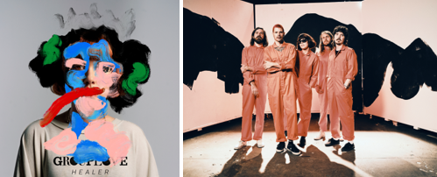
DOWNLOAD HI RES IMAGES HERE

Canvasback Music and Atlantic Records are proud to announce the eagerly awaited new album from Grouplove. Healer arrives everywhere on Friday, March 13th; pre-orders are available beginning today HERE.

Last week, Grouplove kicked off HEALER with the release of their lead single, “Deleter.” After its premiere on Sirius XM, the track and companion video were met with widespread critical acclaim from fans and critics alike. Billboard hailed the “much-anticipated return” as “political and powerful” while Consequence of Sound stated, “It’s almost impossible to hear the song without imagining the band dancing around the recording studio. For the first single from a new album, it certainly bodes well for the musical direction Grouplove are going in.”

“Deleter” arrived alongside an equally anarchic, high-energy companion video, directed by award-winning cinematographer Chris Blauvelt companion video that was directed by Chris Blauvelt, who served as Cinematographer on Jonah Hill’s directorial debut Mid90s.

Grouplove will embark on the wide-spread US headline Healer tour, kicking off March 18th at Santa Fe, NM’s Meow Wolf and then traveling the United States through late May (see trailer HERE and full itinerary below and HERE). Artist and Songkick pre-sales begin Thursday, January 16 at 10AM local time; tickets will go on sale to the general public for most markets on Friday, January 17 at 10AM local. Australian rock group Le Shiv, will support the first half of the tour with fellow Canvasback label-mates Jealous of the Birds supporting the second half. For complete details and ticket information, please visit www.grouplovemusic.com.

Grouplove are partnering with The Ally Coalition for the Healer tour. The Ally Coalition is working with the band to bring organizations that support at-risk LGBTQ youth to each show. They will also be joined on the road by HeadCount, a non-partisan organization that promotes participation in democracy through music, culture and digital media.

Recorded at El Paso, TX’s famed Sonic Ranch with producer Dave Sitek (TV On The Radio, Yeah Yeah Yeahs, Weezer) and at Larrabee Studios in Los Angles with Malay (Frank Ocean, Lorde), Healer marks the first new album from Grouplove since 2016’s acclaimed third LP, BIG MESS.

Grouplove has spent much of its existence on tour, including worldwide headline tours, countless festival appearances, and support runs alongside such like-minded artists as Imagine Dragons, Young the Giant, Foster the People, and Florence and the Machine.

Grouplove is: Hannah Hooper, Christian Zucconi, Andrew Wessen, Daniel Gleason, and Benjamin Homola.

CONNECT WITH GROUPLOVE
OFFICIAL
FACEBOOK
INSTAGRAM
YOUTUBE
SOUNDCLOUD

PRESS CONTACTS:
CHELSEY NORTHERN
CHELSEY.NORTHERN@ATLANTICRECORDS.COM

LIBBY KOBER
LIBBY.KOBER@ATLANTICRECORDS.COM
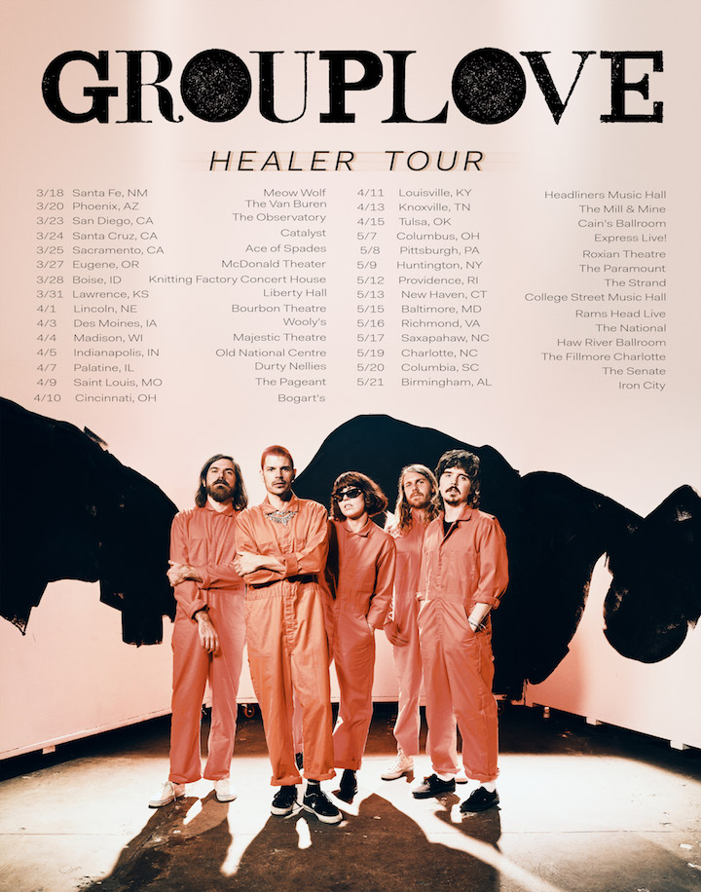

GROUPLOVE HEALER TOUR

MARCH
w/ Le Shiv
18 – Santa Fe, NM – Meow Wolf
20 – Phoenix, AZ – The Van Buren
23 – San Diego, CA – The Observatory
24 – Santa Cruz, CA – Catalyst
25 – Sacramento, CA – Ace of Spades
27 – Eugene, OR – McDonald Theater
28 – Boise, ID – Knitting Factory Concert House
31 – Lawrence, KS – Liberty Hall

APRIL
w/ Le Shiv
1 – Lincoln, NE – Bourbon Theatre
3 – Des Moines, IA – Wooly’s
4 – Madison, WI – Majestic Theatre
5 – Indianapolis, IN – Old National Centre
9 – St. Louis, MO – The Pageant
10 – Cincinnati, OH – Bogart’s
11 – Louisville, KY – Headliners Music Hall
13 – Knoxville, TN – The Mill & Mine
15 – Tulsa, OK – Cain’s Ballroom

MAY
w/ Jealous of the Birds
7 – Columbus, OH – Express Live!
8 – Pittsburgh, PA – Roxian Theatre
9 – Huntington, NY – The Paramount
12 – Providence, RI – The Strand
13 – New Haven, CT – College Street Music Hall
15 – Baltimore, MD – Rams Head Live
16 – Richmond, VA – The National
17 – Saxapahaw, NC – Haw River Ballroom
19 – Charlotte, NC – The Fillmore Charlotte
20 – Columbia, SC – The Senate
21 – Birmingham, AL – Iron City

ADDITIONAL DATES TO BE ANNOUNCED

# # #

