FOR IMMEDIATE RELEASE
MARCH 10, 2021

GROUPLOVE RETURN WITH “DEADLINE”

SURPRISE ALBUM THIS IS THIS ARRIVES FRIDAY

ACCLAIMED BAND ANNOUNCE SURPRISE DROP OF NEW ALBUM THIS IS THIS
OUT FRIDAY, MARCH 12TH

FIRST SINGLE “DEADLINE” OUT NOW
+ OFFICIAL VIDEO STREAMING NOW HERE

LIVE PERFORMANCE OF “DEADLINE” SET FOR TONIGHT’S EPISODE OF
CBS’ THE LATE LATE SHOW WITH JAMES CORDEN

FIRST-OF-ITS-KIND SUBSCRIPTION LIVESTREAM CONCERT SERIES BEGINS TOMORROW
IN PARTNERSHIP WITH PREMIUM DIGITAL LIVE PLATFORM MOMENT HOUSE

LISTEN TO “DEADLINE” HERE
WATCH THE VIDEO HERE
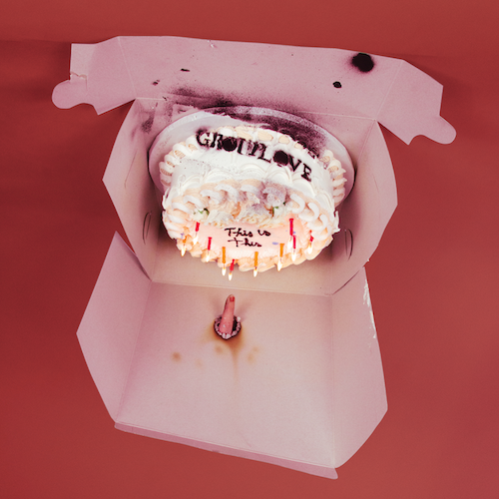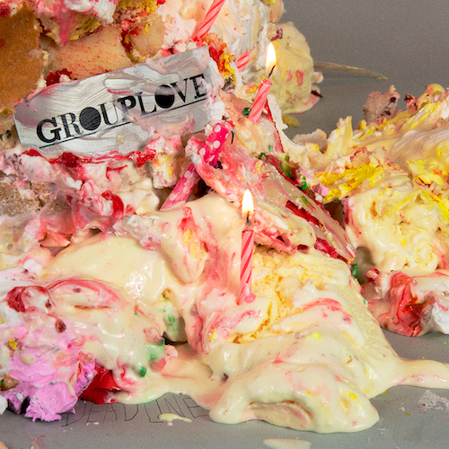
DOWNLOAD ARTWORK HERE

Grouplove has announced the surprise release of their latest album, This Is This, arriving this Friday, March 12th. The acclaimed rock band’s fifth full length LP is heralded by “Deadline,” available now at all DSPs and streaming services HERE. “Deadline” arrives with Isaac Deitz directed official video streaming HERE. Grouplove will celebrate with the first-ever live performance of “Deadline,” tonight on CBS’ The Late Late Show with James Corden.

Produced by Grouplove and collaborator Ricardo Acasuso – with additional songs produced by Dave Sitek (Yeah Yeah Yeahs) and Malay (Frank Ocean) – This Is This, following last year’s GRAMMY-nominated Healer, was written and recorded during the global pandemic, fueled by all the upheaval and hardship of the past year.

“We hope this album gives people the permission to fucking scream or headbang or punch walls,” says Grouplove. “It's important to stay emotional. The whole rainbow is important. If we just live in the light blues, are we really alive? I'm not. I need to feel it all.”

Having been based in Los Angeles for the past decade, Grouplove co-founders Hannah Hooper and Christian Zucconi relocated to Atlanta in late 2020, joining bassist Daniel Gleason. Along with guitarist Andrew Wessen and drummer Ben Homola, the band worked quickly, tracking the entire album in just a week at a local studio. The sessions proved both cathartic and powerfully creative for Grouplove, the sound of five friends finally letting go of all the anxiety, sadness, and frustration they’ve had to endure.

Grouplove are celebrating This Is This by teaming up with premium digital live platform Moment House to launch This is This Moment, a livestream concert series that will allow fans to purchase a subscription to an exclusive monthly live performance, set to begin Thursday, March 11th with new shows following every second Thursday of each month. Each show will feature a completely unique set list, including complete album performances, unreleased music, rarely played fan favorites, surprise cover versions, Q&As, and much more. For tickets and additional details, please visit www.momenthouse.com/grouplove.

GRAMMY nominated and hailed by SPIN as “a masterpiece,” Grouplove’s fourth studio album, Healer, arrived to widespread critical applause on March 13th of last year, just as the world had begun to enter the first phase of lockdown. The album includes the singles, “Youth,” “Inside Out,” and the top 5 Alternative Radio favorite, “Deleter,” all of which are joined by official companion videos directed by award-winning cinematographer Chris Blauvelt (Meek’s Cutoff, Mid90s).

Despite having to reimagine their album release plans, and cancel their certified climate positive tour, Grouplove remained active throughout 2020, following Healer with a number of exclusive releases including a new version of Tom Petty’s classic “Wildflowers” and the stand-alone single, “Broken Angel.” Written by Grouplove and produced by Foxygen’s Jonathan Rado (The Flaming Lips), the track was originally released as a 12” picture disc for Record Store Day 2020 backed by “Trip On Me.” Proceeds from “Broken Angel” benefit The Pittsburgh Foundation’s Mac Miller Fund. Created to carry on Miller’s artistic and creative legacy, The Mac Miller Fund supports programming, resources and opportunities to youth from underserved communities, helping them recognize their full potential through exploration in the arts and community building.

Grouplove is: Hannah Hooper, Christian Zucconi, Andrew Wessen, Daniel Gleason, and Benjamin Homola.

# # #

This is This Tracklist
1. Primetime
2. This Is The End
3. Deadline
4. Scratch
5. Oxygen Swimming
6. Just What You Want
7. Seagulls
8. Shake That Ass
9. Shout

# # #

CONNECT WITH GROUPLOVE
OFFICIAL | FACEBOOK | INSTAGRAM | YOUTUBE | SOUNDCLOUD

GROUPLOVE PRESS CONTACTS:
Kelly McWilliam // Kelly.McWilliam@atlanticrecords.com
Libby Kober // Libby.Kober@atlanticrecords.com

