FOR IMMEDIATE RELEASE
JULY 21, 2020

GROUPLOVE RELEASES TIMELY NEW MUSIC VIDEO FOR “INSIDE OUT”

ACCLAIMED ALTERNATIVE BAND UNVEILS VISUAL FOR TRACK OFF RECENTLY RELEASED FOURTH STUDIO ALBUM HEALER – STREAMING NOW HERE

“We are all in need of some healing right now – luckily Grouplove’s new album Healer is here for all of us. It’s a masterpiece.” – SPIN

“‘Healer’ is at turns earnest and frenetic, packed full to the brim with vulnerability, compassion and bold questioning of an increasingly broken culture, all set to Grouplove’s feverish brand of guitar-driven indie pop”
– BILLBOARD

“a return to form for the LA band” – ROLLING STONE

“…the sounds of resistance and resilience…” – ENTERTAINMENT WEEKLY

“…their loudest and most off-the-wall record yet…” – PASTE

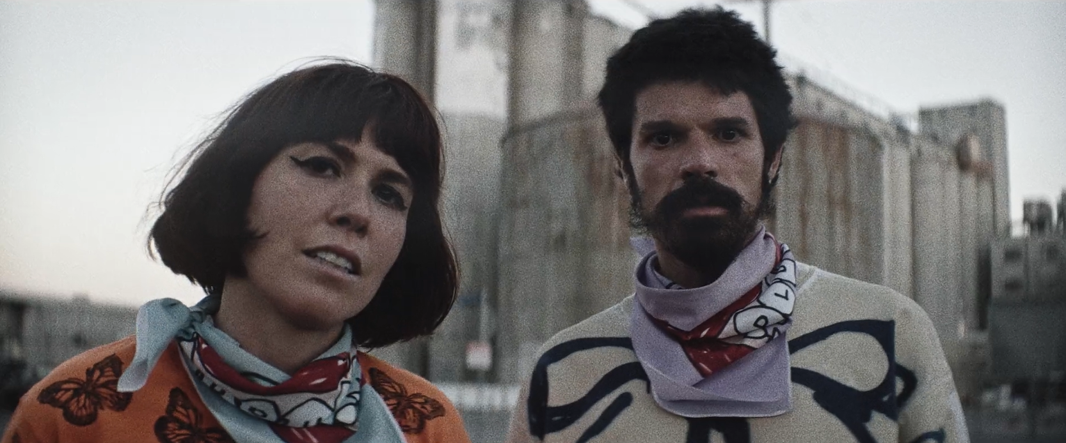
DOWNLOAD HI RES IMAGES HERE

“When you found out there's something so real in me / And that I'll turn out how I am supposed to be / Yeah, you don't gotta look at my every move / But we all need somethin' to do / Inside Out / Yeah, we just got to turn ourselves Inside Out”

Canvasback Music/Atlantic Records acclaimed alternative act Grouplove has released an official music video for “Inside Out,” a standout off their recently released fourth studio album Healer – watch HERE. The video showcases bandmembers and husband/wife duo Hannah Hooper and Christian Zucconi running through the streets of a barren downtown Los Angeles. As the video progresses, the apocalyptic imagery of masked faces and closed businesses is offset by the waves of strangers and an overarching sense of hope and triumph.

The powerful visual was directed by Chris Blauvelt, who served as Cinematographer on Jonah Hill’s directorial debut Mid90s, and also directed the band’s recent music videos “Deleter” and “Youth.”

"’Inside out’ is the realization that change comes from within,” Christian shares, “and the video is acknowledging that we can’t run from that change anymore."

Earlier this year, the Los Angeles-based five-piece released their fourth studio album Healer, highlighted by lead single “Deleter” – which hit #4 at Alternative Radio last month. Grouplove celebrated the release with an incredible, “socially-distant” performance of the track on Jimmy Kimmel Live!

Shortly after, Grouplove joined fellow Canavasback and Atlantic Records artists for a moving performance of Bob Dylan’s “Shelter From The Storm,” and encouraged support for the MusiCares COVID-19 Relief Fund and Help Musicians UK in their valiant efforts to assist musicians and tour crews adversely affected by the Coronavirus crisis.

Last month, the band posted an unreleased demo titled “Shout Shout Shout” to their Bandcamp. Heralded as “wonderfully raw” by Billboard, the track raised money for Campaign Zero – an organization fighting to end police brutality.

Earlier this month, the band released an official cover of Robyn’s classic anthem “Dancing On My Own” – a fan favorite during live performances.

Most recently lead singers Hannah Hooper and Christian Zucconi appeared on GRAMMY Museum’s “The Drop” – watch the Q&A and performance HERE.

Grouplove encourages everyone to go to www.wearorange.org and support the movement to end gun violence in America.

Grouplove is: Hannah Hooper, Christian Zucconi, Andrew Wessen, Daniel Gleason, and Benjamin Homola.

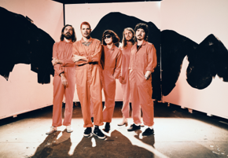

CONNECT WITH GROUPLOVE
OFFICIAL
FACEBOOK
INSTAGRAM
YOUTUBE
SOUNDCLOUD

For press inquiries, please contact:
Kelly McWilliam // Kelly.McWilliam@atlanticrecords.com
Libby Kober // Libby.Kober@atlanticrecords.com

