FOR IMMEDIATE RELEASE
FEBRUARY 16, 2021

GROUPLOVE AND MOMENT HOUSE UNITE FOR
THIS IS THIS MOMENT

BAND PARTNERS WITH PREMIUM DIGITAL LIVE PLATFORM
FOR FIRST-OF-ITS-KIND SUBSCRIPTION SERIES

SUBSCRIPTION FOR EXCLUSIVE MONTHLY LIVESTREAM CONCERT SERIES
ON SALE TOMORROW HERE

PREMIERE PERFORMANCE SET FOR THURSDAY, MARCH 11TH

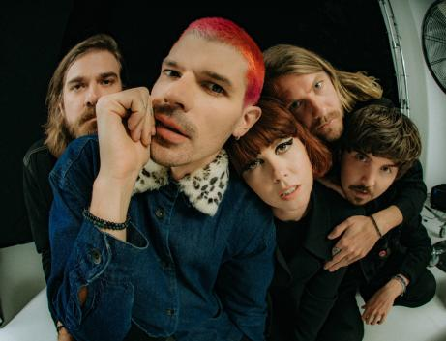

Chart-topping recording artists Grouplove are teaming up with premium digital live platform Moment House to launch a first-of-its-kind subscription-based live series; This is This Moment goes on sale to the general public tomorrow, February 17th HERE.

“Yo we know it’s been a minute but you’ve been on our minds!” Grouplove’s Hannah Hooper shared. “We are launching a monthly live concert series- gonna play some new music! some older albums front to back, some acoustic sets, some collaborations and even share some art- after each show we’ll be doing a live hang and Q&A. We are so excited to share this with you- it’s been far too long. The first show is going to be special to say the least. Gonna leave it at that for now😉”

This is This Moment is a livestream concert series that will allow fans to purchase a subscription to an exclusive monthly live performance, set to begin Thursday, March 11th with new shows following every second Thursday of each month. Each and every show will feature a completely unique set list, including complete album performances, unreleased music, rarely played fan favorites, surprise cover versions, Q&As and much more. Complete details can be found now at momenthouse.com/grouplove.

Hailed by SPIN as “a masterpiece,” Grouplove’s fourth studio album, Healer, arrived on March 13th of 2020, as the world was beginning to come to a halt. Despite having to reimagine their album rollout and cancel their certified climate positive tour, Grouplove kept busy and saw many successes throughout the year. The album included the singles, “Youth,” “Inside Out,” and the top 5 Alternative Radio hit, “Deleter,” all of which were joined by official companion videos directed by award-winning cinematographer Chris Blauvelt (Meek’s Cutoff, Mid90s) and streaming now via the band’s official YouTube channel HERE.

The band followed Healer with a number of exclusive releases including a new version of Tom Petty’s classic “Wildflowers,” which first premiered as part of the annual Tom Petty Birthday Bash on SiriusXM’s Tom Petty Radio. In addition, October 2020 saw Grouplove unveil the powerful single, “Broken Angel.” Written by Grouplove and produced by Foxygen’s Jonathan Rado (The Killers, The Flaming Lips), the track was originally released as a 12” picture disc for Record Store Day 2020 backed by “Trip On Me.” Proceeds from “Broken Angel” benefit The Pittsburgh Foundation’s Mac Miller Fund. Created to carry on Miller’s artistic and creative legacy, The Mac Miller Fund supports programming, resources and opportunities to youth from underserved communities, helping them recognize their full potential through exploration in the arts and community building.

Grouplove is: Hannah Hooper, Christian Zucconi, Andrew Wessen, Daniel Gleason, and Benjamin Homola.

ABOUT MOMENT HOUSE
Moment House is the premium digital live platform that connects artists and their core fans for global, elevated ticketed experiences — called “Moments.” With a mission to bring people together through art and technology, Moment House is uniquely crafted with a focus on artist-friendliness, elegant design, user experience, and support for seamless merchandise integrations, global payments, and more.

Founded in 2019 by an inaugural graduate of the Jimmy Iovine & Dr. Dre Academy for Innovation at USC, Moment House has hosted “Moments” by a range of artists including Halsey, Kaytranada, Ruel, Yungblud and more, as well as collaborated with Justin Bieber on his recent New Year’s Eve livestream performance. The company is backed by top tier investors across the music industry and Silicon Valley, including Scooter Braun, Troy Carter, Jared Leto, Forerunner, Palm Tree Crew Investments (Kygo and Myles Shear), and Kevin Mayer. For more information on Moment House, visit momenthouse.com.

# # #

CONNECT WITH GROUPLOVE
OFFICIAL | FACEBOOK | INSTAGRAM | YOUTUBE | SOUNDCLOUD

CONNECT WITH MOMENT HOUSE
OFFICIAL | TWITTER | INSTAGRAM | FACEBOOK

GROUPLOVE PRESS CONTACTS:
Kelly McWilliam // Kelly.McWilliam@atlanticrecords.com
Libby Kober // Libby.Kober@atlanticrecords.com

MOMENT HOUSE PRESS CONTACTS:
Luke Burland // luke@bbgunpress.com
Sam Citron // sam@bbgunpres.com
Peter Quinn // peter@bbgunpress.com

