FOR IMMEDIATE RELEASE
MARCH 25, 2021

GROUPLOVE UNVEIL “THIS IS THE END”

ACCLAIMED BAND UNVEIL NEW VIDEO FROM SURPRISE FIFTH STUDIO ALBUM, THIS IS THIS

NEW FULL-LENGTH LP ALSO INCLUDES LEAD SINGLE “DEADLINE”

YEAR-LONG FAN ACTION CAMPAIGN LAUNCHED IN SUPPORT OF
BLACK LGBTQ+ YOUTH AND THE CENTERS THAT SERVE THEM

WATCH “THIS IS THE END” HERE
LISTEN TO THIS IS THIS HERE

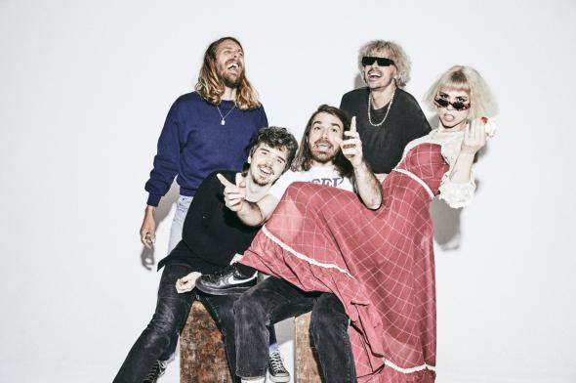
DOWNLOAD PHOTO HERE

Praise for This is This
“This is This finds Grouplove navigating the angst of an uncertain year and their innate drive to keep the music coming – for sanity’s sake. What Grouplove have drawn from this year is that they’re collectively growing as artists without any guidance.” – AMERICAN SONGWRITER

“The group never fails to supply some solid, feel-good indie-pop tracks, even as they lyrically confront their darker feelings.” – PASTE

“[‘This is This’ is] an album forged in the depths of their individual selves coming together to lay bare something raw and relatable as a collective.” – HIGH TIMES

Grouplove have released their official music video for “This Is The End,” one of the many highlights found on their acclaimed new album, This Is This. The one-shot video was directed by Isaac Deitz and styled by Grouplove frontwoman Hannah Hoopper – watch it now HERE.

“This may feel like the end but we want you to know we’ll be together” Hannah Hooper shared.

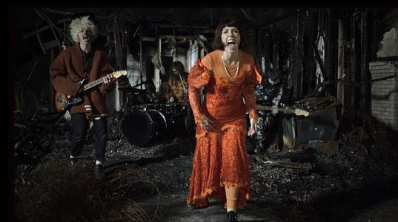

This Is This – which follows last year’s GRAMMY® Award-nominated Healer – was surprise released earlier this month alongside the premiere of the lead single, “Deadline,” joined by an official music video, directed by ATL-based filmmaker Isaac Deitz. Grouplove celebrated the unexpected announcement of This Is This with an incredible live performance of “Deadline” on CBS’ The Late Late Show with James Corden, streaming HERE.

Grouplove will further mark This Is This with the launch of a special action center on Propeller in partnership with The Ally Coalition supporting Black LGBTQ Youth and the centers that serve them. Fans who take action will be entered to win exclusive prizes from Grouplove, including virtual meet and greets, merch, and tickets to an upcoming show.

“Grouplove believes that Pride is not just in June, but is year round. They are continuing their partnership with The Ally Coalition to help fans take action for LGBTQ youth, who disproportionately experience homelessness, depression, bullying and suicidal ideation. TAC provides critical support for undeserved organizations dedicated to bettering the lives of LGBTQ youth and raises awareness about the systemic inequalities facing the LGBTQ community.”

Grouplove first previewed This Is This earlier this month on the inaugural installment of their unprecedented livestream concert series, This is This Moment. Launched in partnership with premium digital live platform Moment House, This is This Moment allows fans to purchase a subscription to an exclusive monthly live performance set for every second Thursday of the month with each show featuring a completely unique set list, including complete album performances, unreleased music, rarely played fan favorites, Q&As, and more. For tickets and additional details, please visit www.momenthouse.com/grouplove.

Grouplove is: Hannah Hooper, Christian Zucconi, Andrew Wessen, Daniel Gleason, and Benjamin Homola.

# # #

DOWNLOAD ARTWORK HERE

CONNECT WITH GROUPLOVE
OFFICIAL | FACEBOOK | INSTAGRAM | YOUTUBE | SOUNDCLOUD

GROUPLOVE PRESS CONTACTS:
Kelly McWilliam // Kelly.McWilliam@atlanticrecords.com
Libby Kober // Libby.Kober@atlanticrecords.com

