FOR IMMEDIATE RELEASE
MARCH 12, 2021

GROUPLOVE UNVEIL THIS IS THIS

ACCLAIMED BAND SURPRISE DROP FIFTH STUDIO ALBUM

NEW FULL-LENGTH LP INCLUDES LEAD SINGLE “DEADLINE”

LIVE PERFORMANCE OF “DEADLINE” ON CBS’ THE LATE LATE SHOW WITH JAMES CORDEN
STREAMING HERE

FIRST-OF-ITS-KIND SUBSCRIPTION LIVESTREAM CONCERT SERIES NOW UNDERWAY
IN PARTNERSHIP WITH PREMIUM DIGITAL LIVE PLATFORM MOMENT HOUSE

LISTEN TO THIS IS THIS HERE
PRE-ORDER THE VINYL HERE
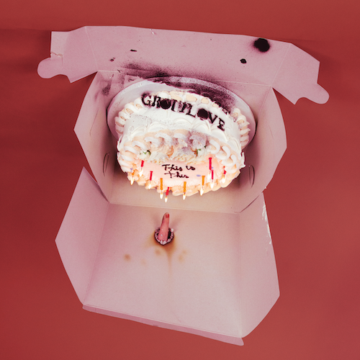
DOWNLOAD ARTWORK HERE

Grouplove has announced today’s surprise release of their fifth studio album. This Is This, featuring lead single “Deadline” and is available now HERE.

“Deadline” arrived earlier this week along with the announcement of the band’s fifth full-length LP and an official video streaming now HERE. Grouplove then celebrated This Is This with a live performance of “Deadline” on CBS’ The Late Late Show with James Corden – watch it HERE.

“We hope this album gives people the permission to fucking scream or headbang or punch walls,” says Grouplove. “It's important to stay emotional. The whole rainbow is important. If we just live in the light blues, are we really alive? I'm not. I need to feel it all.”

Following their GRAMMY-nominated album Healer, This Is This was produced by Grouplove and collaborator Ricardo Acasuso – with additional songs produced by Dave Sitek (Yeah Yeah Yeahs) and Malay (Frank Ocean). The album was written and recorded during the global pandemic, fueled by all the upheaval and hardship of the past year. Recording this album proved both cathartic and powerfully creative for Grouplove, the sound of five friends finally letting go of all the anxiety, sadness, and frustration they’ve all had to endure.

Last night, Grouplove gave fans a sneak peek at the album on the inaugural This is This Moment. The band teamed up with premium digital live platform Moment House to launch the unprecedented livestream concert series. This is This Moment allows fans to purchase a subscription to an exclusive monthly live performance set for every second Thursday of the month with each show featuring a completely unique set list, including complete album performances, unreleased music, rarely played fan favorites, Q&As, and more. For tickets and additional details, please visit www.momenthouse.com/grouplove.

Grouplove is: Hannah Hooper, Christian Zucconi, Andrew Wessen, Daniel Gleason, and Benjamin Homola.

# # #

This is This Tracklist
1. Primetime
2. This Is The End
3. Deadline
4. Scratch
5. Oxygen Swimming
6. Just What You Want
7. Seagulls
8. Shake That Ass
9. Shout

# # #

CONNECT WITH GROUPLOVE
OFFICIAL | FACEBOOK | INSTAGRAM | YOUTUBE | SOUNDCLOUD

GROUPLOVE PRESS CONTACTS:
Kelly McWilliam // Kelly.McWilliam@atlanticrecords.com
Libby Kober // Libby.Kober@atlanticrecords.com

