FOR IMMEDIATE RELEASE
MARCH 4, 2020

GROUPLOVE RELEASES NEW TRACK “YOUTH”
FROM FORTHCOMING ALBUM HEALER OUT MARCH 13TH

ACCLAIMED ROCK BAND UNVEILS NEW TRACK
+ VIDEO STARRING TWIN PEAKS’ GRACE ZABRISKIE

CURRENT SINGLE “DELETER” RAPIDLY CLIMBING TO TOP TEN AT ALTERNATIVE RADIO

OUTDOOR STAGE PERFORMANCE ON JIMMY KIMMEL LIVE! SET FOR MARCH 16TH

HEALER TOUR KICKS OFF MARCH 18TH; TICKETS ON SALE NOW HERE

WATCH: HERE

LISTEN TO “YOUTH”: HERE
DOWNLOAD HI RES IMAGES HERE

Canvasback Music and Atlantic Records are proud to announce the latest single from the acclaimed rock group Grouplove, “Youth.” The track arrives today alongside a nostalgic companion video, which premiered via PAPER and stars Grace Zabriskie (Twin Peaks, Seinfeld) - watch it HERE. “Youth” is the latest track to arrive off the eagerly awaited album Healer, out everywhere Friday, March 13th; pre-order now HERE. Following the release of their forthcoming album, Grouplove will perform on the outdoor stage at Jimmy Kimmel Live! on March 16th.

Last month, Grouplove kicked off HEALER with the release of their lead single, “Deleter.” After its premiere on Sirius XM, the track and companion video were met with widespread critical acclaim from fans and critics alike. Billboard hailed the “much-anticipated return” as “political and powerful” while Consequence of Sound stated, “It’s almost impossible to hear [‘Deleter’] without imagining the band dancing around the recording studio. For the first single from a new album, it certainly bodes well for the musical direction Grouplove are going in.” The single has been rapidly climbing the alternative chart and is headed to the top ten and beyond.

Grouplove will embark on the US headline Healer tour, kicking off March 18th at Santa Fe, NM’s Meow Wolf and running through late May (see trailer HERE and full itinerary below and HERE). Australian rock group Le Shiv, will support the first half of the tour with fellow Canvasback labelmates Jealous of the Birds supporting the second half. Tickets are on sale now; for complete details and ticket information, please visit www.grouplovemusic.com.

The band is proud to be partnering with The Ally Coalition for the Healer tour, working to bring organizations that support at-risk LGBTQ youth to each show. They will also be joined on the road by HeadCount, a non-partisan organization that promotes participation in democracy through music, culture, and digital media.

Recorded at El Paso, TX’s famed Sonic Ranch with producer Dave Sitek (TV On The Radio, Yeah Yeah Yeahs, Weezer) and at Larrabee Studios in Los Angeles with Malay (Frank Ocean, Lorde), Healer marks the first new album from Grouplove since 2016’s acclaimed third LP, BIG MESS.

Grouplove is: Hannah Hooper, Christian Zucconi, Andrew Wessen, Daniel Gleason, and Benjamin Homola.

CONNECT WITH GROUPLOVE
OFFICIAL
FACEBOOK
INSTAGRAM
YOUTUBE
SOUNDCLOUD

PRESS CONTACTS:
CHELSEY NORTHERN
CHELSEY.NORTHERN@ATLANTICRECORDS.COM

LIBBY KOBER
LIBBY.KOBER@ATLANTICRECORDS.COM
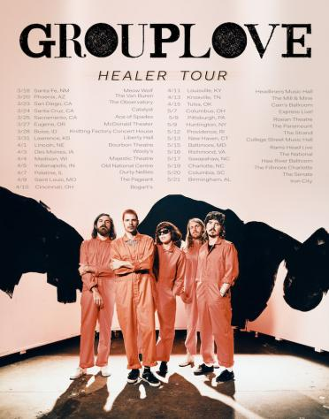

GROUPLOVE HEALER TOUR

MARCH
w/ Le Shiv
18 – Santa Fe, NM – Meow Wolf
20 – Phoenix, AZ – The Van Buren
23 – San Diego, CA – The Observatory
24 – Santa Cruz, CA – Catalyst
25 – Sacramento, CA – Ace of Spades
27 – Eugene, OR – McDonald Theater
28 – Boise, ID – Knitting Factory Concert House
31 – Lawrence, KS – Liberty Hall

APRIL
w/ Le Shiv
1 – Lincoln, NE – Bourbon Theatre
3 – Des Moines, IA – Wooly’s
4 – Madison, WI – Majestic Theatre
5 – Indianapolis, IN – Old National Centre
9 – St. Louis, MO – The Pageant
10 – Cincinnati, OH – Bogart’s
11 – Louisville, KY – Headliners Music Hall
13 – Knoxville, TN – The Mill & Mine
15 – Tulsa, OK – Cain’s Ballroom

MAY
w/ Jealous of the Birds
7 – Columbus, OH – Express Live!
8 – Pittsburgh, PA – Roxian Theatre
9 – Huntington, NY – The Paramount
12 – Providence, RI – The Strand
13 – New Haven, CT – College Street Music Hall
15 – Baltimore, MD – Rams Head Live
16 – Richmond, VA – The National
17 – Saxapahaw, NC – Haw River Ballroom
19 – Charlotte, NC – The Fillmore Charlotte
20 – Columbia, SC – The Senate
21 – Birmingham, AL – Iron City

ADDITIONAL DATES TO BE ANNOUNCED

# # #

