UK duo HONNE premiere “FKHD” featuring KILL J
Debut album - 'Warm On A Cold Night' - out now via Atlantic Records
US, European & UK Tour on sale now

Watch/Post: https://youtu.be/8T5nrXvMqqQ
Buy: http://smarturl.it/FHKD.KillJ

"HONNE's driving production is distinctively clean and elegant, and Kill J's quivering voice matches the surroundings with control and an understated ferocity." -- Pigeons & Planes
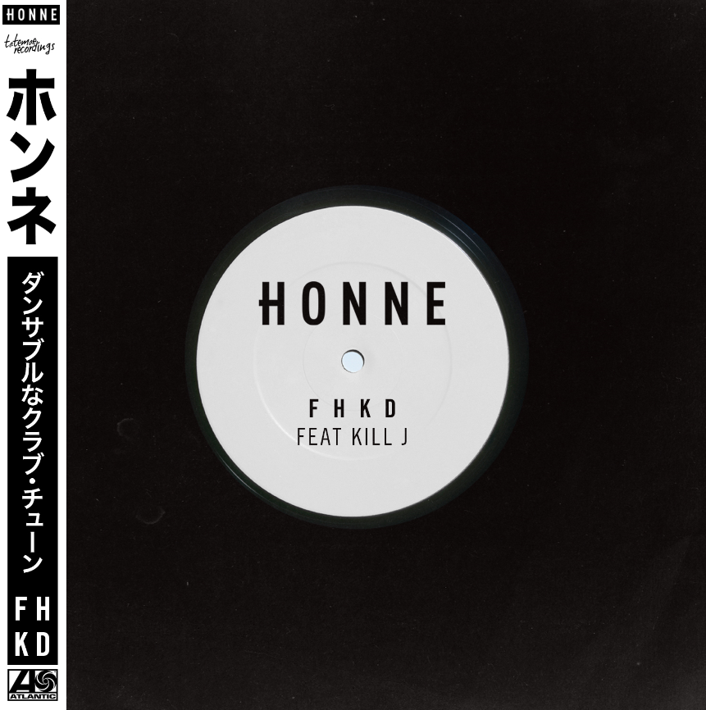
Praise for 'Warm On A Cold Night'
“This steamy upstart electro-soul duo, a growing phenomenon in their native London, purr both sweet nothings over lusty beats and scorched-earth breakup paeans over inversely smooth R&B from New Edition’s playbook.” —NEW YORK TIMES

“Smooth, velvety…intoxicating" —FADER

“…soulful and skittish electronic…” —NOISEY

“[HONNE]…attracted us with their sultry odes to romance.” —NYLON

“…laidback, effortlessly cool...” —PASTE

HONNE have released a special collaborative version of 'FHKD' with KILL J, the original of which closes their critically-acclaimed debut album 'Warm On A Cold Night' (out now via Atlantic Records). Following a breakout festival run and sold-out shows across the US and Europe, an extensive worldwide tour is on sale now. The UK duo have achieved impressive touring triumphs, having sold out shows in many cities visited – including NYC 4x (Bowery Ballroom, Webster Hall, Mercury Lounge, Rough Trade), Los Angeles 2x (Troubadour, El Rey Theatre), Chicago 2x (Schubas, Lincoln Hall), + San Francisco (Rickshaw Shop), San Diego (The Casbah) and Toronto 2x (The Garrison, Mod Clubs). HONNE performed at 7 showcases including the FADER Fort during their first South by Southwest and will return to Texas for Austin City Limits this year. Details of HONNE's next official single will follow soon.

Describing the collaboration with KILL J, HONNE write: 'FHKD is one of our favourite tracks on the album and we always thought it would be good to get a feature on it. KILL J's voice is so unique and interesting and we felt it was the perfect match for what is one of our more electronic/dance orientated tracks. She's added a really fresh flavour to this track.'

HONNE's universal, positive portraits of twenty-first century romance have quickly won them a broad global audience: both parallel to - and a stark reaction against - the sometimes-brutal modern dating climate (“we were terrible at being single,” the band say now). Released this summer, 'Warm On A Cold Night' is a record where expressing feelings may not come naturally, but nonetheless strives for real love in the digital age. In one year, the duo amassed 55M streams globally and currently over 700K a week in the US alone.
HONNE are singer Andy and multi-instrumentalist James, who first bonded over their shared upbringing in South-West England; then, the more evocative, US West Coast grooves of their record collections, and a mutual fascination with Japan. During a midnight re-watching of ‘Lost in Translation’, it became apparent that this sense of a partner at a loose end - of wandering through a strange environment, and struggling to convey what you mean - was just as relevant to their lives off-screen. When James found the word ‘Honne’ later on (a Japanese phrase meaning ‘true feelings’), the boys knew it was theirs. The first song HONNE ever finished, 'Warm On A Cold Night', now titles their stunning debut album. And between the millions of stream and sell-out shows since then, the soulful duo have carved out an instantly-identifiable sound all of their own.

Live dates:
10/1/16 – Austin City Limits – Austin, TX
10/03/16 – Aisle 5 - Atlanta, GA**
10/04/16 – Cat’s Cradle Back Room – Carrboro, NC**
10/5/16 – Warsaw – Brooklyn, NY**
10/07/16 – Paradise – Boston, MA**
10/10/16 - Valley Bar – Phoenix, AZ*
10/11/16 – Soho Music Club – Santa Barbara, CA*
10/12/16 – UC San Diego / The Loft – La Jolla, CA*
10/14/16 – Fonda Theater – Los Angeles, CA*
10/15/16 – Treasure Island Festival – San Francisco, CA
10/17/16 – The Crocodile – Seattle, WA***
10/18/16 – Biltmore Cabaret – Vancouver*** (SOLD OUT)
10/19/16 – Wonder Ballroom – Portland, OR***
*support act Ravyn Lenae
**support act Max Frost
***support act Pat Lok

Connect:
www.soundcloud.com/helloHONNE
www.facebook.com/helloHONNE
www.twitter.com/helloHONNE

HONNE 本音 :: one’s true feelings and desires

For more information please contact:
Jordan Danielle Frazes (National) / jordan.frazes@atlanticrecords.com
Jessica Nall (Tour) / jessica.nall@atlanticrecords.com

