LONDON-BASED DUO HONNE PREMIERE FIRST TRACK “JUST DANCE” FROM FORTHCOMING SOPHOMORE ALBUM!

WATCH/POST: HERE
BUY/STREAM: HERE

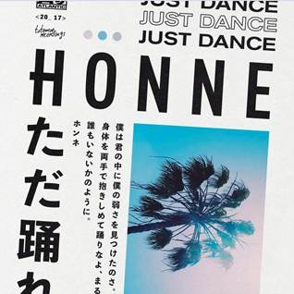

“This steamy upstart electro-soul duo purr sweet nothings over lusty beats” – New York Times
"A record of sleek, understated electronic pop” – The FADER
“Captivating music that flirts with funk and shines in its quieter moments…captivating and downright refreshing” – NYLON

HONNE surprise fans with a new track “Just Dance” – the soulful duo’s first new material since last year’s acclaimed debut record, “Warm On A Cold Night.” Currently hard at work on their second album for Atlantic Records, the band will pause briefly for a series of worldwide festivals this summer, including performances at Panorama, Lollapalooza, and Osheaga. Earlier this spring, the duo completed a 10-show West Coast run including a critically-acclaimed Coachella debut.

“Just Dance” is a thrilling testament to the restless creativity of HONNE, one of those rare bands who’ve achieved an instantly-identifiable sound entirely of their own making, but nonetheless appear intent on pushing forward towards something fresh and new. Blending their nuanced knowledge of R&B, hip-hop, and soul with a love of disco and house-inspired grooves (see Kaytranada, Anderson .Paak), “Just Dance” offers listeners a clear reminder of who HONNE are, and a glimpse of where their sound is headed.

Ultimately, “Just Dance” is a song about losing one’s inhibitions, from two songwriters and producers who’ve often captured precisely what is to feel inhibited (and a culture in which expressing your feelings as men may not come naturally). HONNE’s debut album – “Warm On A Cold Night” – amassed a truly global audience with its sometimes-awkward, always-positive portraits of 21st century romance. From performances at iconic venues including The Regency Ballroom and Roxy Theatre, to building an extensive following across the US, Europe and Asia (the album is double-platinum in Korea), to racking up over 240 million global streams – HONNE’s story looks set to travel further still on Album 2, which the band is currently hard at work on.

“‘Just Dance,’ for us, is a song about losing your inhibitions,” say HONNE. “‘Dance like you are with nobody’ pretty much sums up the feel we wanted for the track. Relentlessly energetic and ready to go until the early hours.” Where HONNE will go next may be uncertain, but “Just Dance” demands to take you with them.

Live Dates:
July 28th Brooklyn, NY @ Panorama Festival
Aug. 2nd Chicago, IL @ The Vic Theatre (w/ Foster The People)
Aug. 3rd Chicago, IL @ Lollapalooza
Aug. 5th Montréal, Canada @ Osheaga Festival
Sept. 3rd Seattle, WA @ Bumbershoot
Nov. 19th Mexico City, MX @ Corona Capital

Connect with HONNE:
www.soundcloud.com/helloHONNE
www.facebook.com/helloHONNE
www.twitter.com/helloHONNE
Press Assets: http://press.atlanticrecords.com/honne/

HONNE 本音 :: one’s true feelings and desires

For more information please contact:
Jordan Danielle Frazes (National) / jordan.frazes@atlanticrecords.com
Jessica Nall (Tour) / jessica.nall@atlanticrecords.com

