FOR IMMEDIATE RELEASE

OCTOBER 26, 2021

**HONNE ANNOUNCE NORTH AMERICAN HEADLINING TOUR**

**ACCALIMED ELECTRO-POP DUO ANNOUNCE TOUR FOLLOWING**

**NEW ALBUM FEATURING KHALID, GRIFF, PINK SWEAT$, NIKI & MORE**

***LET’S JUST SAY THE WORLD ENDED A WEEK FROM NOW, WHAT WOULD YOU DO?***

**OUT NOW** [**HERE**](https://lnk.to/LJSTWEAWFN-WWYD)

**TICKETS ON SALE FRIDAY, OCTOBER 29 AT 10AM LOCAL TIME** [**HERE**](https://www.hellohonne.com/tour.php)

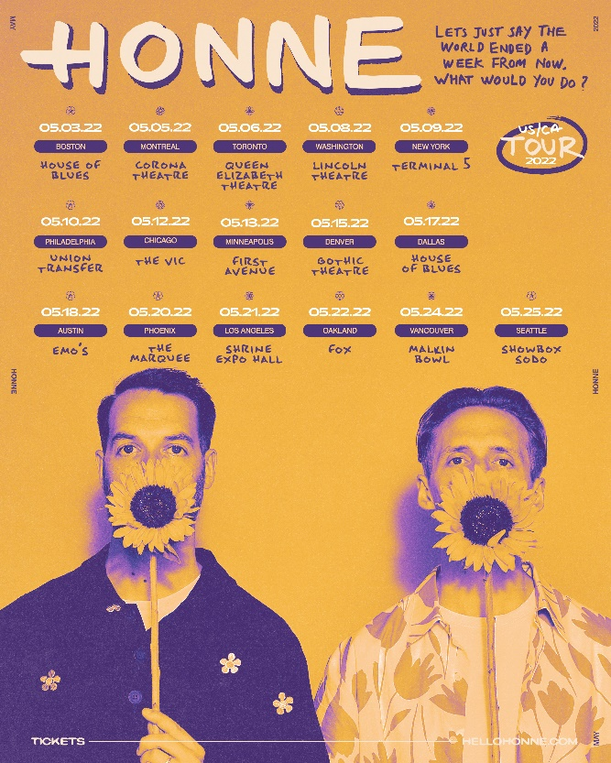

[DOWNLOAD ADMAT HERE](https://press.atlanticrecords.com/honne/)

*“This steamy upstart electro-soul duo purr sweet nothings over lusty beats”*

***– New York Times***

*“Everlasting pop bliss…”*

***-NYLON***

*"sleek, understated electronic pop”*

***– The FADER***

*“An inspiring and energised LP with a clear message”*

***– Dork***

*“This is the album we all need as we head into the darker days of winter”*

***– The Line Of Best Fit***

**HONNE** have announced their North American headlining tour. Starting in Boston, MA in early May 2022, the electro-pop duo will travel across North America in support of their new album [*Let’s Just Say The World Ended A Week From Now, What Would You Do?*](https://lnk.to/LJSTWEAWFN-WWYD). Presales begin Wednesday, October 27 at 10AM local time and general tickets go on sale Friday, October 29 at 10AM local time. For more information please visit: <https://www.hellohonne.com/tour.php>.

Written throughout the course of 2020, L*et’s Just Say The World Ended A Week From Now, What Would You Do?* captures HONNE in limitless full bloom – as songwriters, producers and collaborators. “In the past, we’ve limited ourselves”, HONNE explain. “We might get to a section of a song and things are getting really exciting, but we then pull ourselves back and say, ‘Can we *really* do that?’. Now, we’ve sidestepped the rules and done whatever we wanted to do.”

This sense of freedom permeates the tracklist, which is defined as much by its eye-catching collaborations **– Khalid** (‘Three Strikes’), BRITS Rising Star, **Griff** (‘Back On Top’), **88 Rising’s NIKI** (‘Coming Home’) – as it is by its musicianship, glistening pop feel and intelligent song-writing; Sam Smith & jazz prodigy **Reuben James** (‘Back On Top’), **MNEK** (‘Easy On Me’) and **Arlo Parks** (‘Now I’m Alone’) also co-wrote songs on the album.

Bold and ambitious, and boosted by a series of superb, thematic visuals for album singles [‘What Would You Do?’](https://www.youtube.com/watch?v=62nta49hxg8) ft. **Pink Sweat$** (directed by Ian Robertson) and [‘Coming Home’](https://www.youtube.com/watch?v=9MNQHxX-NE0) ft. **NIKI** (directed by Jay Green), ‘Let’s Just Say The World Ended A Week From Now, What Would You Do?’ brings together everything HONNE have worked towards so far, while simultaneously pushing their music into broad and exciting new spaces.

[DOWNLOAD ARTWORK HERE](https://press.atlanticrecords.com/honne/)

**HONNE NORTH AMERICAN TOUR**

**MAY 2022**

3 - Boston, MA - House of Blues

5 - Montreal, QC - Corona Theatre

6 - Toronto, ON - Queen Elizabeth Theatre

8 - Washington, DC - Lincoln Theatre

9 - New York, NY - Terminal 5

10 - Philadelphia, PA - Union Transfer

12 - Chicago, IL - Vic Theatre

13 - Minneapolis, MN - First Avenue

15 - Denver, CO - Gothic Theatre

17 - Dallas, TX - House of Blues

18 - Austin, TX - Emo's

20 - Tempe, AZ - Marquee Theatre

21 - Los Angeles, CA - Shrine Expo Hall

22 - Oakland, CA - Fox Theatre

24 - Vancouver, BC - Malin Bowl

25 - Seattle, WA - Showbox SoDo

**About HONNE**

London duo Andy Clutterbuck and James Hatcher – better known as HONNE  – have cultivated a huge and fiercely dedicated global fan base since the release of their critically-acclaimed debut LP, ‘Warm on a Cold Night’, in 2016. Boasting over 150 sold-out shows outside of the UK, collaborations with everyone from Tom Misch to BTS and almost 2 billion global streams, their music is deeply emotive; from the spiralling, sugar-coated highs of international hit ‘Day 1’ (lifted from 2018 album ‘Love Me / Love Me Not’), to the warm, acoustic glow of ‘no song without you’ – the first single to be lifted from last summer’s 14-track mixtape of the same name. Laying themselves bare in their songs, HONNE are also hyper-connected with fans both in the UK and all over the world – in 2018 alone for example, they played a sold-out Brixton Academy for the first time, embarked on an extensive, 26-date US headline tour and saw debut album ‘Warm on a Cold Night’ officially certified as 9x Platinum in South Korea. Their new album, ‘Let’s Just Say The World Ended A Week From Now, What Would You Do?’, is out now – listen to it [HERE](https://lnk.to/LJSTWEAWFN-WWYD).

CONNECT WITH HONNE:  
 [Facebook](https://toastpress.us1.list-manage.com/track/click?u=4e1e2dbf318b66a015b7b5f9f&id=8cc7f10d1c&e=faa9fabeae) / [Instagram](https://toastpress.us1.list-manage.com/track/click?u=4e1e2dbf318b66a015b7b5f9f&id=74ca83359b&e=faa9fabeae) / [Twitter](https://toastpress.us1.list-manage.com/track/click?u=4e1e2dbf318b66a015b7b5f9f&id=6a306ee523&e=faa9fabeae) / [YouTube](https://toastpress.us1.list-manage.com/track/click?u=4e1e2dbf318b66a015b7b5f9f&id=611a62d591&e=faa9fabeae)

For press inquiries, please contact:

Jessica Nall / [Jessica.Nall@atlanticrecords.com](mailto:Jessica.Nall@atlanticrecords.com)