FOR IMMEDIATE RELEASE

NOVEMBER 6, 2020



**HONNE RELEASE OFFICIAL VIDEO FOR**

**‘free love’**

**FEEL-GOOD SINGLE FEATURED ON THEIR ACCLAIMED NEW MIXTAPE**

**‘no song without you‘**



**WATCH** [**HERE**](https://www.youtube.com/watch?v=plVSnM1aFD4)

Following the release of their [‘no song without you (dream edits)](https://lnk.to/NSWY-DreamEdits)’ EP in October, **HONNE** are back with a special animated official video for standout track, ‘free love.’

Created by acclaimed animator [Holly Warburton](https://hollywarbs.com/), who also dreamt up short, animated videos for every track on **HONNE’S** [‘no song without you’](https://lnk.to/NSWY-mixtape) mixtape upon its release back in July, the video taps into the warm, fuzzy tones of the track itself and sees the band become fully immersed in the world Warburton created for them. **Watch it** [**HERE**](https://www.youtube.com/watch?v=plVSnM1aFD4).

Released in July, ‘no song without you‘ formed **HONNE’s** first material since the release of 2018 album, ‘Love Me / Love Me Not‘, and saw the band strip everything back to channel the psychedelic and infectious, care-free romanticism of the ‘60s. “It’s ok for things to sound a bit rough”, the duo explained, “rather than going into the studio and compressing guitars over and over. The more character that you leave in it, the more the listener can dive in.”

**HONNE** also released follow up EP, ‘no song without you (dream edits)’ in October - a six-track collection of mixtape favourites, including the title-track, ‘free love‘ and ‘by my side‘, reimagined. You can watch a special ‘london session‘ performance of [‘no song without you‘](https://www.youtube.com/watch?v=WXOlNBDVt0o), which was filmed at Tate Britain in September, [HERE](https://nam04.safelinks.protection.outlook.com/?url=https%3A%2F%2Fwww.youtube.com%2Fwatch%3Fv%3D5VwxjV7aQ-o&data=04%7C01%7CTomas.Fraser%40atlanticrecords.co.uk%7C4d45648b327d429cd51c08d8711c85fe%7C8367939002ec4ba1ad3d69da3fdd637e%7C0%7C0%7C637383714602941647%7CUnknown%7CTWFpbGZsb3d8eyJWIjoiMC4wLjAwMDAiLCJQIjoiV2luMzIiLCJBTiI6Ik1haWwiLCJXVCI6Mn0%3D%7C1000&sdata=5Uq1p6%2FaYKZPz5C%2F0rZj7ooQLeNIjUq3mvZcuOCFRuE%3D&reserved=0).

**‘no song without you‘ is out now:** [**https://lnk.to/NSWY-mixtape**](https://lnk.to/NSWY-mixtape)

**Watch the video for ‘free love’ here: INSERT LINK**

**PRAISE FOR HONNE:**

*“'no song without you' definitely conjures butterflies in the stomach…”-****ESQUIRE***

*“This steamy upstart electro-soul duo purr sweet nothings over lusty beats”* ***– NEW YORK TIMES***

*“Everlasting pop bliss…”* ***-NYLON***

*"sleek, understated electronic pop”****– The FADER***

*“Meet HONNE, the electro-soul duo of your dreams”* ***– L’OFFICIEL***

*“Over a breezy melody, HONNE sing of relying on loved ones for support…”-****UPROXX***

*“The title track of HONNE’s no song without you mixtape is a sweet, stripped-back lullaby that wraps around you like a warm blanket. …” -****IDOLATOR***

*“The psychedelic pop track is a mellow celebration of a specific, supportive love; the breezy atmosphere is an easy one to relax into”* ***– TEEN VOGUE***

*“a patient love song with emotional beats and purposeful lyrics”* ***– DUJOUR***

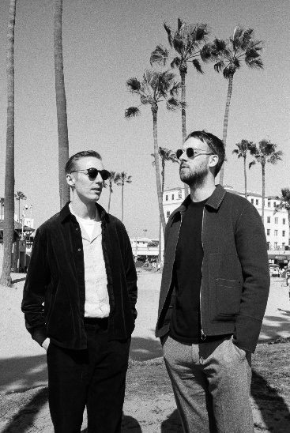

[**DOWNLOAD ARTWORK + PRESS PHOTOS HERE**](http://press.atlanticrecords.com/honne/)

**About HONNE**

London duo Andy Clutterbuck and James Hatcher – better known as HONNE – have cultivated a huge and fiercely dedicated global fan base since the release of their critically-acclaimed debut LP, ‘Warm on a Cold Night’, in 2016. Boasting over 150 sold-out shows outside of the UK, collaborations with everyone from Tom Misch to BTS and over 1.5 billion global streams, their music is deeply emotive; from the glistening, sugar-coated highs of international hit ‘Day 1’, to the heartache and angst played out on ‘Sometimes’ – both standout cuts from 2018’s sophomore record, ‘Love Me / Love Me Not’. Laying themselves bare in their songs, HONNE are hyper-connected with fans both in the UK and all over the world – in 2018 alone, they played a sold-out Brixton Academy for the first time, embarked on an extensive, 26-date US headline tour and saw ‘Warm on a Cold Night’ officially certified as 6x Platinum in South Korea.

**CONNECT WITH HONNE:**  
[Facebook](https://toastpress.us1.list-manage.com/track/click?u=4e1e2dbf318b66a015b7b5f9f&id=8cc7f10d1c&e=faa9fabeae) | [Instagram](https://toastpress.us1.list-manage.com/track/click?u=4e1e2dbf318b66a015b7b5f9f&id=74ca83359b&e=faa9fabeae)|[Twitter](https://toastpress.us1.list-manage.com/track/click?u=4e1e2dbf318b66a015b7b5f9f&id=6a306ee523&e=faa9fabeae)|[YouTube](https://toastpress.us1.list-manage.com/track/click?u=4e1e2dbf318b66a015b7b5f9f&id=611a62d591&e=faa9fabeae)

**PRESS CONTACT:**

Jessica Nall // [Jessica.Nall@atlanticrecords.com](mailto:Jessica.Nall@atlanticrecords.com)