

**HONNE RELEASE NEW ACOUSTIC EP**

***no song without you: dream edits***

**WATCH A SPECIAL LIVE PERFORMANCE OF**

**“no song without you‘** [**HERE**](https://www.youtube.com/watch?v=5VwxjV7aQ-o)

**LISTEN TO *no song without you: dream edits*** [**HERE**](https://lnk.to/NSWY-DreamEdits)

 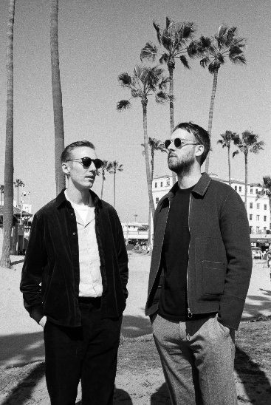

[**DOWNLOAD ARTWORK + PRESS PHOTOS HERE**](http://press.atlanticrecords.com/honne/)

**HONNE** are back with a new acoustic EP, ***no song without you: dream edits*** – a special reimagining of six standout tracks lifted from acclaimed mixtape, [*no song without you*](https://lnk.to/NSWY-mixtape) – listen to the new EP [HERE](https://lnk.to/NSWY-DreamEdits).

To coincide with the EP release, the band have also shared a special “london session” performance of title-track [‘no song without you,”](https://www.youtube.com/watch?v=WXOlNBDVt0o) which was filmed at Tate Britain in September – watch it [HERE](https://www.youtube.com/watch?v=5VwxjV7aQ-o).

Released in July, *no song without you* marked **HONNE’s** first release since their 2018 album*, Love Me / Love Me Not*, which saw the band strip everything back to channel the psychedelic and infectious, care-free romanticism of the ‘60s. “*It’s ok for things to sound a bit rough,”* the duo explained, *“rather than going into the studio and compressing guitars over and over. The more character that you leave in it, the more the listener can dive in.”*

Picking out six standout tracks from the mixtape, including the title-track, “free love” and “by my side,” the dream edits EP further crystalizes the musicianship **HONNE** demonstrated right across "no song without you,” and shines a light on their ability to deliver powerful and emotive live performances.

***no song without you: dream edits*** is out now via Tatemae Recordings/ Atlantic Records [**HERE**](https://lnk.to/NSWY-DreamEdits)

**PRAISE FOR HONNE:**

*“'no song without you' definitely conjures butterflies in the stomach…”-****ESQUIRE***

*“This steamy upstart electro-soul duo purr sweet nothings over lusty beats”* ***– NEW YORK TIMES***

*“Everlasting pop bliss…”* ***-NYLON***

*"sleek, understated electronic pop”****– The FADER***

*“Meet HONNE, the electro-soul duo of your dreams”* ***– L’OFFICIEL***

*“Over a breezy melody, HONNE sing of relying on loved ones for support…”-****UPROXX***

*“The title track of HONNE’s no song without you mixtape is a sweet, stripped-back lullaby that wraps around you like a warm blanket. …” -****IDOLATOR***

*“The psychedelic pop track is a mellow celebration of a specific, supportive love; the breezy atmosphere is an easy one to relax into”* ***– TEEN VOGUE***

*“a patient love song with emotional beats and purposeful lyrics”* ***– DUJOUR***

**About HONNE**

London duo Andy Clutterbuck and James Hatcher – better known as HONNE – have cultivated a huge and fiercely dedicated global fan base since the release of their critically-acclaimed debut LP, “Warm on a Cold Night,” in 2016. Boasting over 150 sold-out shows outside of the UK, collaborations with everyone from Tom Misch to BTS and over 1.5 billion global streams, their music is deeply emotive; from the glistening, sugar-coated highs of international hit “Day 1,” to the heartache and angst played out on “Sometimes” – both standout cuts from 2018’s sophomore record, *Love Me / Love Me Not*. Laying themselves bare in their songs, HONNE are hyper-connected with fans both in the UK and all over the world – in 2018 alone, they played a sold-out Brixton Academy for the first time, embarked on an extensive, 26-date US headline tour and saw “Warm on a Cold Night” officially certified as 6x Platinum in South Korea.

**CONNECT WITH HONNE:**  
[Facebook](https://toastpress.us1.list-manage.com/track/click?u=4e1e2dbf318b66a015b7b5f9f&id=8cc7f10d1c&e=faa9fabeae) | [Instagram](https://toastpress.us1.list-manage.com/track/click?u=4e1e2dbf318b66a015b7b5f9f&id=74ca83359b&e=faa9fabeae)|[Twitter](https://toastpress.us1.list-manage.com/track/click?u=4e1e2dbf318b66a015b7b5f9f&id=6a306ee523&e=faa9fabeae)|[YouTube](https://toastpress.us1.list-manage.com/track/click?u=4e1e2dbf318b66a015b7b5f9f&id=611a62d591&e=faa9fabeae)

**PRESS CONTACT:**

Jessica Nall // [Jessica.Nall@atlanticrecords.com](mailto:Jessica.Nall@atlanticrecords.com)