FOR IMMEDIATE RELEASE
AUGUST 18, 2021

HALESTORM IS “BACK FROM THE DEAD”;
BAND REVEALS FIRST SINGLE FROM ALBUM DUE NEXT YEAR;
“BACK FROM THE DEAD” VIDEO PREMIERED TODAY;
CO-HEADLINE TOUR WITH EVANESCENCE KICKS OFF NOV. 4

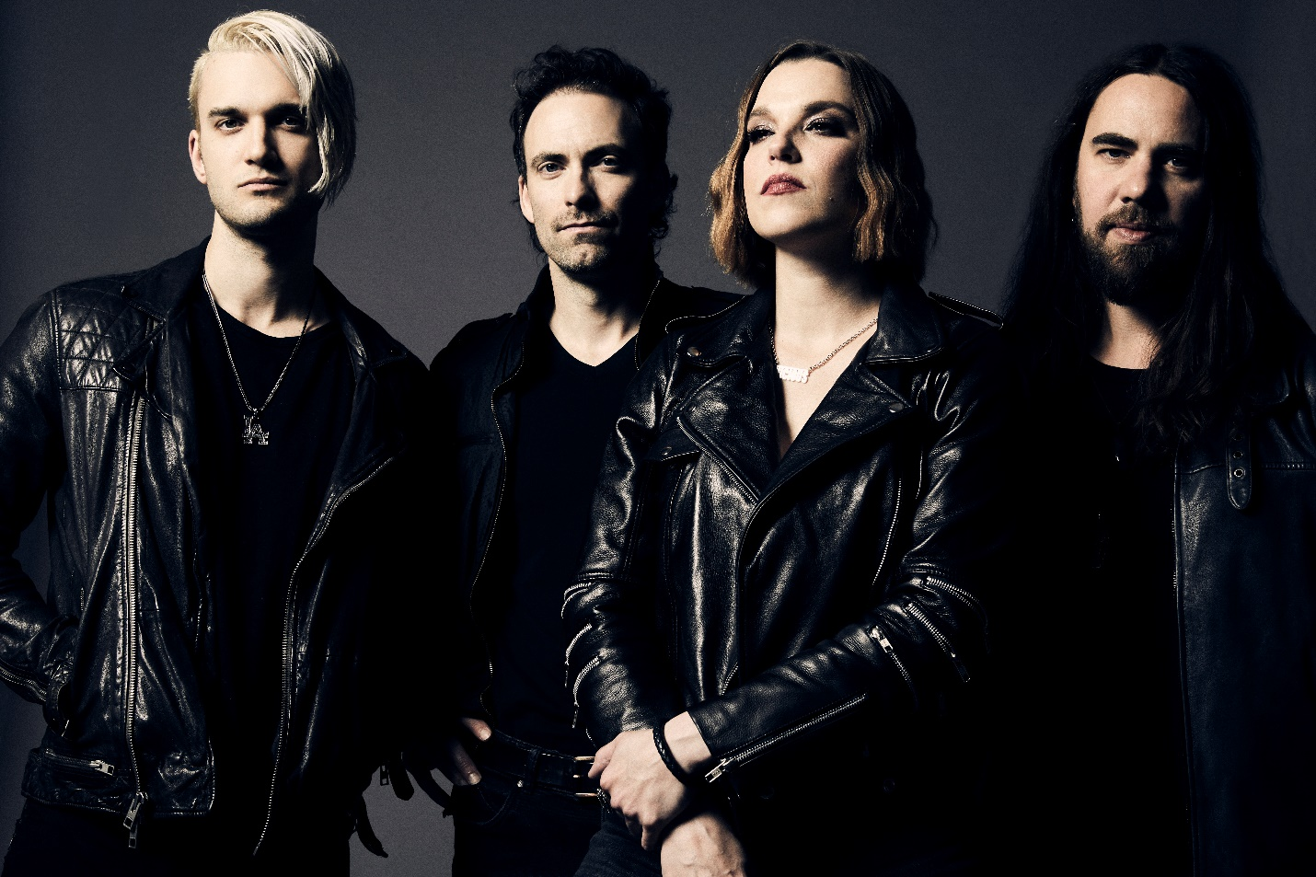
Photo credit: Jimmy Fontaine
Hi res artwork and press materials available here.

Stream “Back From The Dead” here.
Watch the video for “Back From The Dead” here.

Grammy-winning hard rock band Halestorm today revealed “Back From The Dead,” their first new song since 2018’s album Vicious, and the first single from an upcoming album due in 2022.

The video of “Back From The Dead” also premiered this morning via YouTube. Directed by Dustin Haney (Noah Cyrus, Luke Combs) and produced by Revolution Pictures, the clip features Lzzy and the band in a morgue and cemetery somewhere between life and death.

“’Back From the Dead’ is about survival, not in a physical sense, even though I know we all have been touched by death especially these last few years,” said Lzzy Hale. “This song is personal and written from a mental health perspective. I wanted to give myself and the world a hard rock song we could shout out loud as the gates opened again. I was on the edge of this world getting completely lost in oblivion, but even though it was the harder of two choices, I didn’t just let the darkness and depression in my mind dig me an early grave. I didn’t just sit and let it take me. I’ve erased my name from my headstone, so save your prayers, I’m back! I hope this song, as I pass it on to you, reminds YOU of your strength individually and that you are not alone.”

On August 31, Halestorm kicks off a series of headline dates and a set at Rocklahoma prior to a co-headline run with Evanescence beginning November 5 in Portland, OR, running through December 18 in Worcester, MA. Recently named the first female Brand Ambassador by Gibson Guitars, Lzzy Hale is currently on the cover of Pollstar with Evanescence frontwoman Amy Lee to celebrate the tour. Hale is also currently featured on “The Next Curse,” the latest song from alt rock band Slothrust, released last week.
***
Halestorm has grown from a childhood dream of siblings Lzzy and Arejay Hale into one of the most celebrated rock bands of the last two decades. Currently at work on their follow-up to 2018’s Vicious, Halestorm’s music has surpassed a billion streams worldwide. Called a “muscular, adventurous, and especially relevant rock record” by Rolling Stone, Vicious earned the band their second Grammy nomination, for Best Hard Rock Performance for the song “Uncomfortable,” the band’s fourth #1 at rock radio, and led Loudwire to name Halestorm “Rock Artist of the Decade” in 2019. Fronted by the incomparable Lzzy Hale with drummer Arejay Hale, guitarist Joe Hottinger, and bass player Josh Smith, Halestorm has earned a reputation as a powerful live music force, headlining sold-out shows and topping festival bills around the world, and sharing the stage with icons including Heaven & Hell, Alice Cooper, and Joan Jett.
HALESTORM
2021 FALL TOUR DATES

*denotes The Hu and Cory Marks supporting
Sept. 11 with Crobot supporting
Nov. 4 with Rival Sons and Dorothy supporting
^denotes co-headline with Evanescence
Nov. 17 with Plush supporting
Dec. 2-18 with Lilith Czar supporting

AUGUST
31 Syracuse, NY New York State Fairgrounds

SEPTEMBER
1 Lewiston, NY Art Park
3 Bonner Springs, KS Azura Amphitheater*
4 Camdenton, MO Ozarks Amphitheater*
5 Pryor, OK Rocklahoma
8 Asheville, NC Thomas Wolfe Auditorium, US Cellular Center*
9 Danville, VA Blue Ridge Rock Festival
11 Nashville, IN Brown County Music Center
12 Mansfield, OH Inkcarceration Festival 2021

NOVEMBER
4 Garden City, ID Revolution Concert House & Event Center
5 Portland, OR Veterans Memorial Coliseum^
7 Seattle, WA Seattle, WA^
9 San Jose, CA SAP Center at San Jose^
12 Las Vegas, NV The Chelsea, The Cosmopolitan of Las Vegas^
13 San Diego, CA Viejas Arena^
15 Phoenix, AZ Arizona Federal Theatre^
17 Salt Lake City, UT Union Event Center (The Union)
20 Fort Worth, TX Dickies Arena^
21 Houston, TX The Terminal^

DECEMBER
2 Duluth, GA Gas South Arena^
5 St. Louis, MO Chaifetz Arena^
8 Joliet, IL Rialto Square Theatre^
11 Detroit, MI Little Caesars Arena^
12 Cincinnati, OH Heritage Bank Center^
14 Pittsburgh, PA Petersen Events Center, University of Pittsburgh^
15 Newark, NJ Prudential Center^
17 Camden, NJ BB&T Pavilion^
18 Worcester, MA DCU Center^

For more information on Halestorm, visit and follow:
https://www.halestormrocks.com/
https://www.facebook.com/halestormrocks
https://twitter.com/halestorm
https://www.instagram.com/halestormrocks/
https://www.youtube.com/user/HalestormRocks

# # #

Contact:
Ashley White
Ashley White Public Relations
ashley@ashleywhitepr.com
(512) 436-9260

