FOR IMMEDIATE RELEASE
NOVEMBER 3, 2021

HALESTORM WISHES YOU “HAPPY HALE-I-DAYS”
GRAMMY-WINNING BAND TO STREAM SHOW DECEMBER 23;
TICKETS ON-SALE THIS FRIDAY, NOVEMBER 5TH;
“BACK FROM THE DEAD” IS #1 AT ROCK RADIO;
“UNPLUGGED” VERSION OUT TODAY;
CO-HEADLINE RUN WITH EVANESCENCE KICKS OFF FRIDAY
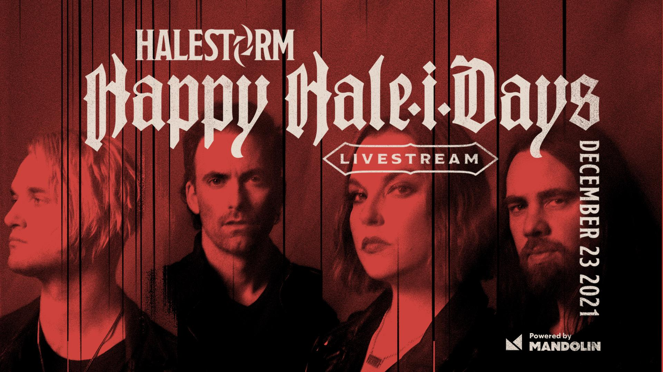
Photo credit: Jimmy Fontaine
Hi res artwork and press materials available here.

Stream “Back From The Dead (Unplugged)” here.
Concert stream and virtual meet and greet details are here.

Grammy-winning hard rock band Halestorm, who currently have the #1 rock song in the country with “Back From The Dead,” has announced a one-night-only streamed concert on December 23rd. Tickets for the “Happy Hale-i-days” concert stream, recorded in September at the Brown County Music Center in Nashville, IN, are available starting this Friday at Mandolin.com. A fan pre-sale is available starting tomorrow at Blabbermouth.

Today Halestorm also announced a second set of virtual meet and greets from their upcoming tour dates for fans who’d like a one-on-one experience with the band before they hit the stage, also available via Mandolin. Prior to the streamed concert on December 23rd, fans will also have the option to purchase tickets for a VIP Party an hour before showtime. For all details, visit Mandolin.com.

This week, Halestorm claimed their sixth #1 at rock radio with “Back From The Dead.” Today the band unveiled an acoustic, re-imagined version of the song. “Back From The Dead (Unplugged)” is available here.

“Back From The Dead” remains the first and only glimpse yet of Halestorm’s new album due in 2022. Rolling Stone called it “a biting, cathartic howler about overcoming obstacles -- even death,” and Consequence praised frontwoman Lzzy Hale’s “powerhouse pipes” and lead guitarist Joe Hottinger’s “blistering solo.” Revolver declared it a “raucous, hard-rock rager about staying strong in the face of crushing adversity.”

Halestorm begins their final leg of 2021 touring tomorrow night with a show in Garden City, Idaho, and on Friday the band joins with Evanescence to kick off the two bands’ arena co-headline tour in Portland, OR, running through December 18 in Worcester, MA. Tour dates are included below.

About Mandolin:
Mandolin helps artists and venues create connections with fans and prosper through the music they produce. We intentionally push the boundaries of livestream, giving artists the right tools to create content, share it widely, and then better understand how fans engage. Mandolin gives artists the ability to build a digital strategy, all while giving fans unprecedented access to the artists they love. Mandolin Live+ digitally amplifies in-person shows; turning every live fan into a digital fan, opening up opportunities only available in the virtual realm, and helping artists deepen fan relationships through data. To learn more about how Mandolin is transforming the music industry through hybrid events, visit mandolin.com or Facebook, Instagram, or Twitter. Brand Partnership Inquiries: kate@mandolin.com.

HALESTORM: 2021 FALL TOUR DATES
Nov. 4 with Rival Sons and Dorothy supporting
^denotes co-headline with Evanescence
Nov. 17 with Plush supporting
Dec. 2-18 with Lilith Czar supporting

NOVEMBER
4 Garden City, ID Revolution Concert House & Event Center
5 Portland, OR Veterans Memorial Coliseum^
7 Seattle, WA Climate Pledge Arena^
9 San Jose, CA SAP Center at San Jose^
10 Inglewood, CA YouTube Theatre^
12 Las Vegas, NV The Chelsea, The Cosmopolitan of Las Vegas^
13 San Diego, CA Viejas Arena^
15 Phoenix, AZ Arizona Federal Theatre^
17 Salt Lake City, UT Union Event Center (The Union)
18 Denver, CO Bellco Theatre^
20 Fort Worth, TX Dickies Arena^
21 Houston, TX The Terminal^
30 Tampa, FL Amalie Arena^

DECEMBER
2 Duluth, GA Gas South Arena^
3 Nashville, TN Bridgestone Arena^
5 St. Louis, MO Chaifetz Arena^
7 Minneapolis, MN The Armory^
8 Joliet, IL Rialto Square Theatre
11 Detroit, MI Little Caesars Arena^
12 Cincinnati, OH Heritage Bank Center^
14 Pittsburgh, PA Petersen Events Center, University of Pittsburgh^
15 Newark, NJ Prudential Center^
17 Camden, NJ BB&T Pavilion^
18 Worcester, MA DCU Center^

For more information on Halestorm, visit and follow:
https://www.halestormrocks.com/
https://www.facebook.com/halestormrocks
https://twitter.com/halestorm
https://www.instagram.com/halestormrocks/
https://www.youtube.com/user/HalestormRocks

# # #

Contact:
Ashley White
Ashley White Public Relations
ashley@ashleywhitepr.com
(512) 436-9260

