FOR IMMEDIATE RELEASE
NOVEMBER 15, 2019

HAYLEY KIYOKO DROPS IRRESISTIBLY CATCHY
NEW SINGLE “L.O.V.E. ME”

TRAILBLAZING POP STAR CONTINUES TO BUILD HER
I’M TOO SENSITIVE FOR THIS SHIT PROJECT

KIYOKO’S “I’M TOO SENSITIVE FOR THIS SHIT TOUR” KICKS OFF JANUARY 2020

LISTEN TO “L.O.V.E ME” HERE
WATCH “L.O.V.E. ME” LYRIC VIDEO HERE

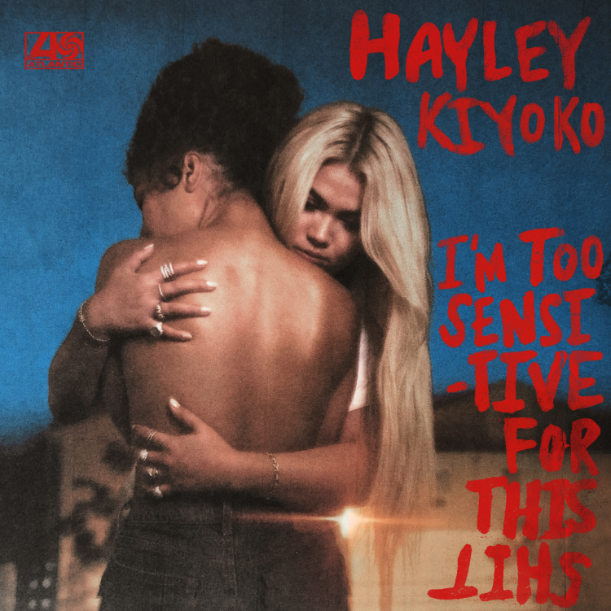
DOWNLOAD PHOTOS HERE

Boundary-breaking pop star Hayley Kiyoko is back with a new single “L.O.V.E Me” available now via Atlantic Records at all DSPs and streaming services HERE. The infectious and upbeat track shows Kiyoko’s playful side as she begs for her crush’s love and attention over a beat you can’t help but dance to. The track comes paired with a vibrant lyric video, watch it HERE.

“L.O.V.E. Me” is the newest addition to Hayley’s unapologetic body of work I’M TOO SENSITIVE FOR THIS SHIT, which includes previously released hit singles “I Wish” and “Demons.” The full project will continue to build up to a January 2020 release date, just ahead of Hayley’s massive nationwide headline tour.

“’L.O.V.E. Me’ is a song I’ve been trying to write for years!! I’m very protective of my personal life but admittedly I’m a big romantic at heart. ‘L.O.V.E. Me’ captures what it feels like to fall head over heels and want to shout from the rooftops about it. It’s showcasing the classic struggle we sometimes face when someone tells you they love you in private, but is too scared to express that love publicly. I hope this song brings some relatability to anyone who is craving that declaration of love.”
-Hayley Kiyoko

In January, Hayley will take her empowered and electrifying live show on an epic “I’m Too Sensitive For This Shit” North American headlining tour featuring a stop at NYC’s Terminal 5 on February 20th and culminating with a performance at LA’s Palladium on March 13th. In addition to her headlining tour, Hayley will also appear at multiple festivals including the recently announced Lollapalooza South America. For additional information and tickets please visit http://www.hayleykiyokoofficial.com/.

This week, the LGBTQ icon will be honored with the “Youth Innovator Award” at The Trevor Project’s TrevorLIVE Los Angeles Gala on November 17th for her work using her voice in the music industry to shine a light on marginalized communities. This thrilling recognition follows Kiyoko’s first-ever Billboard Magazine cover which hit stands in August and also featured Tegan Quin, Adam Lambert, Big Freedia and ILoveMakonnen.

“L.O.V.E Me”, “Demons” and “I Wish” mark Hayley’s first releases since her breakthrough debut album EXPECTATIONS, which dropped in March of last year and was widely celebrated by fans and critics alike as one of #20GAYTEEN’s best albums. According to Rolling Stone, EXPECTATIONS placed her “at the forefront of an unapologetically queer pop movement.” In #20GAYTEEN, Kiyoko was nominated for two VMAs where she performed “Curious” and won Push Artist Of The Year. Since her 2015 debut, Hayley has amassed over 300 million global streams, have 1.8 million YouTube subscribers and has accrued over 350 million lifetime YouTube views. She took her captivating live performance on the road for a nationwide headline tour, Coachella festival debut and support during Panic! At The Disco’s North American arena tour. On top of stunning on the covers of NYLON and PAPER, Kiyoko was named to NPR’s list “The 21st Century's Most Influential Women Musicians,” and was honored with the Rising Star Award at Billboard’s annual Women in Music event.

CONNECT:
WEBSITE | FACEBOOK | TWITTER | INSTAGRAM | YOUTUBE | PRESS ASSETS

PRESS CONTACTS:
Chelsey Northern/Atlantic Records (NATIONAL)
chelsey.northern@atlanticrecords.com

Andrew George/Atlantic Records (TOUR/ONLINE)
andrew.george@atlanticrecords.com

HAYLEY KIYOKO
2020 NORTH AMERICAN
“I’M TOO SENSITIVE FOR THIS SHIT” TOUR

JANUARY
29 -- San Diego, CA -- SOMA
30 -- Las Vegas, NV -- House of Blues

FEBRUARY
1 -- Phoenix, AZ -- The Van Buren
3 -- Dallas, TX -- South Side Ballroom
4 -- Austin, TX -- Stubb’s Waller Creek Amphitheater
5 -- Houston, TX -- Revention Music Center
7 -- New Orleans, LA – The Fillmore
9 -- Nashville, TN -- Marathon Music Works
10 -- Raleigh, NC -- The Ritz
11 -- Atlanta, GA -- Tabernacle
13 -- Silver Spring, MD -- The Fillmore
15 -- Philadelphia, PA -- The Fillmore
17 -- Boston, MA -- House of Blues
20 -- New York, NY – Terminal 5
22 -- Montreal, QC -- MTELUS
24 -- Toronto, ON -- Rebel
26 -- Detroit, MI – The Fillmore
28 -- Chicago, IL – Byline Bank Aragon Ballroom
29 -- Louisville, KY -- Old Forester's Paristown Hall

MARCH
1 -- St. Louis, MO -- The Pageant
3 -- Minneapolis, MN – The Fillmore
5 -- Denver, CO -- Fillmore Auditorium
6 -- Salt Lake City, UT -- The Complex
8 -- Seattle, WA -- Showbox SoDo
10 -- Portland, OR -- Crystal Ballroom
12 -- San Francisco, CA -- Masonic Theater
13 -- Los Angeles, CA -- Hollywood Palladium

# # #

