**HAYLEY KIYOKO COMPLETES *I’M TOO SENSITIVE FOR THIS SHIT* WITH “SHE”**

**GROUNDBREAKING POP STAR SHARES THE FINAL SINGLE FROM HER**

**INNOVATIVE PROJECT *I’M TOO SENSITIVE FOR THIS SHIT***

**EMPOWERED NEW SONG ARRIVES ALONGSIDE**

**NOSTALGIC AND PLAYFUL SELF-DIRECTED VIDEO**

**LISTEN TO “SHE”** [**HERE**](https://Atlantic.lnk.to/ITSFTS)

**WATCH THE MUSIC VIDEO** [**HERE**](https://Atlantic.lnk.to/WatchShe)

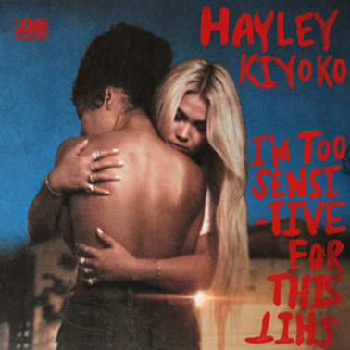 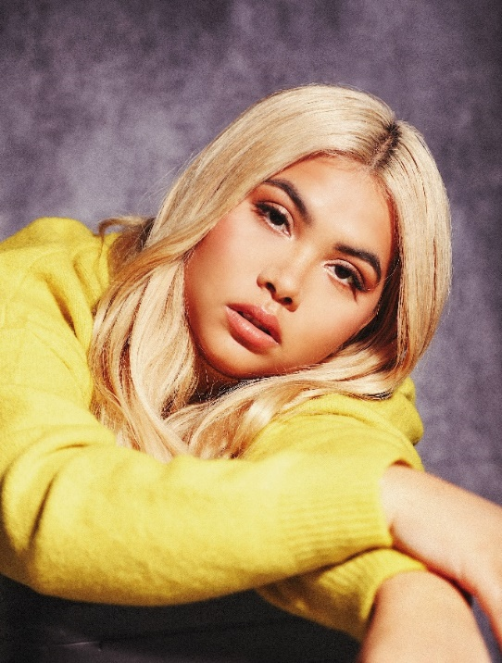

([Download High Res Art](https://warnermusicgroup.app.box.com/s/76fgxkt7osjqcvbz68o88tv4mns5ke5v) // Photo Credit: Amanda Charchian)

([Download Hi Res Press Photo](https://warnermusicgroup.app.box.com/s/es0yd7syz1mpqcuazxz1tix9xbbx0ura) // Photo Credit: Trevor Flores)

*“At this point it's clear, there is no filler to be had on this project. None.” –*[**E! ONLINE**](https://www.eonline.com/news/1102687/the-mixtape-presents-harry-styles-dua-lipa-and-more-new-music-musts)

*“Lesbian Jesus has blessed us with another bop” –* [**NYLON**](https://nylon.com/soundcheck-12-14-2019)

*“[L.O.V.E. Me is] an irresistible earworm*.” *–*  [**ELLE**](https://nam04.safelinks.protection.outlook.com/?url=https%3A%2F%2Fwww.elle.com%2Fculture%2Fmusic%2Fa29808423%2Fhayley-kiyoko-love-me-interview%2F&data=02%7C01%7CMegan.Rasmussen%40atlanticrecords.com%7C6f3855bd2fe449e7b43008d77ea316b7%7C8367939002ec4ba1ad3d69da3fdd637e%7C0%7C0%7C637117111229872058&sdata=bGGy3u5S%2FVIXeu%2FJzVt3BZf6ooZBWmdFg6DTgkx28E4%3D&reserved=0)

**Hayley Kiyoko** has shared “**she**,” the final single on her bold and brave ***I’M TOO SENSITIVE FOR THIS SHIT*** project. On the upbeat anthem, the trailblazing pop star sings about self-empowerment and knowing your self-worth. “she” is available now [HERE](https://Atlantic.lnk.to/ITSFTS).

*“’She’ is an unofficial anthem to keep me going through the hard times when I’m unsure of myself. I wrote this song as a tribute to embracing your dreams and being unafraid to live fully in your truth without regrets. To NOT be ashamed of being a strong, vulnerable, hardworking woman who knows what she wants, and who won't let anyone or anything stop her from chasing her dreams.”*

– Hayley Kiyoko on “she”

The inspiring new song comes with a one-shot nostalgic and playful self-directed music video. Filled with WordArt, lava lamps, posters covering every single wall and even a cameo from **N’SYNC’s Lance Bass**, Hayley takes us back to her childhood bedroom during a time when “Lesbian Jesus” was a mere figment of imagination beyond her wildest dreams. While extremely relatable, the visual is also a note to the popstar’s younger self and a beautiful reminder for all of us to keep dreaming and to be kind to our younger selves.Watch the video [HERE](https://Atlantic.lnk.to/WatchShe).

*“I used to be so embarrassed of who I was, what I liked and what I looked like*. *While I always felt good expressing myself by experimenting with my hairstyles and fashion, I never really felt like I fit in. Never in my wildest dreams did I think that my biggest insecurities would be the best parts of who I am today. This video celebrates that young, insecure girl that I used to be, who struggled with self-doubt but always dreamt big. It's a love letter to all the young people out there who are still dreaming.  I hope this video inspires people to have faith that their struggles today will give them strength for tomorrow.”*

– Hayley Kiyoko on “she” Official Music Video

Hayley first announced ***I’M TOO SENSITIVE FOR THIS SHIT*** in October. The unapologetic body of work also features previously released tracks “[runaway](https://Atlantic.lnk.to/ITSFTS)” “[L.O.V.E Me](https://Atlantic.lnk.to/ITSFTS),”  “[Demons](https://Atlantic.lnk.to/ITSFTS),” and “[I Wish](https://Atlantic.lnk.to/ITSFTS).” Sonically upbeat yet lyrically intimate, Kiyoko has been delivering these new songs in real time, continuing to break ground as she lets listeners in on the most vulnerable parts of her life. Dropping new music each month, the full project is now complete with the release of “she.” See complete tracklisting below.

Hayley will also be releasing an exclusive *I’M TOO SENSITIVE FOR THIS SHIT* vinyl, available only at Urban Outfitters. The apple-red colored vinyl will be available January 24, pre-order it now [HERE](https://www.urbanoutfitters.com/shop/hayley-kiyoko-im-too-sensitive-for-this-s-limited-lp?category=vinyl-records-cassettes&color=060&type=REGULAR).

Last month, Hayley Kiyoko returned to host *Billboard’s* 14th Annual “Women in Music” event after being honored with the Rising Star Award in 2018. Watch a highlight from her moving opening speech [HERE](https://www.youtube.com/watch?v=CkPjWDwV-tw). Recently, the LGBTQ icon was honored with the “Youth Innovator Award” at The Trevor Project’s TrevorLIVE Los Angeles Gala and landed her first-ever [Billboard Magazine](https://nam04.safelinks.protection.outlook.com/?url=https%3A%2F%2Fwww.billboard.com%2Farticles%2Fnews%2Fpride%2F8526156%2Fpride-roundtable-lgbtq-trailblazers-billboard-cover-story-2019&data=02%7C01%7CMegan.Rasmussen%40atlanticrecords.com%7C6f3855bd2fe449e7b43008d77ea316b7%7C8367939002ec4ba1ad3d69da3fdd637e%7C0%7C0%7C637117111229882054&sdata=FReG6E3RuLR59%2BbF8Bg0p8UeAnGOQGFIMg5OybZPmTA%3D&reserved=0) cover which hit stands in August and also featured Tegan Quin, Adam Lambert, Big Freedia and ILoveMakonnen.

*I’M TOO SENSITIVE FOR THIS SHIT*marks Hayley’s first new project since her breakthrough debut album [*EXPECTATIONS*](https://nam04.safelinks.protection.outlook.com/?url=https%3A%2F%2Fatlantic.lnk.to%2FExpectations&data=02%7C01%7CMegan.Rasmussen%40atlanticrecords.com%7C6f3855bd2fe449e7b43008d77ea316b7%7C8367939002ec4ba1ad3d69da3fdd637e%7C0%7C0%7C637117111229882054&sdata=sMjr6hLomVBIyh5dQ1rm0Mp9MoyNnpTKmd9ZMwZNpp4%3D&reserved=0)*,* which dropped in March of last year and was widely celebrated by fans and critics alike as one of #20GAYTEEN’s best albums. According to *Rolling Stone*, [*EXPECTATIONS*](https://nam04.safelinks.protection.outlook.com/?url=https%3A%2F%2Fatlantic.lnk.to%2FExpectations&data=02%7C01%7CMegan.Rasmussen%40atlanticrecords.com%7C6f3855bd2fe449e7b43008d77ea316b7%7C8367939002ec4ba1ad3d69da3fdd637e%7C0%7C0%7C637117111229892055&sdata=fQHKTp9qRwMG6dIDzUO8VIxbPTLFjQiiom2Ap2XHKu0%3D&reserved=0) placed her “*at the forefront of an unapologetically queer pop movement*.” In #20GAYTEEN, Kiyoko was nominated for two VMAs where she performed “Curious” and won Push Artist Of The Year. Since her 2015 debut, Hayley has amassed over 366 million global streams, has 1.8 million YouTube subscribers and has accrued over 350 million lifetime YouTube views. She took her captivating live performance on the road for a nationwide headline tour, Coachella festival debut and support during Panic! At The Disco’s North American arena tour. On top of stunning on the covers of *NYLON* and *PAPER*, Kiyoko was named to *NPR*’s list of the “The 21st Century's Most Influential Women Musicians,” and was honored with the Rising Star Award at *Billboard*’s Women in Music event where she returned to host last month.

**CONNECT:**

[WEBSITE](https://nam04.safelinks.protection.outlook.com/?url=http%3A%2F%2Fwww.hayleykiyokoofficial.com%2F&data=02%7C01%7CMegan.Rasmussen%40atlanticrecords.com%7C6f3855bd2fe449e7b43008d77ea316b7%7C8367939002ec4ba1ad3d69da3fdd637e%7C0%7C0%7C637117111229892055&sdata=5AG%2BkZl2OPd5UwyyFlhpbUCyK%2BcpySbnpbl1fZXMVPU%3D&reserved=0) | [FACEBOOK](https://nam04.safelinks.protection.outlook.com/?url=https%3A%2F%2Fwww.facebook.com%2FHayleyKiyoko%2F&data=02%7C01%7CMegan.Rasmussen%40atlanticrecords.com%7C6f3855bd2fe449e7b43008d77ea316b7%7C8367939002ec4ba1ad3d69da3fdd637e%7C0%7C0%7C637117111229902043&sdata=A7HReDNexKdvN3SDgpQPfZAdmijMaazNRf1ruDcdEjs%3D&reserved=0) | [TWITTER](https://nam04.safelinks.protection.outlook.com/?url=https%3A%2F%2Ftwitter.com%2FHayleyKiyoko&data=02%7C01%7CMegan.Rasmussen%40atlanticrecords.com%7C6f3855bd2fe449e7b43008d77ea316b7%7C8367939002ec4ba1ad3d69da3fdd637e%7C0%7C0%7C637117111229902043&sdata=oPen%2FXIvwOOIvQXxeRtbuqBUER803Qkz48437EreQ8U%3D&reserved=0) | [INSTAGRAM](https://nam04.safelinks.protection.outlook.com/?url=https%3A%2F%2Fwww.instagram.com%2Fhayleykiyoko%2F&data=02%7C01%7CMegan.Rasmussen%40atlanticrecords.com%7C6f3855bd2fe449e7b43008d77ea316b7%7C8367939002ec4ba1ad3d69da3fdd637e%7C0%7C0%7C637117111229912040&sdata=FQoLEGWMiQkZgZlPZ3C42lVj5Nzkyg2ZgKByh%2F65h1M%3D&reserved=0) | [YOUTUBE](https://nam04.safelinks.protection.outlook.com/?url=https%3A%2F%2Fwww.youtube.com%2Fchannel%2FUC00X4AUEmat8Pk772tDu8OA&data=02%7C01%7CMegan.Rasmussen%40atlanticrecords.com%7C6f3855bd2fe449e7b43008d77ea316b7%7C8367939002ec4ba1ad3d69da3fdd637e%7C0%7C0%7C637117111229912040&sdata=g%2BRflAT1XBamt%2Fmt%2BZF9lr2WQCB4pLZgv6mX9mYAGmk%3D&reserved=0) | [PRESS ASSETS](https://nam04.safelinks.protection.outlook.com/?url=http%3A%2F%2Fpress.atlanticrecords.com%2Fhayley-kiyoko%2F&data=02%7C01%7CMegan.Rasmussen%40atlanticrecords.com%7C6f3855bd2fe449e7b43008d77ea316b7%7C8367939002ec4ba1ad3d69da3fdd637e%7C0%7C0%7C637117111229922030&sdata=3gdHZsvgfwc1AUi%2Bib49HBm8SSJmkfFX%2BXuSTc6D3aI%3D&reserved=0)

**PRESS CONTACTS:**

Chelsey Northern/ [chelsey.northern@atlanticrecords.com](mailto:chelsey.northern@atlanticrecords.com)

Andrew George / [andrew.george@atlanticrecords.com](mailto:andrew.george@atlanticrecords.com)

***I’M TOO SENSITIVE FOR THIS SHIT***

**OFFICIAL TRACKLIST**



1. “she”
2. “runaway”
3. “L.O.V.E. Me”
4. “Demons”
5. “I Wish”

###