ILLITERATE LIGHT PROCLAIMS “I WANNA LEAVE AMERICA”
(RELEASES LIVE PERFORMANCE FROM SOLD-OUT SHOW AT DC9)

HIGH-ENERGY RECORDING + VISUAL ADD TO
“IN THE MOMENT” LIVE SERIES

WATCH: https://illiteratelight.lnk.to/IWLALive/youtube
BUY/STREAM: https://illiteratelight.lnk.to/IWLALive

“an explosive mission statement from a band that’s here to stay”
NPR 2020 ARTIST TO WATCH

“The promising Virginia-based duo has an ambition that is promising at a time when rock needs it.”
“two guys, in the moment, playing their respective rigs; no substitutions”
SPIN

“Illiterate Light’s live show is its own idiosyncratic phenomenon”
RELIX

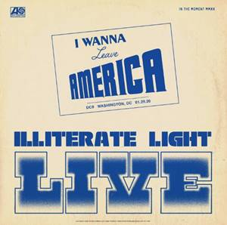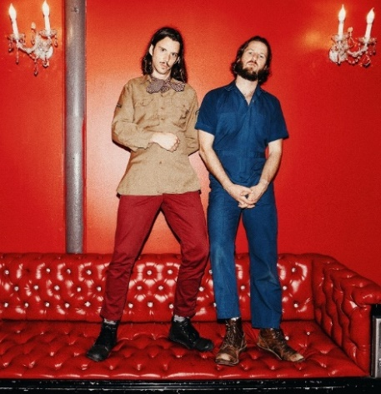
download artwork download hi-res press photo

Alternative folk-rock duo Illiterate Light admits “I Wanna Leave America” -- releasing a high-energy live version of their fan-favorite track. While today’s audio and thrilling performance visual for “I Wanna Leave America (Live from DC9)” (watch here) was captured months ago during a sold-out DC show in January, its release comes at a poignant time for Americans.

This song always takes on a life of its own when we play it in our nation’s capital. We are firm believers in building the world and culture that we want to be a part of. The opening line (“I Wanna Leave America”) was just the feeling and the phrase that many people with a reasonable moral conscience felt after the 2016 election. This song is about waking up and trusting the heart-space, which is the path to love, which is what we need more of in our country and politics.

We live in a democracy, and it’s a beautiful thing that we get to vote in our elections. However, we would encourage all of us to think about how we vote every day; with our money, with our lifestyle, with our words, with our thoughts. The revolution doesn’t happen by casting a ballot every 4 years. It starts with our conscious awareness and daily lives and decisions and permeates the universe from there. This November let’s vote for the candidate that is going to bring peace and justice into a divided country, but let’s also vote every day and create the world we want to live in. We can do it. It is possible.

Enjoy the passionate performance and be sure to head to http://headcount.org to register to vote ya’ll.

The track adds to Illiterate Light’s live series “In The Moment,” which the band has been building out with recordings + videos from their incredible live shows. While originally begun back in January, the series has taken on new meaning over the last couple of months – becoming a tribute to the power of the live performances and the community formed during shows – something all music fans are so desperately missing.

The past two releases – “Thank You Too!” & “Carolina Lorelei” – both came from the sold-out performance at The Basement East. In May, the band released a live version of “Sometimes Love Takes So Long,” recorded during a sold-out show at Allston’s Great Scott. Somewhat cosmically, the long-planned release came just days after Great Scott’s owners announced the venue would sadly not be re-opening its doors, making the video an homage of sorts to the historic club and leading local Boston outlet Vanyaland to declare: “this Great Scott capture is something special.”

To kick off the “In The Moment” series, the band released a spirited cover of Neil Young’s “Vampire Blues,” which has become a fan favorite during their live shows (watch here). Their second release, a live version of “Nuthin’s Fair,” premiered on Relix with the outlet declaring: “Indie-fuzz duo Illiterate Light have been on a whirlwind since the release of their eponymous debut album… a new live video from the band showcases their DIY roots and their hometown venue The Golden Pony.” In March, the band released “In The Ground” which was aptly described by SPIN as: “two guys, in the moment, playing their respective rigs; no substitutions.”

download hi-res "I Wanna Leave America" artwork
After sold-out shows this fall in Richmond and Harrisonburg, VA, the duo kicked off a North American headline tour at the end of January – playing to sold out rooms in Washington DC, Philadelphia, Boston, and an enraptured crowd at Brooklyn’s Rough Trade. They also performed live sessions for both Relix and Paste. After attending their show in Minneapolis, Chris Riemenschneider (music critic at the Star-Tribune) declared: “Bounced from the fancy new Fillmore to the grimy old Entry last night and caught a young band that could soon be too big for both rooms… They jammed through a killer Neil Young cover too.”

This year’s live shows followed heavy touring last year with Rainbow Kitten Surprise and The Head And The Heart – winning over crowds with their “hypnotic” (Billboard) performances and “electrifying” (Uproxx) stage presence. Despite being one of the festival’s earliest acts, they even received a standing ovation at Newport Folk Fest — “no small feat before noon,” the Boston Globe declared.

At the top of 2020, the duo was named to NPR’s “Slingshot Artists to Watch,” with the outlet featuring them amongst just 12 other artists “sure to do big things in 2020.” NPR specifically highlighted the duo’s “energetic live shows,” during which the two play a full band’s worth of instruments. “This isn’t a gimmick,” KTBG The Bridge’s Jon Hart continued, “the music on the duo’s self-titled release holds up.” NPR previously highlighted the group in their “Best Songs of 2019 (So Far),” declaring “Carolina Lorelai” to be “an explosive mission statement from a band that’s here to stay.”

In September, Relix named the band to their “5 Artists You Should Know,” asserting: “Illiterate Light’s live show is its own idiosyncratic phenomenon… from the booming psych-rock anthem ‘Growin’ Down’ to the atmospheric sing-along ‘Carolina Lorelai.’”

Illiterate Light’s single “Better Than I Used To” also received accolades from NPR, which declared it “a perfect addition to your summertime playlist.” The music video for “Better Than I Used To” was premiered via Billboard, which called it “a visual that translates the euphoric, restorative powers of love into a reverent and downright hypnotic experience.” The track cracked the Top 10 of the Adult Alternative chart at the top of 2020.

All of this comes on the heels of Illiterate Light’s self-titled debut album, released in October via Atlantic Records. Upon release, Uproxx heralded the album as a “refined vein of My Morning Jacket / Band of Horses-style Americana.” Focused around the alchemic collaboration and camaraderie between members Jeff Gorman (lead vocals, guitar, synth pedals he plays with his feet) and Jake Cochran (vocal harmonies, stand-up drum kit) and recorded with producers Adrian Olsen (Foxygen, Natalie Prass) and Vance Powell (Jack White, Kings Of Leon, Chris Stapleton), the album is part soaring indie rock, part swirling psychedelia, part atmospheric folk and — alongside critically acclaimed performances this summer at Bonnaroo, Newport Folk Festival, and Lollapalooza — signals their triumphant arrival as an emergent musical force.

###

CONNECT WITH ILLITERATE LIGHT
Facebook | Instagram | Twitter | Official Site

PRESS CONTACTS:
Libby Kober | Libby.Kober@AtlanticRecords.com
Trish Mollo | Trish.Mollo@AtlanticRecords.com

