ILLITERATE LIGHT’S “ELECTRIFYING, COMBUSTIBLE”
SELF-TITLED DEBUT OUT TODAY

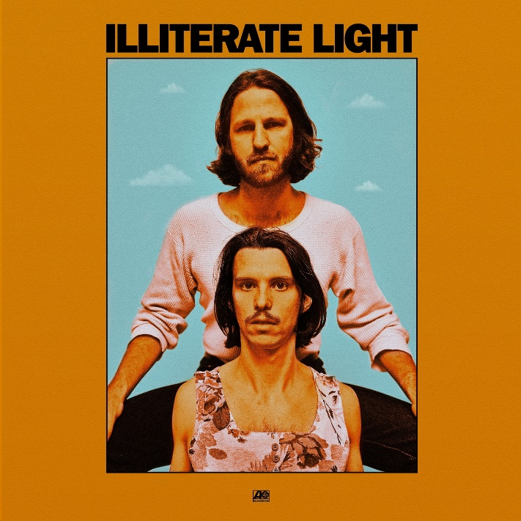

ANNOUNCE 20+ DATE COAST-TO-COAST HEADLINING U.S. TOUR WITH STOPS IN NYC, LOS ANGELES, D.C., BOSTON + MORE

Virginia duo Illiterate Light’s self-titled debut album — which crystallizes their “explosive” (Boston Globe) live energy into a “refined vein of My Morning Jacket / Band Of Horses-style Americana” (Uproxx) — is out today on Atlantic Records. Focused around the alchemic collaboration and camaraderie between members Jeff Gorman (lead vocals, guitar, synth pedals he plays with his feet) and Jake Cochran (vocal harmonies, stand-up drum kit) and recorded with producers Adrian Olsen (Foxygen, Natalie Prass) and Vance Powell (Jack White, Kings Of Leon, Chris Stapleton), the album is an “explosive mission statement” (NPR Music) that — alongside performances at Bonnaroo, Newport Folk Festival, and Lollapalooza — signals their triumphant arrival as an emergent musical force.

Stream Illiterate Light here: https://illiteratelight.lnk.to/LP

NPR Music featured their lead single “Carolina Lorelei” as one of the Best Songs of 2019 So Far. Check it out here: https://n.pr/326da3m

In conjunction with the album release, the duo also announces a 2020 headlining U.S. tour with dates in NYC, Los Angeles, Washington D.C., Boston, Houston, and more — full dates below. For the past several months, the group has been hitting the road hard with Rainbow Kitten Surprise and The Head And The Heart – winning over crowds with their “hypnotic” (Billboard) performances and “electrifying” (Uproxx) stage presence. Despite being one of the festival’s earliest acts, they even received a standing ovation at Newport Folk Fest — “no small feat before noon” according to the Boston Globe.

Check out a live performance of their track “Better Than I Used To,” which NPR called “a perfect addition to your summertime playlist.” – https://n.pr/321KFDL

Illiterate Light's story has taken them a lot of places: an organic farm in the Shenandoah Valley, a radical community center frequented by Mennonites and Anarchists alike, bicycle tours of the mid-Atlantic with their Petrol Free Jubilee Carnival Tour, and now to their major label debut. All along the way, Gorman and Cochran have crafted a unique worldview that emphasizes radical community — a fact that’s evident on Illiterate Light, a generous and blissful record that welcomes listeners with open arms and open ears.

Full 2020 tour routing HERE and below.

Illiterate Light Tracklisting
- In the Ground
- Carolina Lorelei
- Better Than I Used To
- I Wanna Leave America
- Existential Crisis
- Wish I Didn’t Have Any Problems
- Without Walls
- Sometimes Love Takes So Long
- Vacant Lover
- Here Lie The Bones Of My Favorite Car
- Nuthin’s Fair
- American Boy

Illiterate Light 2020 Tour Dates
*10/11 Wallingford, CT Toyota Presents The Oakdale Theatre
*10/12 Boston, MA Agganis Arena
*10/14 Pittsburgh, PA UPMC Events Center
*10/15 Detroit, MI The Fillmore Detroit
*10/16 Columbus, OH Palace Theatre
10/17 Alfred, NY The Knight Club
*10/18 Ottawa, ON Algonquin Commons Theatre
*10/19 Montreal, QC MTELUS
*10/20 Toronto, ON Meridian Hall
^10/24 Richmond, VA Richmond Music Hall
10/25 Harrisonburg, VA The Golden Pony
10/26 Harrisonburg, VA The Golden Pony
1/25 Washington, DC DC9
1/27 Philadelphia, PA Johnny Brenda's
1/28 Brooklyn, NY Rough Trade
1/30 Boston, MA Great Scott
1/31 Montréal, QC Bar Le Ritz P.D.B
2/1 Toronto, ON The Drake Hotel
2/3 Columbus, OH The Basement
2/4 Ann Arbor, MI Blind Pig
2/5 Chicago, IL Schubas Tavern
2/7 Minneapolis, MN 7th Street Entry
2/8 Kansas City, MO Record Bar
2/10 Denver, CO Larimer Lounge
2/11 Salt Lake City, UT Kilby Court
2/13 Portland, OR Mississippi Studios
2/14 Vancouver, BC Wise Hall
2/15 Seattle, WA Barboza
2/17 San Francisco, CA Cafe Du Nord
2/18 Los Angeles, CA Moroccan Lounge
2/20 San Diego, CA Casbah
2/21 Phoenix, AZ Valley Bar
2/22 Tucson, AZ 191 Toole
2/24 Austin, TX Barracuda
2/25 Houston, TX White Oak Music Hall - Upstairs
2/26 Dallas, TX Three Links
2/28 Birmingham, AL Saturn
2/29 Nashville, TN The Basement East

*w/ The Head and The Heart
^w/ TWEN and Grayling Skyy

CONNECT WITH ILLITERATE LIGHT
Facebook | Instagram | Twitter | Official Site

