ILLITERATE LIGHT PAYS TRIBUTE TO ICONIC NASHVILLE VENUE THE BASEMENT EAST WITH LIVE VERSION OF “CAROLINA LORELEI”

LIVE PERFORMANCE FROM SOLD-OUT CONCLUSION OF WINTER TOUR ADDS TO “IN THE MOMENT” SERIES

WATCH “CAROLINA LORELEI (LIVE AT THE BASEMENT EAST)”: https://illiteratelight.lnk.to/CLLATBEPR/youtube

BUY/STREAM: https://illiteratelight.lnk.to/CLLATBE

DONATE TO THE BASEMENT EAST: https://bit.ly/BeastPayPal

NPR 2020 ARTIST TO WATCH
“an explosive mission statement from a band that’s here to stay”
– NPR

“The promising Virginia-based duo has an ambition that is promising at a time when rock needs it.”
“two guys, in the moment, playing their respective rigs; no substitutions”
– SPIN

“Illiterate Light’s live show is its own idiosyncratic phenomenon”
– RELIX

“electrifying, combustible… a refined vein of My Morning Jacket / Band of Horses-style Americana”
– UPROXX

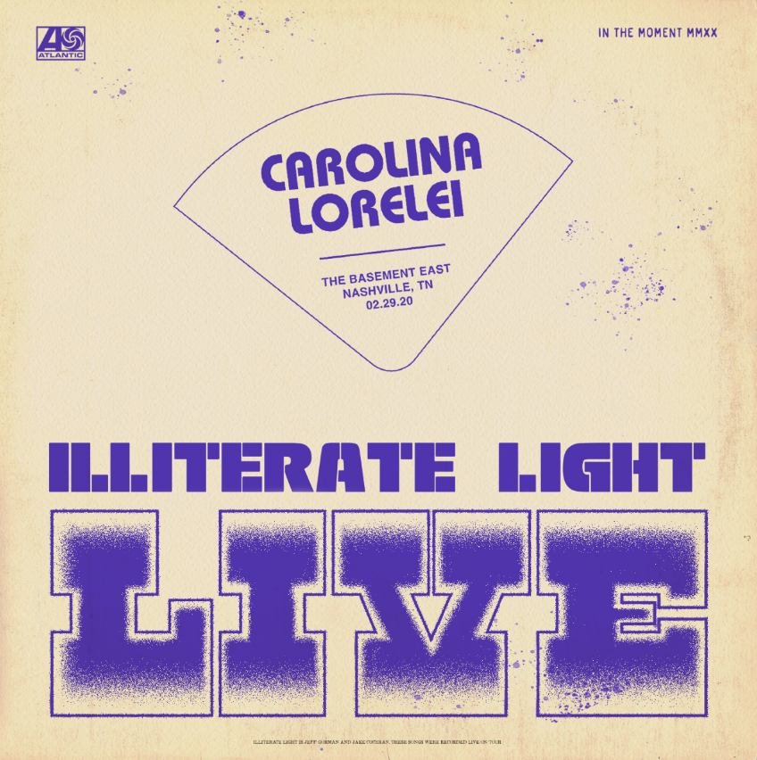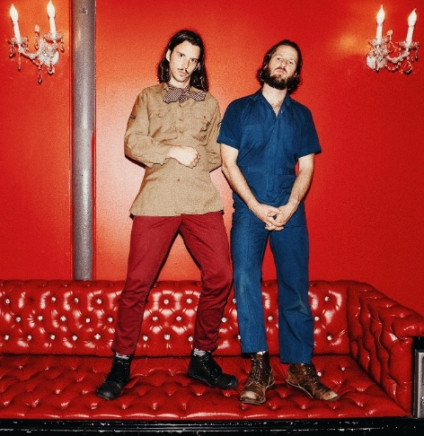
download artwork download hi-res press photo

Indie folk-rock duo Illiterate Light has released a live version of “Carolina Lorelei,” recorded during a show at legendary Nashville venue The Basement East. The audio + electrifying performance visual (watch here) were captured during the conclusion of the band’s US headline tour – ultimately one of the last shows to be held at the venue, just two days prior to the devastating tornado that impacted Nashville.

When we started touring heavily in 2017, Nashville quickly became a second home for us…so it truly meant the world to finish out our winter tour with a packed house at the Basement East this past February. It was a magical night...cold outside, hot inside, sweaty, singing, crowd surfing, staff made us feel like family, seeing friends and family after living on the road for a couple months...a rowdy homecoming. Little did we know that two days later the Beast would be destroyed by a massive tornado that swept through Nashville. The news was devastating and we’re so thankful that no one was hurt. The Basement East is now rebuilding and looking to reopen by the end of the year. We hope you dig this version of “Caroline Lorelei” live from The Basement East - February 29, 2020 #NashvilleStrong

PS - so many of the venues that we’ve toured over the last couple of years are at serious risk of not making it through the pandemic. Please visit https://www.nivassoc.org/ to learn more and send a letter to legislators asking for specific solutions that will help keep these venues alive.

Today’s release adds to the Illiterate Light’s live series “In The Moment,” which the band has been building out with recordings + videos from their incredible live shows. While originally begun back in January, the series has taken on new meaning over the last couple of months – becoming a tribute to the power of the live performances and the community formed during shows – something all music fans are so desperately missing.

Last month’s release – “Sometimes Love Takes So Long” – was recorded during a sold-out show at Allston’s Great Scott. Somewhat cosmically, the long-planned release came just days after Great Scott’s owners announced the venue would sadly not be re-opening its doors, making the video an homage of sorts to the historic club and leading local Boston outlet Vanyaland to declare: “this Great Scott capture is something special.”

To kick off the “In The Moment” series, the band released a spirited cover of Neil Young’s “Vampire Blues,” which has become a fan favorite during their live shows (watch here). Their second release, a live version of “Nuthin’s Fair,” premiered on Relix with the outlet declaring: “Indie-fuzz duo Illiterate Light have been on a whirlwind since the release of their eponymous debut album… a new live video from the band showcases their DIY roots and their hometown venue The Golden Pony.” In March, the band released “In The Ground” which was aptly described by SPIN as: “two guys, in the moment, playing their respective rigs; no substitutions.”

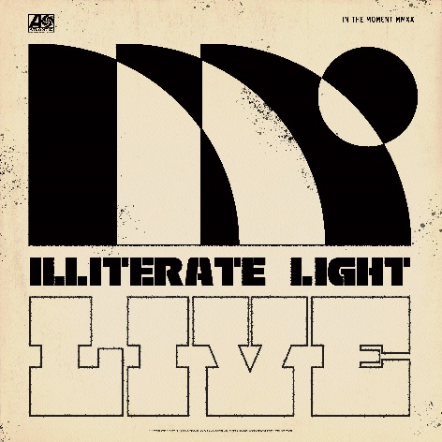
download hi-res "In The Moment" album artwork
After sold-out shows this fall in Richmond and Harrisonburg, VA, the duo kicked off a North American headline tour at the end of January – playing to sold out rooms in Washington DC, Philadelphia, Boston, and an enraptured crowd at Brooklyn’s Rough Trade. They also performed live sessions for both Relix and Paste. After attending their show in Minneapolis, Chris Riemenschneider (music critic at the Star-Tribune) declared: “Bounced from the fancy new Fillmore to the grimy old Entry last night and caught a young band that could soon be too big for both rooms… They jammed through a killer Neil Young cover too.”

This year’s live shows followed heavy touring last year with Rainbow Kitten Surprise and The Head And The Heart – winning over crowds with their “hypnotic” (Billboard) performances and “electrifying” (Uproxx) stage presence. Despite being one of the festival’s earliest acts, they even received a standing ovation at Newport Folk Fest — “no small feat before noon,” the Boston Globe declared.

At the top of 2020, the duo was named to NPR’s “Slingshot Artists to Watch,” with the outlet featuring them amongst just 12 other artists “sure to do big things in 2020.” NPR specifically highlighted the duo’s “energetic live shows,” during which the two play a full band’s worth of instruments. “This isn’t a gimmick,” KTBG The Bridge’s Jon Hart continued, “the music on the duo’s self-titled release holds up.” NPR previously highlighted the group in their “Best Songs of 2019 (So Far),” declaring “Carolina Lorelai” to be “an explosive mission statement from a band that’s here to stay.”

In September, Relix named the band to their “5 Artists You Should Know,” asserting: “Illiterate Light’s live show is its own idiosyncratic phenomenon… from the booming psych-rock anthem ‘Growin’ Down’ to the atmospheric sing-along ‘Carolina Lorelai.’”

Illiterate Light’s single “Better Than I Used To” also received accolades from NPR, which declared it “a perfect addition to your summertime playlist.” The music video for “Better Than I Used To” was premiered via Billboard, which called it “a visual that translates the euphoric, restorative powers of love into a reverent and downright hypnotic experience.” The track cracked the Top 10 of the Adult Alternative chart at the top of 2020.

All of this comes on the heels of Illiterate Light’s self-titled debut album, released in October via Atlantic Records. Upon release, Uproxx heralded the album as a “refined vein of My Morning Jacket / Band of Horses-style Americana.” Focused around the alchemic collaboration and camaraderie between members Jeff Gorman (lead vocals, guitar, synth pedals he plays with his feet) and Jake Cochran (vocal harmonies, stand-up drum kit) and recorded with producers Adrian Olsen (Foxygen, Natalie Prass) and Vance Powell (Jack White, Kings Of Leon, Chris Stapleton), the album is part soaring indie rock, part swirling psychedelia, part atmospheric folk and — alongside critically acclaimed performances this summer at Bonnaroo, Newport Folk Festival, and Lollapalooza — signals their triumphant arrival as an emergent musical force.

###

CONNECT WITH ILLITERATE LIGHT
Facebook | Instagram | Twitter | Official Site

PRESS CONTACT:
Libby Kober | Libby.Kober@AtlanticRecords.com

