FROM TOURING ON BICYCLE TO ATLANTIC RECORDS: ILLITERATE LIGHT RELEASE “CAROLINA LORELEI”

SET TO PLAY BONNAROO, LOLLAPALOOZA AND NEWPORT FOLK FESTIVAL THIS SUMMER

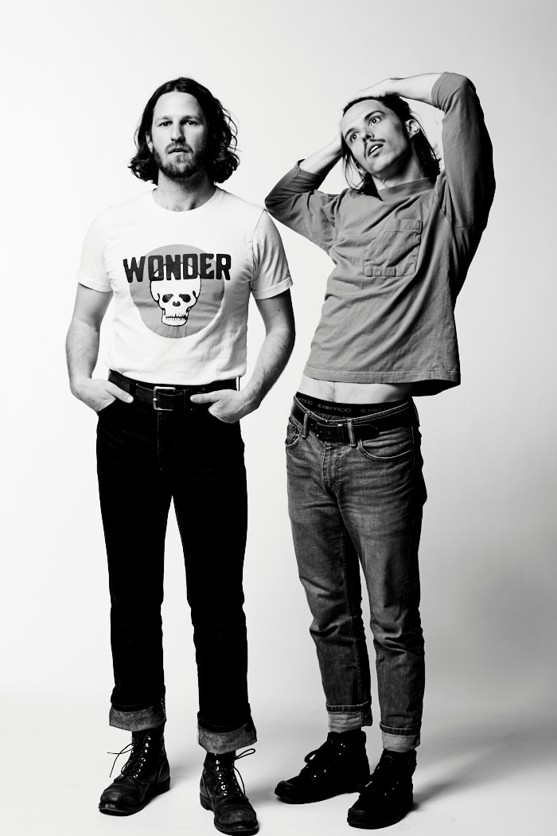
Photo Credit: Jimmy Fontaine

WATCH THE MUSIC VIDEO FOR “CAROLINA LORELEI” OVER AT
UNDER THE RADAR: http://bit.ly/2whJYIg

Today, Illiterate Light — the musical partnership between Jeff Gorman (vocals, guitar, synth pedals) and Jake Cochran (drums, vocals) — release their new single “Carolina Lorelei.” The track precedes what will be an immense summer for the erstwhile organic farmers: They are slated to play festivals including Bonnaroo, Lollapalooza and Newport Folk Festival, as well as a series of fall dates supporting Rainbow Kitten Surprise.

Watch the video for “Carolina Lorelei” over at Under The Radar, which calls it ”a propulsive folk-rock anthem that emanates the firm conviction of the love the song is based on”: http://bit.ly/2whJYIg

“Carolina Lorelei” is a concise summation of the band’s winning, less-is-more sound: clattering drums from Cochran’s standup kit, Gorman’s loping guitar runs and the duo’s harmonious vocal interplay. All of this is bolstered by the synth tones Gorman stomps out with his feet, which provide an atmospheric color that shifts from ghostly wisps to arena-filling bass swells. Says Jeff Gorman, “Carolina Lorelei came out of a moment when I was chopping wood in a small town north of Asheville, NC. I saw my partner walking up this hill to meet me, and her simple yet radiant beauty struck me like never before. She was glowing. My sense of time completely vanished and I fell so deeply in love with her. The song, in essence, is my attempt to unpack that blissful, quasi-mystical moment.”

Listen to a live version of early single “Better Than I Used To,” which NPR says “builds to a sunburst of a crescendo” and is “a perfect addition to your summertime playlist”: https://youtu.be/z7gravapVL0

Illiterate Light’s swift come-up belies some humble roots, as they’ve gone from touring the mid-Atlantic on bicycle to being signed by Atlantic Records. In the meanwhile they’ve been grinding it out on the road, wowing audiences as they’ve opened for Mt. Joy, Shakey Graves and Rayland Baxter. Earlier this year, they self-released their debut Sweet Beast EP, and they are putting the finishing touches on a debut full length with Vance Powell (Jack White, Kings Of Leon, Chris Stapleton) and Adrian Olsen (Foxygen, Natalie Prass) — more details on that coming soon.

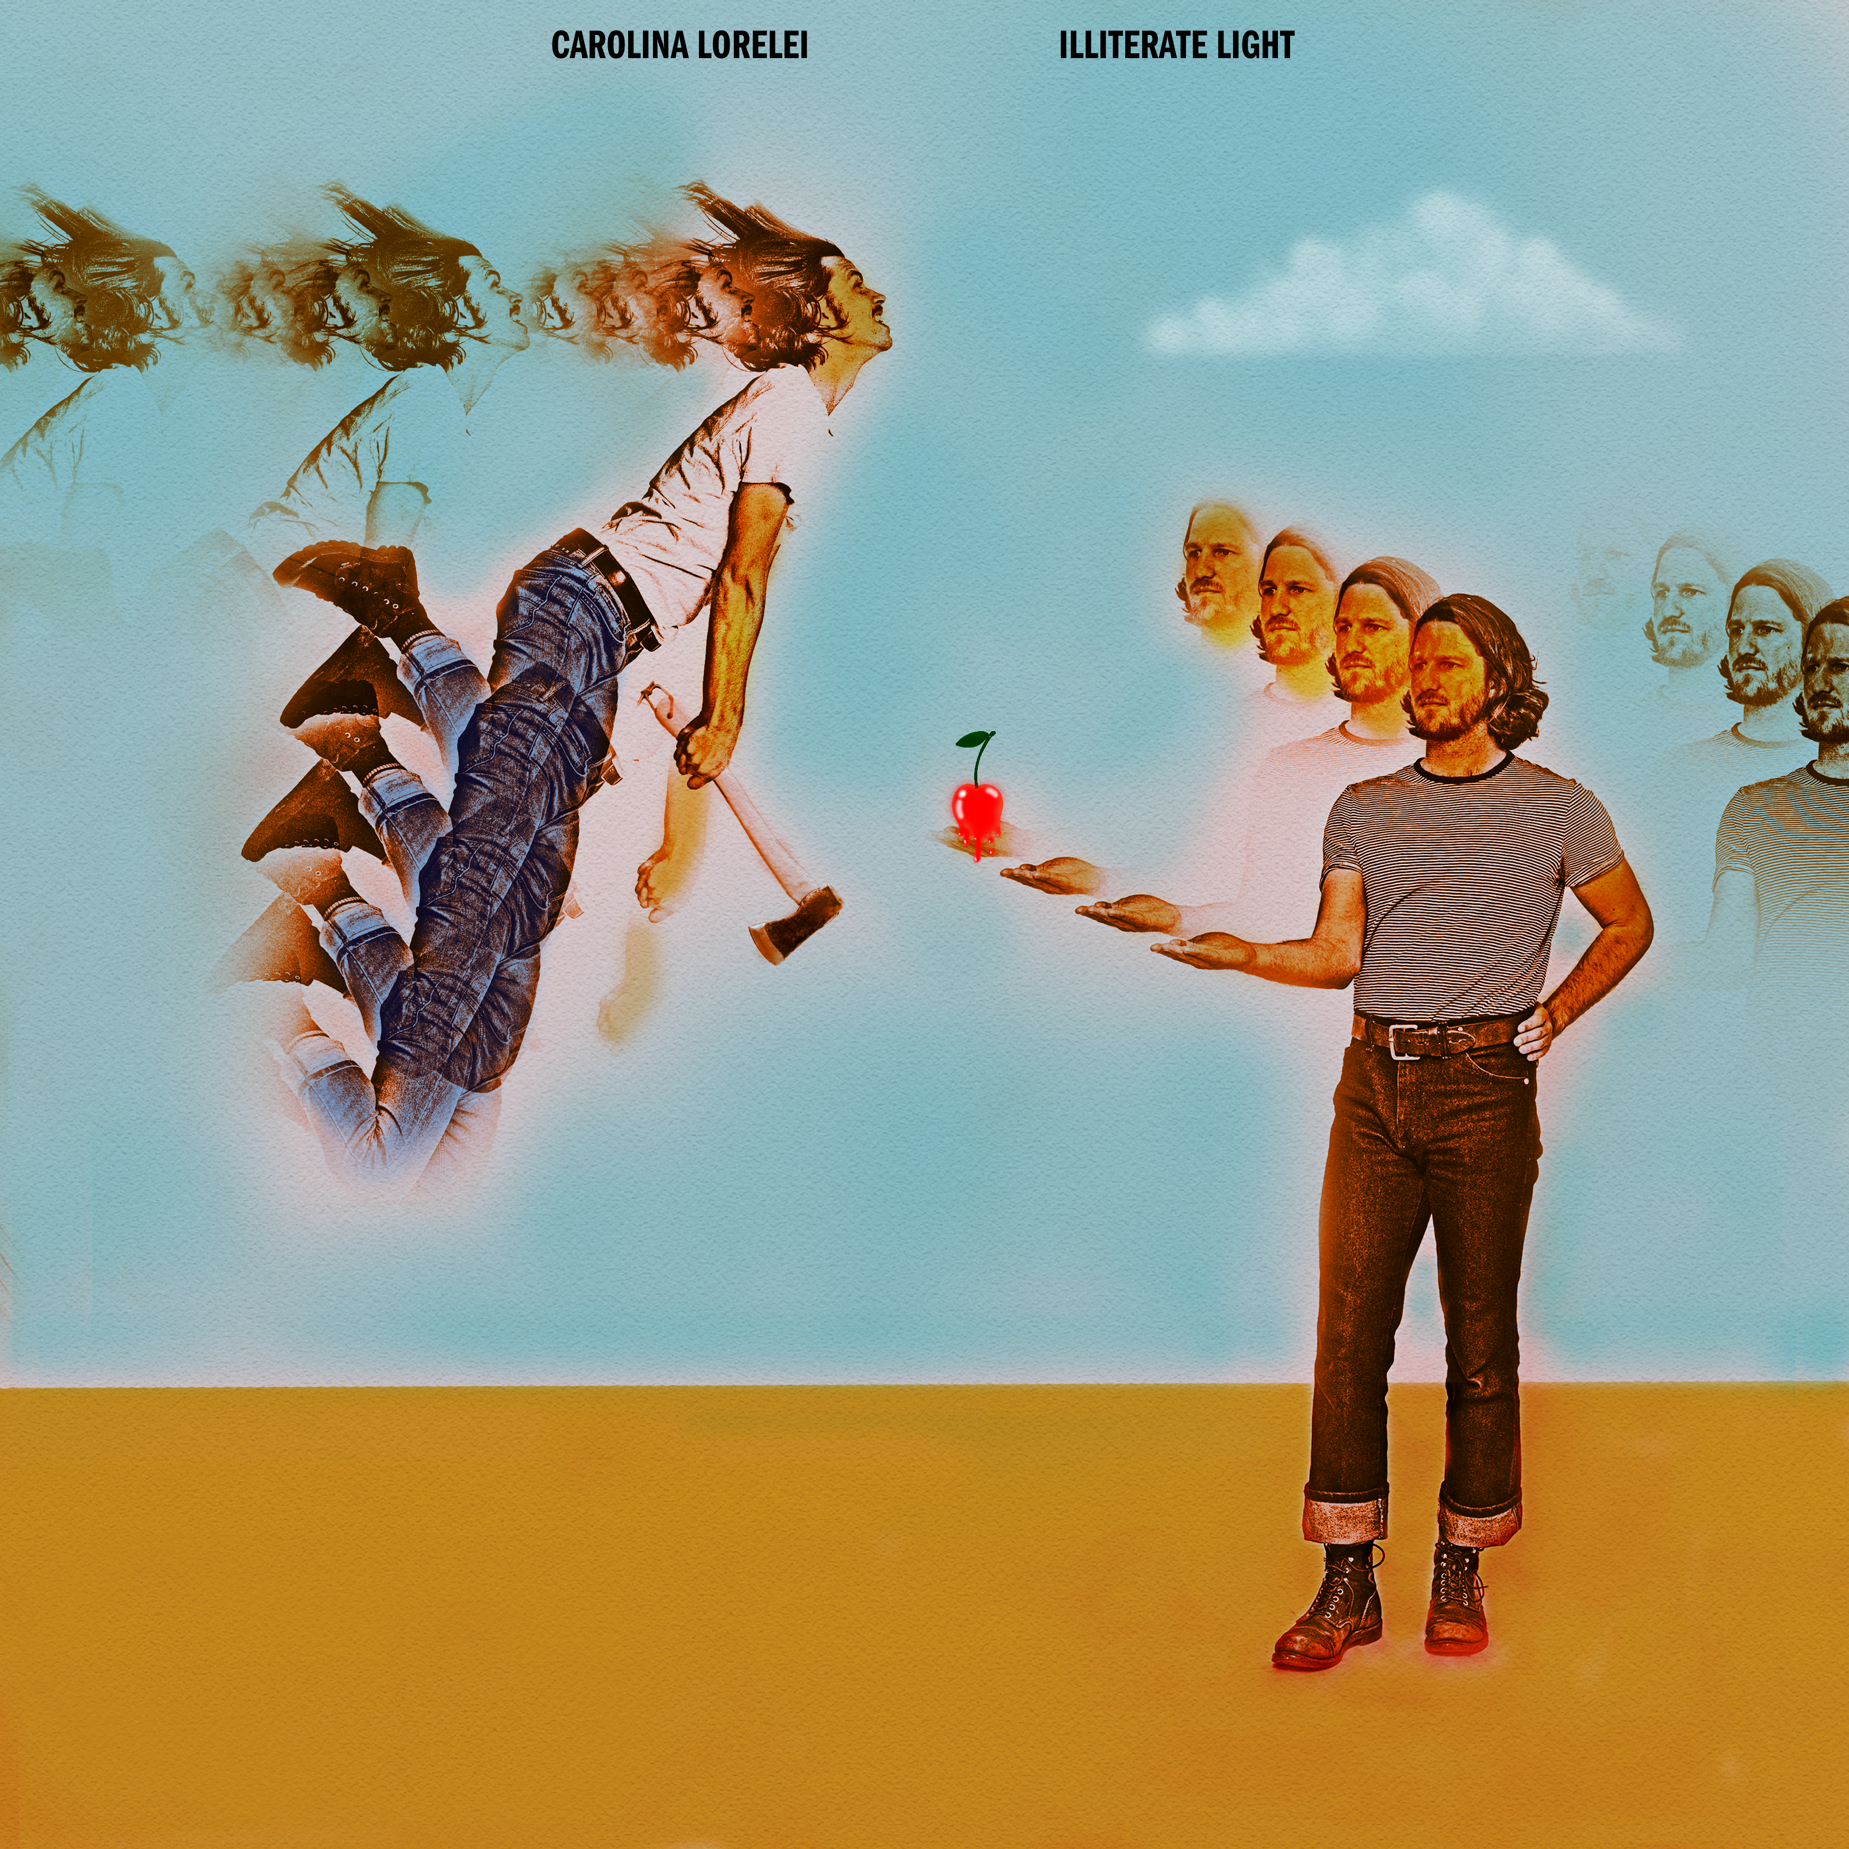

Tour Dates
May 23 — Harrisonburg, VA @ Golden Pony
May 24 — Richmond, VA @ Friday Cheers
June 1 — Roseland, VA @ Music in the Blue Ridge
June 7 — Norfolk, VA @ First Fridays
June 14 — Manchester, TN @ Bonnaroo Music Festival
July 27 — Newport, RI @ Newport Folk Festival
August 4 — Chicago, IL @ Lollapalooza
September 14 — Montreal, QC @ Corona Theatre*
September 20 — New Haven, CT @ College Street Music Hall*
September 22 — Bethlehem, PA @ Levitt Pavilion Steel Stacks*
September 24 — Ithaca, NY @ State Theatre*
September 25 — Detroit, MI @ Fillmore Detroit*
September 27 — Charlotte, NC @ Metro Credit Union Amphitheatre*
September 28 — Greenville, NC @ Peace Center Concert Hall*
September 30 — Orlando, FL @ House Of Blues*
October 3 — Athens, GA @ Georgia Theatre*
October 4 — Athens, GA @ Georgia Theatre* – SOLD OUT

*Supporting Rainbow Kitten Surprise

Illiterate Light On The Web
https://www.illiteratelight.com/
https://www.facebook.com/illiteratelight/
https://twitter.com/illiteratelight
https://www.instagram.com/illiteratelight

